Short term plan

Unit 1 Homes and away  Unit of a long term plan unit1 |  |  |  |  | School:
Date: |  |  |  |  | Teacher name:
CLASS: 5 |  |  |  |  | Number present: |  |  | absent:
Lesson title |  |  | Homes 1
Learning objectives(s) that this lesson is contributing to (link to the Subject programme) |  |  | L1. Understanding sequence of supported classroom instructions  S7. Use appropriate subject- specific vocabulary and syntax to talk about a limited range of general topics  UE3. Use a growing variety of adjectives and regular and irregular comparative and superlative adjectives an a limited range of familiar general and curricular topics  W3 write with support factual descriptions at text level which describe people, places and objects
Lesson objectives |  |  | All learners will be able to:  Name parts of yurt, understand vocabulary, describe places  Most of learners will be able to:  Understand specific vocabulary
Assessment criteria |  |  | Say topic words with clear pronunciation. Say expressions clearly  describe places and objects use adjectives in degrees
Language objective |  |  | Yurt , shanyrak uwyk a carcass
Values links |  |  | To keep ,to increase and to hand down traditions and friendship between people
Cross-curricular links |  |  | art
Previous learning |  |  | Review
Plan
Planned timings | Planned activities (replace the notes below with your 9planned activities) |  |  |  |  |  | Resources
Start | Greetings,  Good morning pupils! Who is on duty today? Who is absent?  Teacher divides pupils in 2 groups with cards: “ Yurts’, “ Homes”
Middle | L1 Task 1 Listen to and repeat attentively after teacher : a bedroom, a dining room, bathroom, a living room, a toilet, a study,  a round-shaped , a shanyrak , a kerege ,a uwyk  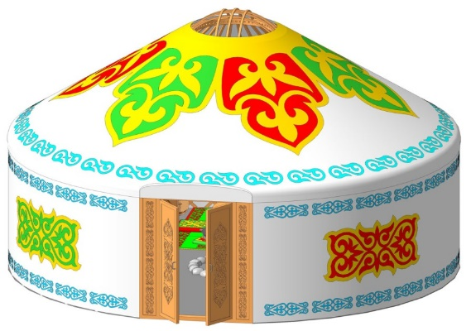  L 1 Task 2 Match the pictures with the words  Yurt is a round-shaped, it consists of three main parts and many other smaller parts. Three main  parts include Shanyrak – top of the Yurt, Kerege – walls carcass and Uwyk – a carcass  part from Kerege to the Shanyrak.  Yurt usually does not have rooms in it, and it was a common practice to have a separate  YuYrt as a bedroom, separate one as a kitchen, guesthouse, etc as long as people could  afford that.  Task 2 Find out which of these adjectives in positive degree, in comparative degree, in superlative degree  1 A building is bigger than yurt.  2. Yurt is smaller than a building.  3. A house is modern.  4. A living room is the most comfortable room in the house.  5.Yurt is the oldest house.  Descriptor: Learners find degrees of adjectives  W3 Task 4 Write things you remember from the texts  Yurt, kerege ,house ,shanurak .small ,beautiful ,modern  Bedroom, living-room ,comfortable  Descriptor: Pupils write names of rooms ,describe of house
End | Answer the question “ How can be a modern house?”  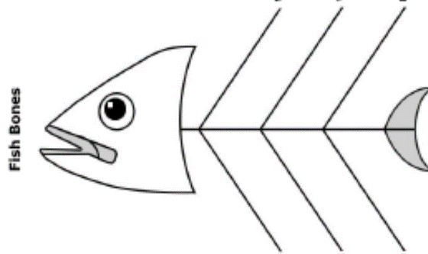
Additional information

Differentiation – how do you plan to give more support? How do you plan to challenge the more able learners? |  |  |  | Assessment – how are you planning to check learners’ learning? |  | Health and safety check
Differentiation can be achieved through the selection of activities, identification olearning outcomes for a certain student, provision of individual support to learners, selection of learning materials and resources based on the individual abilities of leaners (Theory of Multiple Intelligences by Gardner). |  |  |  | Use this section to record the techniques that you will use to assess what the learners have learned during the lesson. |  | Health saving technologies.  Using physical exercises and active activities.  Rules from the Safety Rules book which can be applied in this lesson.
Reflection  Were the lesson objectives/learning objectives realistic?  Did all the learners achieve the lesson objectives/ learning objectives? If not, why?  Did my planned differentiation work well?  Did I stick to timings?  What changes did I make from my plan and why? |  | Use the space below to reflect on your lesson. Answer the most relevant questions from the box on the left about your lesson.

