Разработка урока

«The Fisherman and the fish»
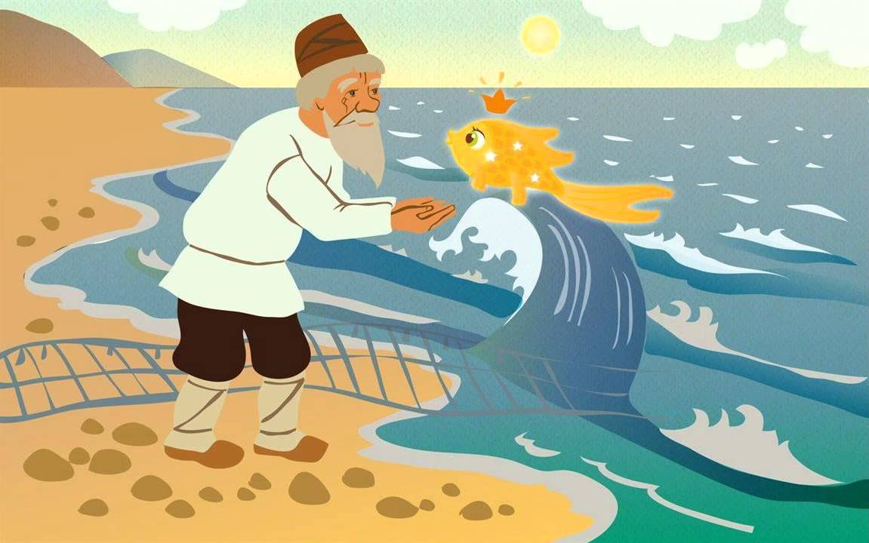

Учитель английского языка Хамитова А.С.

Lesson plan
CLASS: | 5
Lesson title: | «The Fisherman and the fish»
Learning objectives(s) that this lesson is contributing to (link to the Subject programme) | recognize the opinion of the speaker(s) in basic, supported talk on an increasing range of general and curricular topics5. W6 link, with some support, sentences into coherent paragraphs using basic connectors on a limited range of familiar general topics.  communicate meaning clearly at sentences level during pair, group and whole class exchanges  use simple perfect forms of common verbs to express what has happened [indefinite time] on a limited range of familiar general and curricular topics
Level of thinking skills | Knowledge, Understanding, application  All learners will be able to-read the text, identify the meanings of the words and match them with their definitions  — underline the simple perfect form sentences from the given text Most learners will be able to  — say their opinions on a short video on the theme «The Fisherman and the fish»
Lesson objectives | — summarize their ideas/ opinion on the theme  Some learners will be able to make up sentences using new vocabulary
Assessment criteria | Identify the speaker’s point of view in a simple conversationConnect sentences into paragraphs with some support

Greetinging | Teacher greets the learners. Learners greet the teacher | 1 minute
Org moment | Teacher divides the students into 2 groups using colour cards and pupils take their places. | 1 minute
Warm-up | The theme of our lesson today is «The Fisherman and the fish». What do you think we are going to talk about? | 3 min
Middle | Student’s Book p 76 ex 1. Pupils read and translate a short text about Alexander Pushkin. | 5 min
 | Look at the pictures. What can you see? Which one shows:  a beautiful house? Picture F  a fisherman catching a fish? Picture D  dark sea and rain? Picture A  an angry woman with a bucket? Picture B  a queen ans her servants? Picture E | 2 min
Working with new vocabulary | Pupils looking up the translations of new words and expressions at the end of the Student’s Book p 150 | 2 min
Waching the video | Pupils watch the video and discuss it:  What have they understood?  What was it about?  What words have they heard? | 5 min
orking with the text  Consolidation | Pupils are given 3 tasks to each group:  To translate their half of the text  To underline 5 new words and translate them  To make up 3 sentences using new vocabulary  Team #1  Pupils translate the text in groups:  An old fisherman and his wife lived in a small house near the sea. They were very poor. One day, the fisherman caught a golden fish.  ‘Please, let me go,’ said the fish , ‘and you can have anything you wish!’ The firsherman was very surprised. The fish could speak!  “Dear little fish,” said the old man, ‘I don’t want anything!”  He let the fish go and walked home. He told his wife about the fish.  “You fool!” she shouted. “We need a new bucket! Go back and ask for a bucket!”  So the fisherman went back to the sea. It was calm. He called the golden fish and it swam up to him.  “What do you want, good man?” it asked  “My wife wants a new bucket,’ said the firsherman.  “You can have your wish. Go home now”, said the fish and swam away.  The fisherman went home and saw a new bucket , but his wife was still angry. She wanted a new house. So the fisherman went back to the sea and called the golden fish again. This time the sea was not so calm.  Team # 2  The fish granted his wish and the fisherman went back home. He saw a beautiful new house, but his wife was still angry. She wanted to be rich with a huge house. So the fisherman went back to find the fish. The sea was dark now and the sky was grey. The fish granted her wish, but still she wasn’t happy. She wanted to be a queen with a palace and servants so she sent her husband back to find the fish. The fish granted her wish, but still she wasn’t happy. She wanted to be the Queen of the Land and Sea, with the golden fish as her servants.  The fisherman went back to the sea and called the golden fish. The sea was stormy and there were clouds in the sky.  “I’m sorry, dear fish!” he cried. “Now my wife wants to be Queen of the Land and Sea, and she wants you to be her servant.”  The fish didn’t answer. It turned and swam away.  The fisherman went home. He couldn’t see the palace or the servants. All he could see was his small house and his wife. She was poor again and I front of her was the old bucket.  Student’s book p 77 ex 4. Pupils complete the sentences:  - One day, the fisherman caught a golden fish but he …  - The golden fish offered the fisherman a wish , but the old man didn’t …  - When the fisherman told his wife about the fish, she called him a …  - The fisherman’s wife asked for a … with her second wish. | 10 min  3 min
 | 5.The fisherman’s wife wished to be the Queen of the …  6. At the end of the story, the fisherman and his wife only had…  Pupils are given the antonyms which they should match:  Rich – poor  Small – huge  New – old  Kind – rude  Young – old  Dark – light | 2 min
 | Why did the fisherman’s wife stay with her old house and old bucket?  What do you think the maim idea? | 1 min
 | What is your wish to the gold fish? Pupils write it and stick on the blackboard near the fish.
Giving the home task | SB p 77 ex 6  Quiz 6 a  To make up 5 sentences using new words | 1 min

