7.3C Natural Disasters. |  |  |  | School: Azat school
Date: _15.03.2018_ |  |  |  | Teacher’s name: Khudaikulova M.L.
Grade 7 |  |  |  | Number present: |  |  | absent:
Theme of the lesson |  |  |  | Refugees and Natural Disasters
Learning objectives(s) that this lesson is contributing to |  |  | 7.L5 understand most specific information and detail of supported, extended talk on a range general and curricular topics  7.S3 Give an opinion at sentence and discourse level on an increasing range of general and curricular topics.  7.S7 Use appropriate subject-specific vocabulary and syntax to talk about a limited range of general topics, and some curricular topics.
Lesson objectives |  |  | All learners will be able to:
- Make an attempt to answer the questions and guess the topic of the lesson.
- Understand the general idea while watching a video and try to answer the questions.
- Understand the general idea while reading a text and try to prepare a cluster
 |  |  | Most learners will be able to:
- Answer the questions using specific vocabulary and guess the topic of the lesson.
- Understand the main idea while watching a video and answer the questions.
- Understand the main idea while reading a text and prepare a cluster
 |  |  | Some learners will be able to:
- Answer the questions using specific vocabulary and critically analyzing the situations.
- Understand the details while watching a video and answer the questions without any support.
- Assist less able learners during class/group/pair discussions.
Language objective |  |  | Natural Disasters
Value links |  |  | Lifelong learning, cooperation, respect to different opinions, transparency in evaluation
Cross curricular links |  |  | Geography, History
Previous learning |  |  | Unit 3 Natural Disasters
Use of ICT |  |  | - Projector or Smart board for showing a presentation  - Access to the for showing a video
Intercultural awareness |  |  | Be aware of global problems as global citizens
Kazakh culture |  |  | Natural disasters in Kazakh land
Pastoral Care |  |  | Promote a sense of self-esteem and self-respect and respect for others among all the learners.
Health and Safety |  |  | Everyday classroom precautions will ensure that safety measures are provided to prevent the exposure of electrical power cords
Planned timings | Planned activities |  |  |  |  | Resources
5min  Main Part  3min  5 min  3min  15min  5min  4min | Lead-in: W  Teacher greets learners and sets environmentally-friendly atmosphere within the classroom. «Circle of wishes»  I wish you….  Pre teaching activity W  Teacher introduces the topic to learners through the pictures.  Then teacher and learners together set the lesson objectives.  Teacher reminds that today’s lesson is dedicated to revise the whole unit.  Vocabulary revision activity P,G  Discriptors  Put the letters correctly 6-7 - 3smiles 4-5 - 2 smiles 1-3 - 1 smiles  Match the word with their definitions 5-6 -3 smiles 3-4 - 2 smiles 1-2 – 1 smiles  Video with multiple choice questions W, I  Teacher tells the learners that they are going to watch two times a short video about natural disasters and answer multiple choice questions.  Peer assessment  Learners check one another using answer key which is provided by teacher.  - What kind of disasters are in our country?  Relaxing  Reading and speaking about natural disasters  Teacher suggests reading the text « Natural disasters». In a peer make a cluster.  Assessment criteria: 1. Using new words  2. Prepare the information clearly to other groups.  Prepare a cluster on an A3 paper  Feedback  Students answer the questions:  How many types of natural disaster can you name? Which is the worst?  What natural disasters are common in your country?  If you face to natural disasters what 3 things you will take?  Teacher gives comments on the activities which learners had and provides the whole class with general feedback.  Reflection  If you understand the lesson very good put choose the sun.  If you understand the lesson good choose the cloud.  If you don’t understand the lesson choose the rain.  Out lesson is over. Good bye! |  |  |  |  | PowerPoint presentation slide1  Appendix 1: Worksheet  https://youtu.be/Skz0Rgchm6g  Appendix 2: Multiple choice questions worksheet  Appendix 3:  Text « Natural disasters».  PowerPoint Presentation, slide 3  Appendix 4: Reflection cards
End  1min | Feedback: Teacher asks learners what task was difficult to them and which pair worked well.
Additional information
Differentiation – how do you plan to give more support? How do you plan to challenge the more able learners?  - More support:  - Provide less able learners with the names of natural disasters  - Create mixed ability groups for discussion. |  | Assessment – how are you planning to check learners’ learning?  - Assessment criteria will be presented to the learners before starting the activity  - Observe learners when presenting their group projects. Did the group dynamics work? Did each learner contribute to the presentation? If not, why not? (e.g. didn’t understand what to do; not so confident speaking English; not interested in topic; other)  - Monitor learners to check they can manage the activities and are able to participate interactively |  |  | Critical thinking  - Analyzing the video learners try to answer the follow up questions
Summary evaluation
What two things went really well (consider both teaching and learning)?
1: 1: reading task
2: warming up activity

What two things would have improved the lesson (consider both teaching and learning)?
1: pay more attention to drilling
2: time management

What have I learned from the lesson about this class or individuals that will inform my next lesson?

Most of my learners love group work and self-study. They liked helping a teacher

Summary evaluation
What two things went really well (consider both teaching and learning)?
1:
2:

What two things would have improved the lesson (consider both teaching and learning)?
1:
2:

What have I learned from the lesson about this class or individuals that will inform my next lesson?

Most of my learners love group work and self-study. They liked helping a teacher

Appendix 2
Multiple Choice Questions:

1.______ suffered the fourth largest earthquake ever recorded.
a. Chile
b. Japan
c. Australia
2. Japan was hit by a _____ magnitude earthquake.
a. 0.9
b. 9.9
c. 9.0
3.______ died when buildings and homes collapsed like papers.
a. over 190 people
b. 190 people
c. less than 190 people
4. A two weeks old baby and his mother were rescued after ______.
a. 34 hours
b. 2 days
c. 24 hours
5.______ suffered the worst flood since the 1970’s.
a. Austria
b. Austral
c. Australia
6.Twelve million people were affected by a severe ______.
a. drug
b. drought
c. drag
7.In the southern states of the USA ______ destroyed thousands of homes.
a. wildfires
b. warfare
c. wares
Appendix 2
Crossword worksheet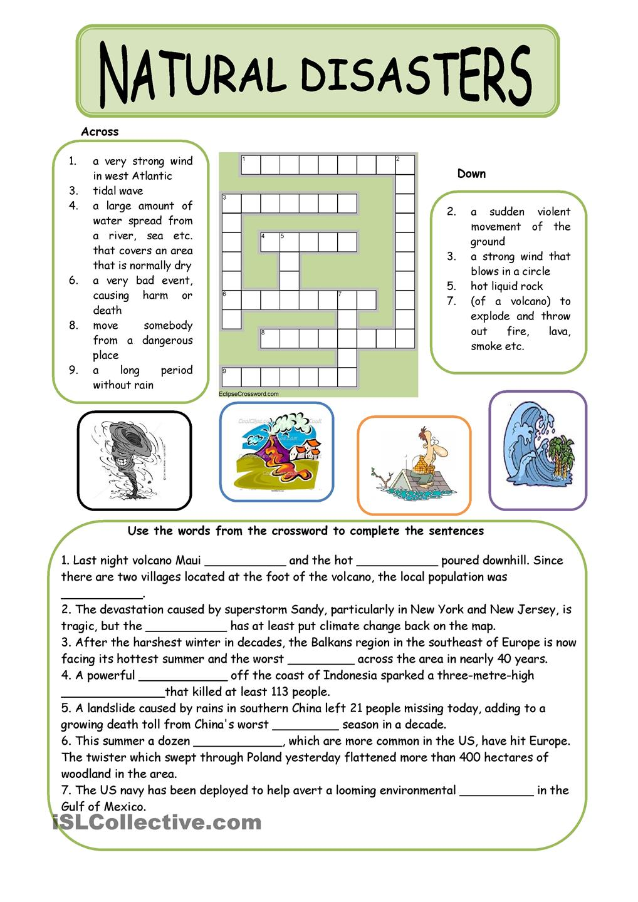
Appendix 3
Reflection Cards
- I’m doing well with …
- I’m proud of myself for …
- I still need help with …
- My goal …

