Read the text and do the tasks//

Mysterious Monster
At different times, thousands of people say that they have seen a large animal in the famous lake called Loch Ness in Scotland. For many centuries, people have tried to catch it. People who live there always talk about the mysterious animal in the lake, and many of them believe that it is still there today.
In 1933, John McGregor, a local businessman, saw that the lake began to bubble, and a huge animal with two humps came out of it.
After that, scientists examined the lake with underwater equipment and tried to find out what kind of animal lived there. Of course, they haven’t found it yet, because the lake is so deep and so dark.
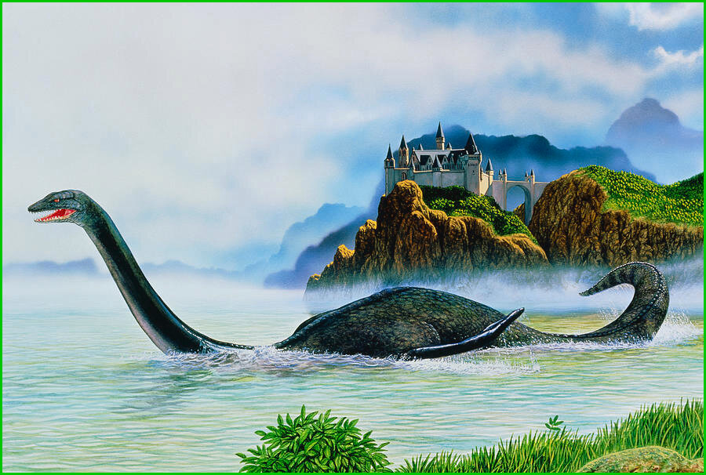

Tourists from all over the world have visited Loch Ness, they hope to see the monster. They have even given it a nickname “Nessie”. Many people even show photos of the monster, but they are usually photos of the pictures of the monster. Scientists suppose that the Loch Ness monster is a dinosaur, which has survived since the Ice Age.
Here is a description of the monster:
- Length: About 50 metres.
- Body: With two humps.
- Half horse, half snake and quite small.
- Long and thin, like a giraffe.
- Yellow-brown.
- People think that it eats sheep on land and underwater plants.
- Shy, doesn’t want to be seen.
- Lives in the deepest and coldest parts of the lake about 1 km from the surface.
Tasks.
Exercise 1. Insert the words according to the text.
have visited, haven’t found, tried, so deep and so dark, came out of it
- For many centuries people ... to catch it.
- The lake began to bubble and a huge animal...
- Of course they ... it yet.
- The lake is …...
- Tourists from all over the world ... Loch Ness.
Exercise 2. Выберите правильную концовку для предложений.
- Loch Ness is in …
- England b) Scotland c) Wales
- Loch Ness is …
- a lake b) a river c) a village
- Scientists examined the lake with
- a) underwater equipment c) computers d) special ultrasound gadgets
- Tourists have given the monster a nickname
- Locky b) Nessie c) Lohnessi
Exercise 3. True or false.
- For many centuries, people have tried to catch the Loch Ness monster.
- No one believes that the Loch Ness monster is still in the lake today.
- In 1956, John McGregor, a local businessman, saw that the lake began to bubble.
- The lake is very deep.
- Many people show photos of the monster.
Exercise 4. Дополните описание Лохнесского чудовища.
- Length: About _______ (1)
- Body: With two humps.
- Half __________ (2), half snake and quite small.
- Long and thin, like a giraffe.
- Yellow-brown.
- People think that it eats __________ (3) on land and underwater ________ (4).
- Shy, doesn’t want to be seen.
- Lives in the deepest and __________ (5) parts of the lake about 1 km from the surface.

