***Разнообразие животных***

**Найдите спрятанные слова:**

|  |  |  |  |  |  |  |  |  |  |
| --- | --- | --- | --- | --- | --- | --- | --- | --- | --- |
| Р | О | К | В | А | М | Н | Х | О | Р |
| У | С | Р | О | М | К | А | Ы | Ь | Ё |
| С | И | В | Ж | Ы | В | Б | А | Н | Б |
| А | Л | А | К | Ш | Ь | З | Б | Б | О |
| К | А | К | Ш | У | Р | О | Ё | Ж | А |
| Ы | Р | Л | Я | Г | О | Д | Р | И | Ь |
| Ж | А | М | Е | Д | В | Е | Д | Ь | М |
| О | Я | Е | М | З | И | Я | Т | С | Ь |
| У | Л | С | А | Р | Ы | М | И | Ы | А |
| Н | О | С | Ь | Ф | Е | Р | Г | Р | З |

**_________________________**- наука о животных.

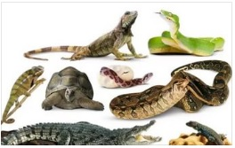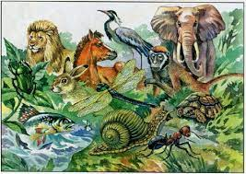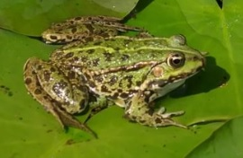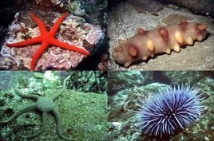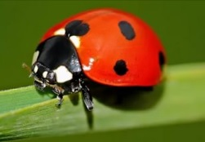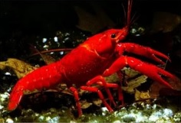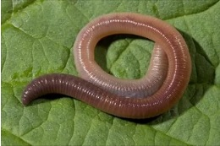

**Определите группу животных и закрасьте одним цветом:**

**Сурок; Мышь; Кабан; Лиса; Бобер; Ёж; Лягушка; Медведь; Змея; Тигр; Рысь; Лось.**



**Черви: __________________________________________________________________________________________________**

**Моллюски: __________________________________________________________________________________________________**

**Иглокожие: __________________________________________________________________________________________________**

**Ракообразные: __________________________________________________________________________________________________**

**Паукообразные: __________________________________________________________________________________________________**

**Насекомые: __________________________________________________________________________________________________**

**Рыбы: __________________________________________________________________________________________________**

**Земноводные:_____________________________________________________________________________________**

**__________________________________________________**

**Пресмыкающиеся: __________________________________________________________________________________________________**

**Птицы: _________________________________________________________________________________________________**

**Звери, или млекопитающие: __________________________________________________________________________________________________