Проверочная работа для определения времени, названий месяцев, времён года и дней недель.

1. What time is it? Choose the right answer.
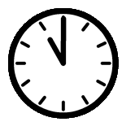  It's half past eleven.  It's eleven o'clock.  It's twelve o'clock. | 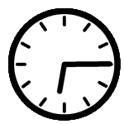  It's a quarter past six.  It's half past three.  It's a quarter to six. | 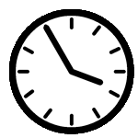  It's five past three.  It's five past four.  It's five to four.
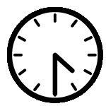  It's half past four.  It's four o'clock.  It's half past five. | 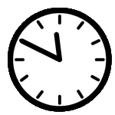  It's ten past eleven.  It's ten to twelve.  It's ten past twelve. | 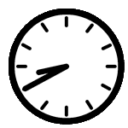  It's twenty to nine.  It's nine to twenty.  It's twenty past eight.
2. Answer the questions:
- The coldest season of the year is …
a) autumn b) spring c)winter d) summer
- The hottest season of the year is …
a) autumn b) spring c)winter d) summer
- Pupils have the longest holidays in …
a) autumn b) spring c)winter d) summer
- September, October, November are the months of the …
a) autumn b) spring c)winter d) summer
- Spring has three months: March, April and …
a) June b) May c)July d) August
6. New Year starts in …
a) January b) November c)February d) December
3. Translate the sentences:
- Monday is the first day of the week. - __________________________________________________________________________
- February is the second month of the year. - __________________________________________________________________________
- October is the second month of the autumn. - __________________________________________________________________________
- April is the second month of the spring. - _________________________________________________________________________
4. Answer the questions:
- What season is after winter? - __________________________________________________
- What month is before January? - ________________________________________________
- What month is after February? - ________________________________________________
- What month is between April and June? - _________________________________________

