Present Perfect Tense. Exercises. Упражнения на отработку Present Perfect Simple
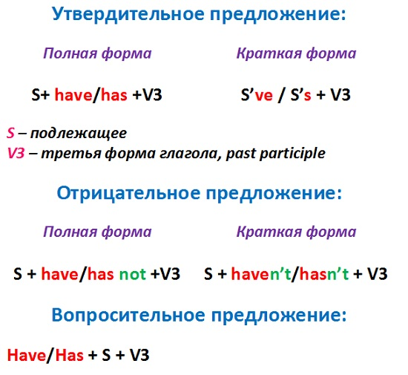
Упражнения на Present Perfect помогут вам
- закрепить образование и употребление третьей формы английского глагола
- вспомнить случаи употребления Present Perfect
- отработать употребление for и since, a также already, never и yet.
- отработать построение утвердительных, отрицательных и вопросительных предложений в Present Perfect Tense

Форма глагола в Present Perfect Tense. Exercises.

Упражнение 1. Заполните таблицу, используя следующие формы глагола. Complete the table with the base forms and the past participles. Use the words in the box.
Lose, taken, swim, bought, do, written, run, eaten, take, won, write, done, buy, lost, win, run, eat, swum
base form | past simple | past participle
_________  _________  _________  _________  _________  _________  _________  _________  _________ | bought  did  ate  lost  ran  swam  took  won  wrote | _________  _________  _________  _________  _________  _________  _________  _________  _________

Упражнение 2. Поставьте глаголы в скобках в Present Perfect.
- He _____ (finish) training.
- She _____ (score) twenty points in the match.
- We _____ (watch) all the Champions League matches this season.
- That's amazing! She _____ (run) fifteen kilometers this morning!
- She _____ (buy) some really nice rollerblades!
- Oh, no! I _____ (lose) my money!
- My mum _____ (write) shopping list. It's on the kitchen table.
- Dad, you _____ (eat) my biscuit!
- I’m tired. I _____ (watch) three X-Files videos.
- Hurry up! They _____ (start) the film!
- Mary _____ (study) hard this year, so she'll pass her exams.
- Oh no! She _____ (drop) the plate!
- The garden is very green. It _____ (rain) a lot this month.
- These are my favourite trousers. I _____ (have) them for five years.
- Tom's my best friend. I _____ (know) him for three years.
- They _____ (live) in Miami for two years.
- Jo has earache. He _____ (have) it since 7 o'clock.
- Brad _____ (live) in Chicago since 1998.
Упражнение 3. Поставьте глаголы в скобках в Present Perfect negative.
- I _____ (not clean) my football boots.
- They _____ (not start) their meal.
- I _____ (not do) my homework.
- He _____ (not win) all his matches this year.
- My brother and I _____ (not see) any films this week.
- It's my birthday party today. I _____ (not invite) many people.
- He _____ (not wash) his hands. They're very dirty.
- Mum's really angry. We _____ (not tidy) our room!
- I can't play with my friends this evening. I _____ (not finish) my homework.
- I _____ (not visit) New York for three years.
- Where's Alison? We _____ (not see) her since yesterday.
- Dad _____ (not take) a holiday since last August.
- John _____ (not play) the violin since he was school.

Упражнение 4. В письме есть 4 ошибки на использование for и since. Найдите и исправьте их. These are some sentences from Nigel’s letter home from Africa. He has made four mistakes in using ‘for’ and ‘since’. Correct his mistakes.
Dear Mum and Dad,
I've lived in Africa since two weeks and I love it! Africa is beautiful! I haven’t travelled to any faraway place for last summer. I’m so happy now!
I’ve already seen Mr. Rambler. He is working for WWF here and taking photos of wild animals. I haven’t seen any lions yet. I think I’ll see them later.
Thank you for the trip. I’ve dreamed of Kenya for my childhood. I haven’t seen you since ages! I miss you so much!
Love, Nigel.
Упражнение 5. Дополните предложения словами for или since. Complete the sentences. Use for or since.
- I've lived in Washington _____ 1997.
- Ben has studied English _____ three years.
- They haven't visited their grandparents _____ months.
- Julie's ill. She's been in bed _____ Tuesday.
- My dad has had his car_____ sixteen.
- It's been ten years_____ we moved to Oxford.
Упражнение 6. Пользуясь опорными словами, a также словами for и since составьте предложения в Present Perfect Simple.
- Kate/be/in bed/a long time.
- She / not eat / anything / this morning.
- She / not see / her friends / a week.
- She / stay / at home / Tuesday.
- She / have / a red nose / three days.
- She / not play / basketball / last weekend.
- She / not do / any school work / Monday.
Упражнение 7. Zork и Zena – инопланетяне, впервые прилетевшие на Землю. Они составили список дел. Напишите вопросы и ответы о том, что они уже сделали, а чего пока нет.
Пример:
Zork (eat) a hamburger?
Has Zork eaten a hamburger?
Yes, he has.
Zork and Zena (drink) a cola?
Have Zork and Zena drunk a cola?
No, they haven't.
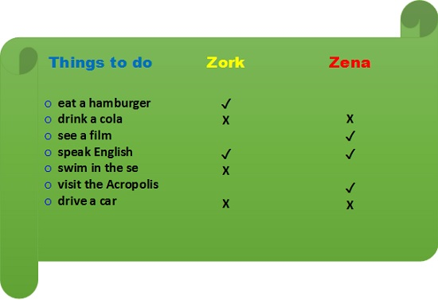
- Zena (see) a film?
- Zork and Zena (speak) English?
- Zork (swim) in the sea?
- Zena (visit) the Acropolis?
- Zork and Zena (drive) a car?

Упражнение 8. Напишите вопросы в Present Perfect, используя глаголы в скобках. Дайте правдивые ответы.
Пример:
(eat Italian food)
— Have you ever eaten Italian food?
— Lots of times.
1 (ski)
— ______________________
- ______________________
2 (win money)
- ______________________
- ______________________
3 (have a dream)
- ______________________
- ______________________
4 (break a leg)
- ______________________
- ______________________
5 (go to a concert)
- ______________________
- ______________________

Упражнение 9. Дополните диалог вопросами и ответами в Present Perfect.
Reporter: (you do) Have you done a lot of training this year?
Trish: Yes, I have. I have trained six times a week all year.
Reporter: Who ______________ (1 you train) with?
Trish: With my coach, and the team.
Reporter: Where ______________ (2 you play) this year?
Trish: Mostly in Britain. But we've also travelled to Holland.
Reporter : ______________ (3 you win) many matches?
Trish: Yes, we (4) ______________ .
Reporter: And how many matches ______________ (5 you lose)?
Trish: Only three.
Reporter: That's great. ______________ (6 you have) any injuries?
Trish: No, I ______________ (7) .
Reporter: Thanks, Trish, and good luck.
Упражнение 10. Напишите вопросы с How long. Дополните ответы, используя for или since. Write questions with How long. Complete the answers with for or since.
Пример:
I live in London.
How long have you lived in London?
For three years.
1 He's a teacher.
____________________
____________ September.
2 My parents work in a shop.
____________________
____________ 1992.
3 My sister knows Robbie Williams.
____________________
_________ six months.
4 We've got a new car.
____________________
________ two weeks.

Упражнение 11. Заполните письмо Джейн глаголами в Present Perfect. Complete Jane's letter to her American friend. Use the Present Perfect Tense.
Dear Amy
I _____ (1 not have) a letter from you for a long time. _____ (2 you lose) my address? I bought the new Steps CD at the weekend. I _____ (3 already listen) to it. _____ (4 you hear) it yet? It’s brilliant. There’s a new video too, but I _____ (5 not see) it yet.
School is going OK. I _____ (6 just finish) some exams, but the holidays _____ (7 not start) yet. We’re going to Ireland. I _____ (8 never be) there.
Write soon with your news.
Love
Jane
Упражнение 12. Ник готовится к путешествию. Он собирается навестить бабушку.
Ознакомьтесь со списком дел, которые ник планирует сделать до отъезда. Напишите, что он уже сделал, а что нет. Используйте alreadyи yet. Nick is getting ready to travel. He is going to visit his Granny. Read the list of things he must do before travelling. Write what he has done and what he hasn’t done.
THINGS TO DO
- to pack suitcases (+)
- to water flowers (+)
- to take my library book back
- to say ‘good-bye’ to Nigel (+)
- to clean my shoes
- to call Granny (+)
- to buy some food and drinks (+)
- to clean the parrot’s cage
- to change the water for the fish
- to buy a present for Granny (+)

