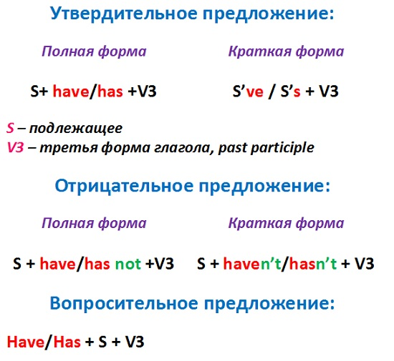
Упражнение 1. Дополните предложения правильной формой Present Perfect.
- I know who your boss is. I (work) for him.
- Look! Somebody already (broke) the tree.
- Mary (go) to Mosow, but she’ll be back next Monday at the latest.
- Andy is in hospital now. He (have) a bad crash.
- Jane is crying. She (hurt) her knee.
Упражнение 2. Поставьте глаголы в скобках в Present Perfect.
- He _____ (finish) training.
- She _____ (score) twenty points in the match.
- We _____ (watch) all the Champions League matches this season.
- That’s amazing! She _____ (run) fifteen kilometers this morning!
- She _____ (buy) some really nice rollerblades!
- Oh, no! I _____ (lose) my money!
- My mum _____ (write) shopping list. It’s on the kitchen table.
- Dad, you _____ (eat) my biscuit!
- I’m tired. I _____ (watch) three X-Files videos.
- Hurry up! They _____ (start) the film!
- Mary _____ (study) hard this year, so she’ll pass her exams.
- Oh no! She _____ (drop) the plate!
- The garden is very green. It _____ (rain) a lot this month.
- These are my favourite trousers. I _____ (have) them for five years.
- Tom’s my best friend. I _____ (know) him for three years.
- They _____ (live) in Miami for two years.
- Jo has earache. He _____ (have) it since 7 o’clock.
- Brad _____ (live) in Chicago since 1998.
Упражнение 3. Поставьте глаголы в скобках в Present Perfect negative.
- I _____ (not clean) my football boots.
- They _____ (not start) their meal.
- I _____ (not do) my homework.
- He _____ (not win) all his matches this year.
- My brother and I _____ (not see) any films this week.
- It’s my birthday party today. I _____ (not invite) many people.
- He _____ (not wash) his hands. They’re very dirty.
- Mum’s really angry. We _____ (not tidy) our room!
- I can’t play with my friends this evening. I _____ (not finish) my homework.
- I _____ (not visit) New York for three years.
- Where’s Alison? We _____ (not see) her since yesterday.
- Dad _____ (not take) a holiday since last August.
- John _____ (not play) the violin since he was school.
Упражнение 4. Расставьте слова по порядку. Переведите получившиеся предложения.
- have – Britain – several – I – to – times – been
- Spain – since – she – lived – in – 1994 – has
- five – married – have – they – years – been – for
- I – coffee – made – already – for – have – you
- never – Bob – a bike – has – had
Упражнение 5. Поставьте наречия из скобок в нужное место.
- Have you washed your hands? (already)
- We have phoned the doctor. (just)
- Has she ridden a horse? (ever)
- I have danced the tango. (never)
- The train hasn’t arrived. (yet)
Упражнение 6. Переведите предложения:
- Я ещё никогда не был за границей.
- Мои родители уже переехали в новую квартиру.
- Он ещё не закончил уборку. Когда я был в командировке, я познакомился с прекрасной девушкой.
- Я видел эту комедию трижды.
- Ты уже читал сегодняшнюю газету?
- Мы играли в компьютерные игры с 1 до 3.

