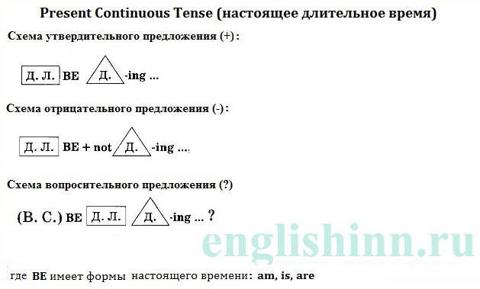

1/ Add the ending "-ing"
1. camp __
2. swim __
3. travel __
4. walk __
5. have __
6. write __
7. cook __
8. shop __4
2/Complete the sentences
1. His dad and brother __ (cycle) to the shops.4
2. We __ (not travel) in Japan.5
3. I __ (sunbathe) on the beach.4
4. She __ (not watch) TV.3
5. They __ (not swim) in the sea.1
6. Sue __ (stay) at home today.1
3/Write the questions and the short answers
1. your dad / work / today /?5
__
Yes, __
2. you / have a good time / on holiday / ?1
__
Yes, __
3. your mum / cook dinner / now / ?4
__
Yes, __
4. your friends / play football / ?3
__
Yes, __
4/Complete the dialogues
1. a. I´m going on holiday.1
b. Where __ ?
2. a. He´s cooking dinner.
b. What __ ?3
3. a. My sister is going to England.
b. Who __ ?3
4. a. We aren´t staying in a hotel.1
b. Where __ ?
5/Complete the sentences1
A.
1. I __ (watch) a reality show on TV.1
2. My favourite team __ (win)!1
3. Someone __ (swim) in the sea.1
4. Two people __ (cook) dinner on the beach.1
5. We __ (not watch) a soap opera.1
6. I __ (not do) my homework.1
7. Mum __ (read) a magazine.1
8. My brother __ (not listen) to the radio.2
9. Dad __ (not cook) dinner.1
10. Tara __ (talk) by phone.1
11. Joe __ (play) on the computer.1
12. Who __(watch) TV?1
13. Tina __ (do) grammar exercises.1
14. I __ (eat) a pizza.1
15. We __ (sit) in the classroom.1
16. I __ (not write) an email.1
17. Amy __ (not go) to school today.2
18. We __ (not have) fun today.
19. My team __ (not win) the match.
20. My parents __ (drive) to work now.
21. __ they __ (read) magazines? Yes, they are.
22. __ you __ (learn) English? Yes I am.
23. __ Helen __ (write) a letter? No, she isn´t.
24. __ Sarah __ (play) the guitar? Yes, she is.
25. We __ (not play) basketball.
B.
1. Trina __ (walk) past the supermarket.
2. Where are you? We __ (wait) for you!
3. I´m on a bus and it __ (not move).
4. When __ you __ (come) to see me?
5. I __ (sit) on a bus.
6. Pete´s mother __ (not have) a burger.
7. John´s friends __ (play) football at the Sports Centre.
8. My best friend __ (sit) next to me.
9. I __ (not wear) something blue.
10. My teacher __ (not stand) behind me.
C.
1. I __ (learn) how to swim.
2. I __ (eat) my lunch.
3. I __ (watch) television.
4. She __ (read) a book.
5. Dad __ (bake) a cake.
6. My sister __ (listen) to music.
7. Peter __ (clean) his car.
8. The dog __ (bark) in the garden.
9. We __ (sing) our favourite song.
10. My brother and I __ (play) a computer game.
11. The teachers __ (show) us a film.
12. They __ (bring) a TV in the classroom.
13. She´s bored. Her friend __ (watch) TV again.
14. Martin´s excited. Chelsea __ (win) the match.2
15. I´m scared. A big dog __ (stand) in front of me.
16. She´s happy. She __ (not work) today.
17. I´m worried. It __ (rain) and I haven´t got an umbrella.
18. The teacher is annoyed. We __ (not listen).
19. What __ you __ (wait) for? I´m __ (wait) for John.
20. __ it __ (snow)? No, it __ (rain).
21. What __ you __ (do) today? We __ (go) to the park.
22. __ you __ (listen) to me? No, I __ (listen) to the radio.
23. __ you __ (watch) TV? No, we __ (study).
24. What __ you __ (do)? I __ (do) my homework.+
25. __ they __ (sleep)? Yes, they are.

