Short term plan 2

7.3A Entertainment and media  Term 3 Unit 2 |  |  |  | School: 28
Date: |  |  |  | Teacher’s name: Esimkulova A.
Grade |  |  |  | Number present: |  |  | absent:
Theme of the lesson |  |  |  | Music
Learning objectives(s) that this lesson is contributing to |  |  | 7.3.3.1 give an opinion at discourse level on a growing range of general and curricular topics;  7.4.3.1 understand the detail of an argument on a growing range of familiar general and curricular topics, including some extended texts
Lesson objectives |  |  | All learners will be able to:
 |  |  | - Understand most specific information and detail while reading;
 |  |  | Most learners will be able to:
- Complete reading task with all the missing words;
- Understand whether statements are true or false while listening;
 |  |  | Some learners will be able to:
 |  |  | - Complete listening tasks with two missing words without spelling mistakes.
Language objective |  |  | Book vocabulary:  listen to the music  dance to music  learn to play musical instruments  have an ear for music  a violin  a cello  a flute  a trumpet  a harp
Value links |  |  | Lifelong learning, Collaboration, Respect to different opinions, Transparency in evaluation, Global Awareness
Cross curricular links |  |  | Music of different countries
Previous learning |  |  | Fiction and Non-Fiction Literature
Use of ICT |  |  | Projector or Smart board for showing a presentation
Intercultural awareness |  |  | Accept diversity of other cultures’ literature
Kazakh culture |  |  | Discussion of Kazakh music
Pastoral Care |  |  | Student centered teaching: respect, support and scaffolding;  To create a friendly atmosphere for collaborative work.  Promote a sense of self-esteem and self-respect and respect for others among all the learners.
Health and Safety |  |  | Everyday classroom precautions will ensure that safety measures are provided to prevent the exposure of electrical power cords
Planned timings | Planned activities |  |  |  |  | Resources
Beginning  6-7 min  3 min  1-2 min  12 min  5 min  7-8 min  5 min | Organizational moment  Teacher greets students.  Teacher sets positive atmosphere by asking such ice breaking questions as  - How was your weekend?  - What date is it today?  - What is the weather like today?  Teacher discusses learning objectives with the students.  Look at the interactive board. What do you see?  - What are these? (These are notes)  Your task is to take note and open it. On the note you can read new words of our lesson.  a violin  a cello  a flute  a trumpet  a harp  a bagpipe  a clarinet  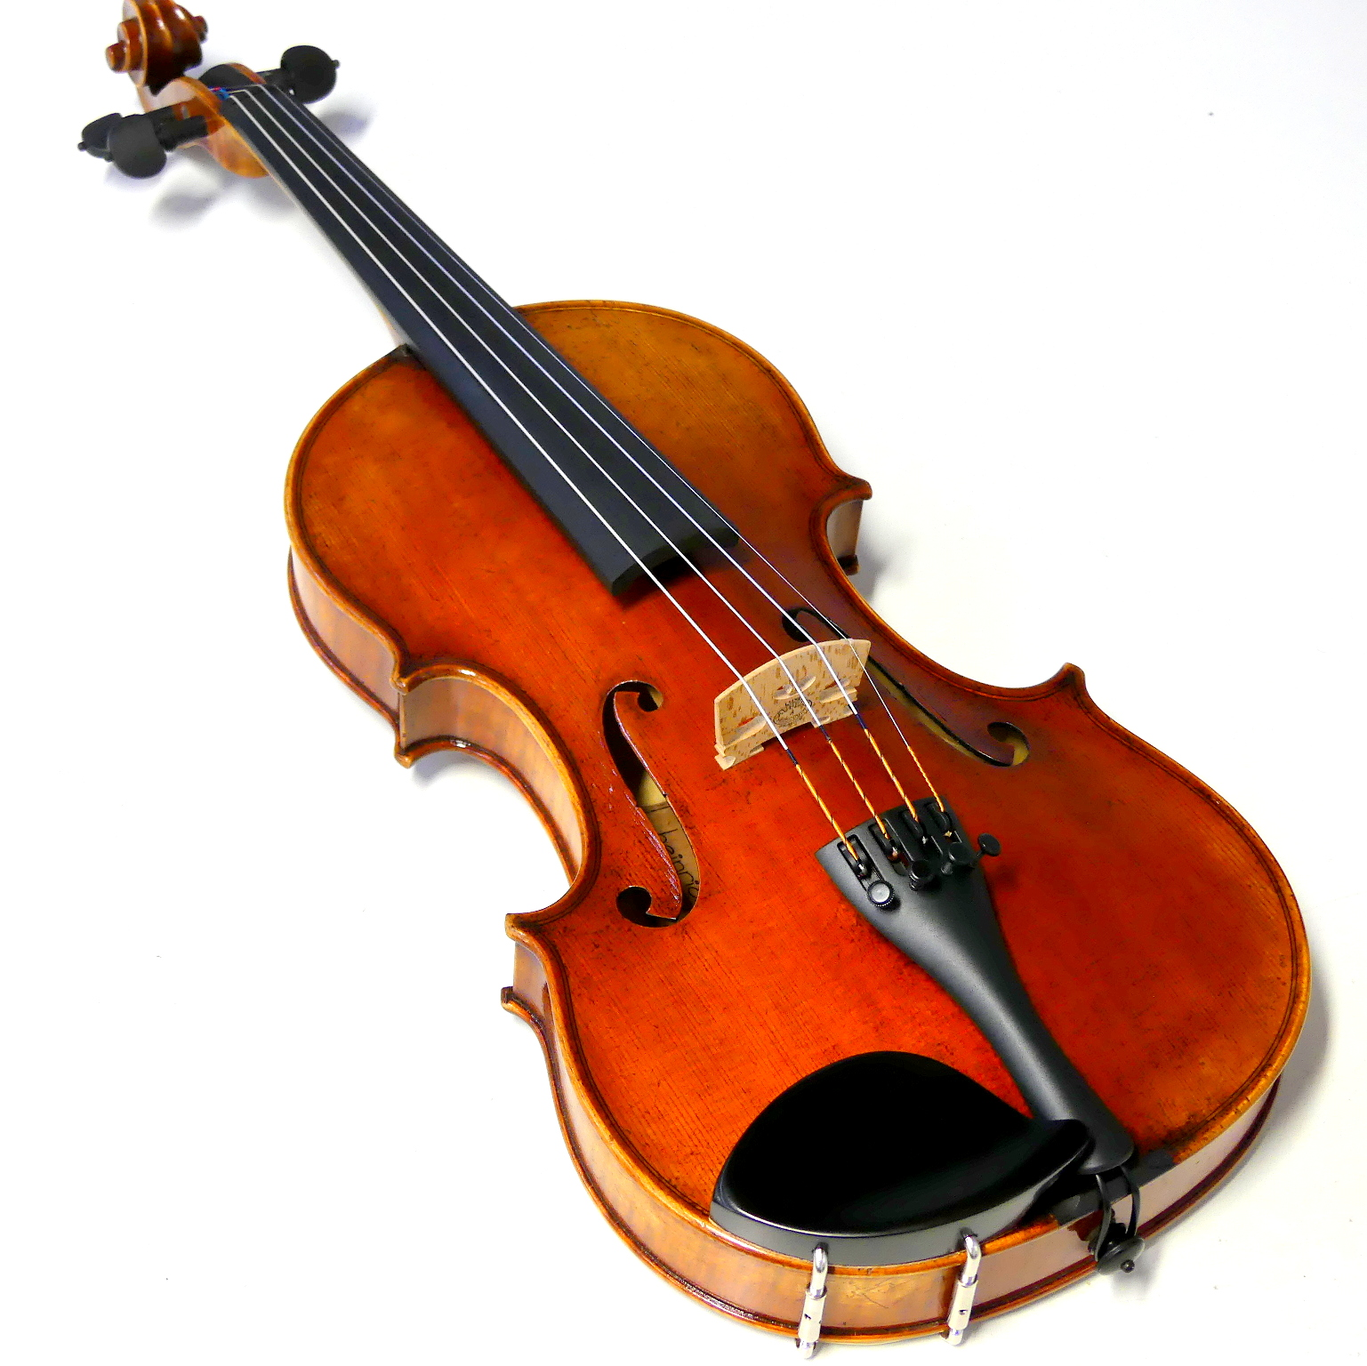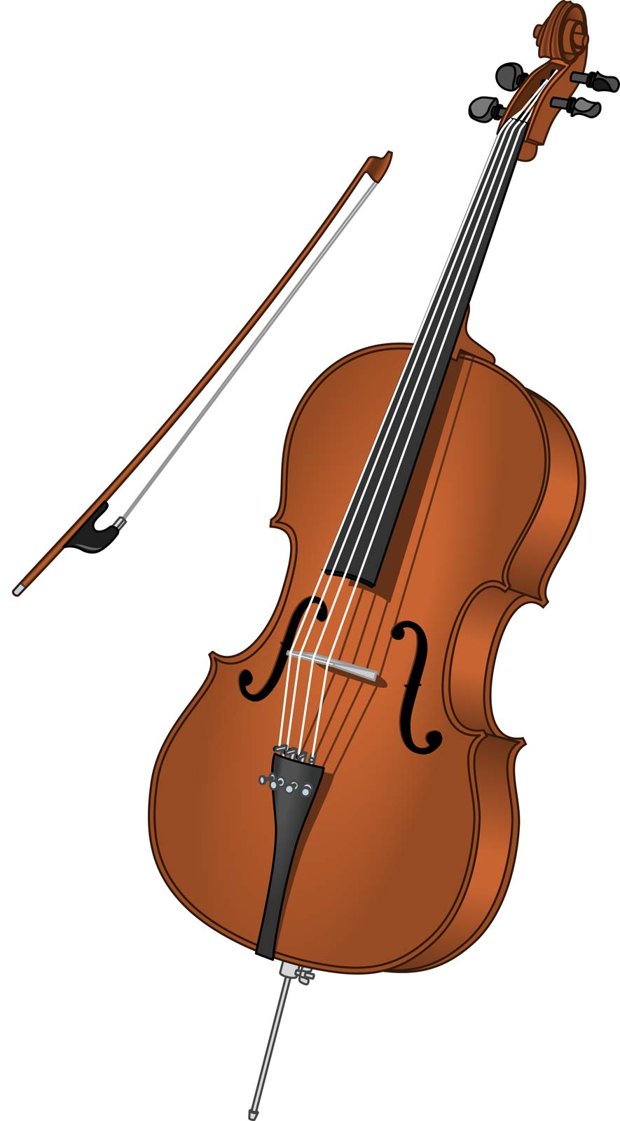  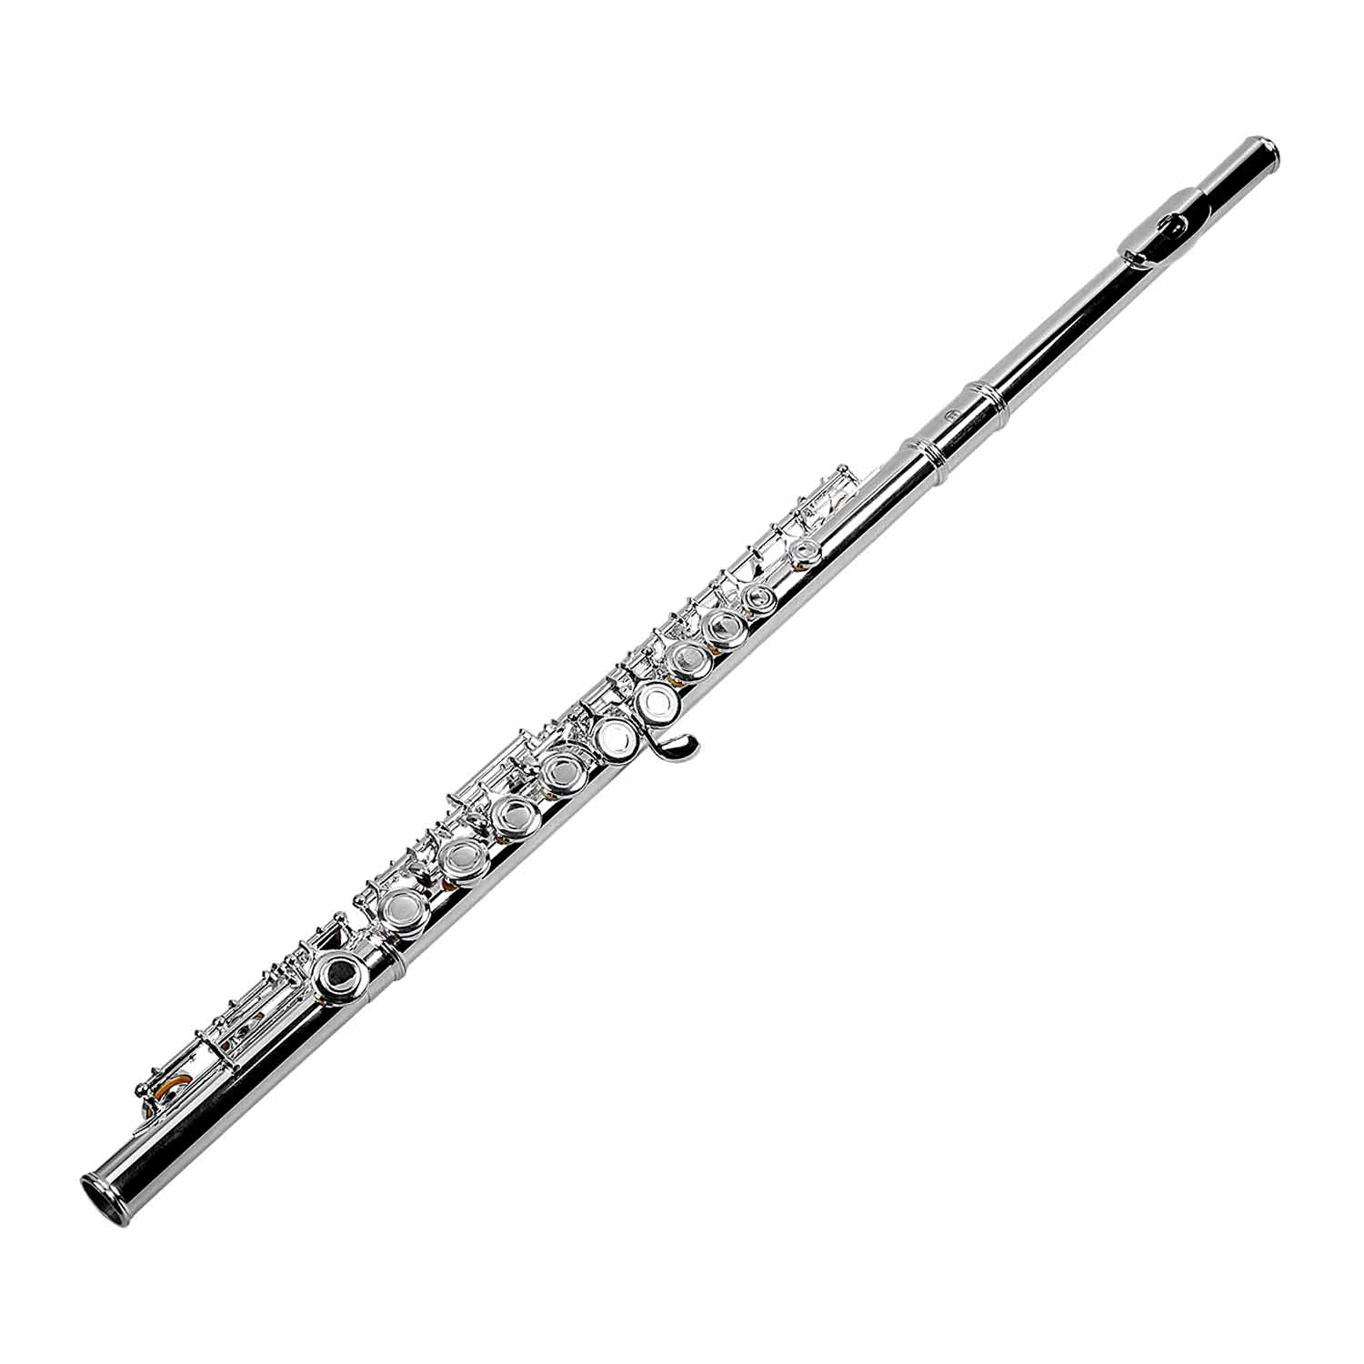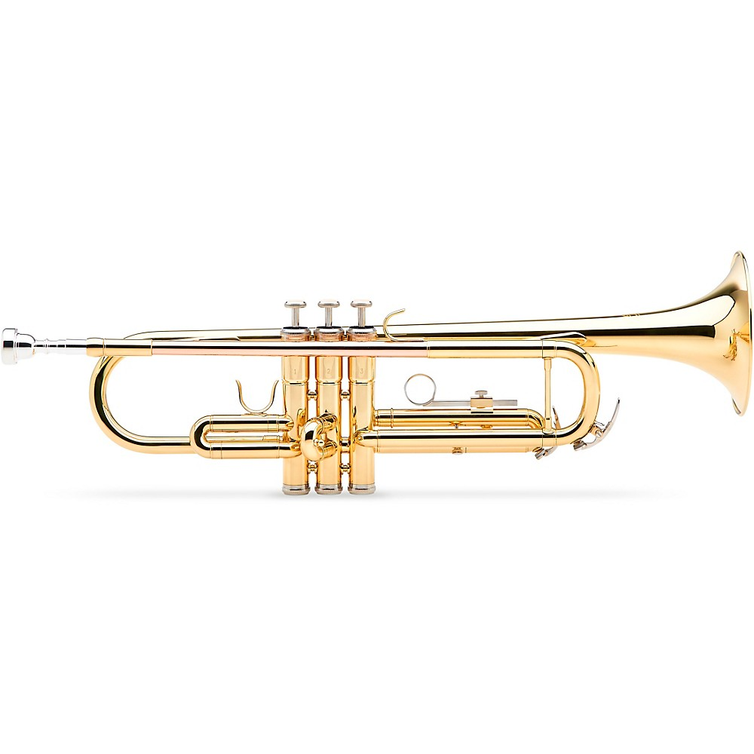  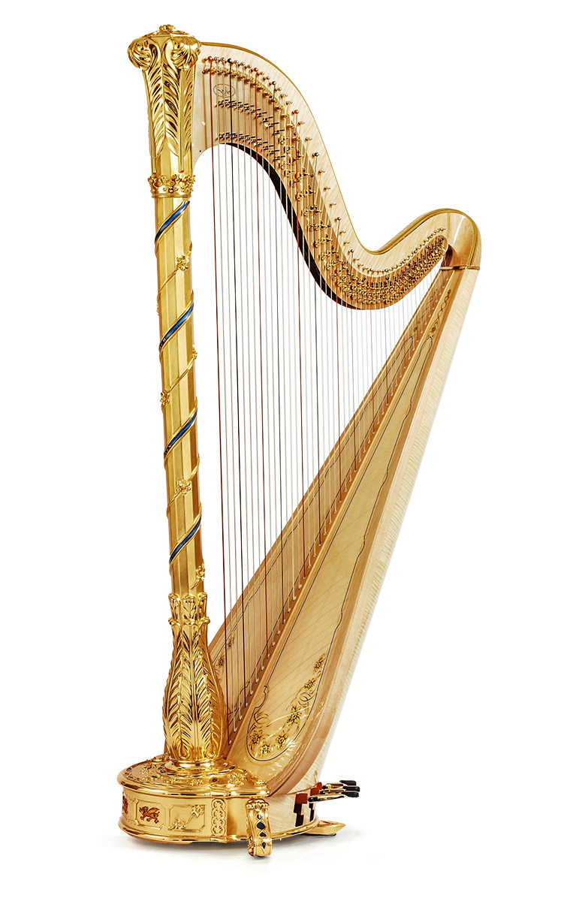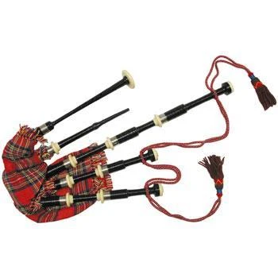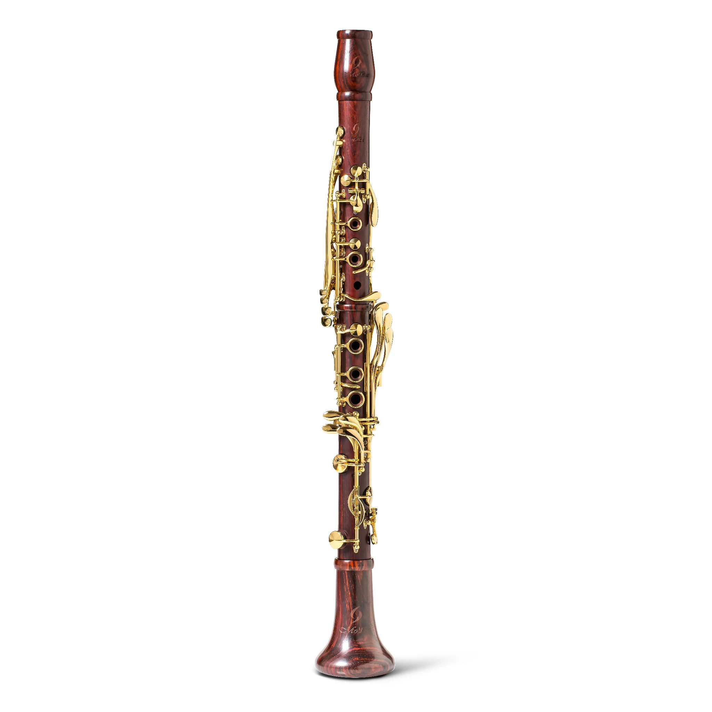  Pre reading . Strategy «What instrument is it»  Pupils listen different kinds of music and try to guess what instrument is it  Before beginning to do the 1st task lets devide into 4 groups.  Strings  Woodwind  Brass  Percussion  Task 1. Group work.  Strategy «Guesses about the meaning of the word»  Each group has text with new material. They should:  Descriptor  - Read the text  - Understand the meaning of the text  - present important information to the class  Group assessment  Excellent!  Good!  Try again!  Task 2. Pair work.  Pupils have a table and words. They should correlate it correctly.  Complete the table  strings woodwind brass percussion  Assessment criteria:  - correlate the words correctly  - Put the word in a right column  - Say not less than seven correct musical instruments  Peer assessment  8-10 – Excellent!  6-7. Good job!  4-5 Try again!  Task 3. Work with whole class  Strategy «Thin and thick questions»  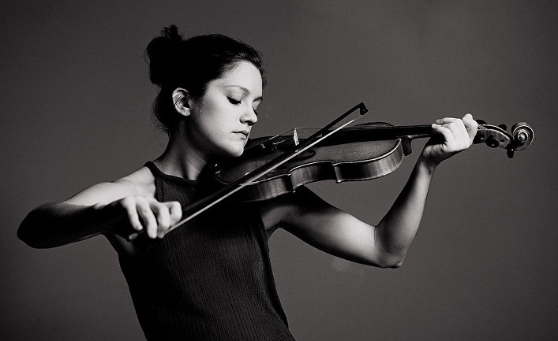  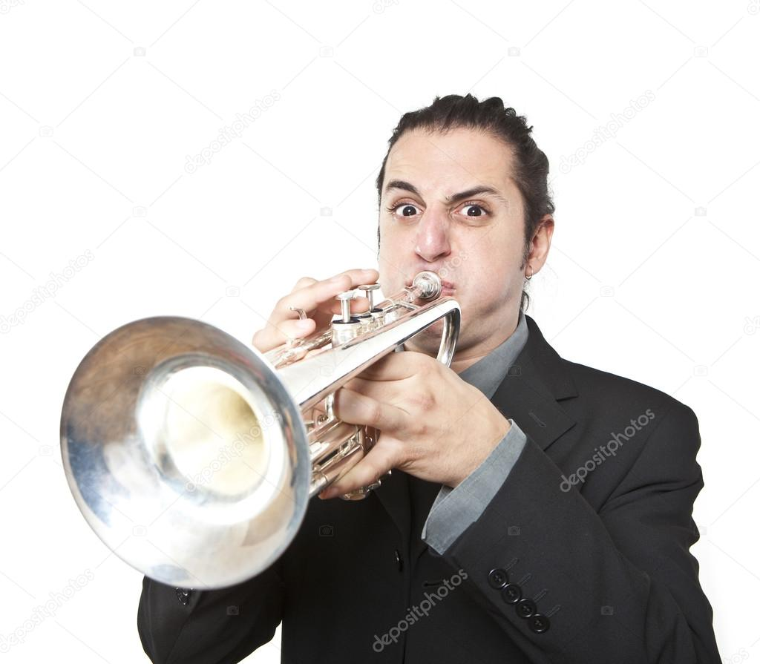  Who is he\she?  What is she\he doing?  What kind of instrument is it?  Where is she\he?  Why is she\he playng?  How do you think does she\he like her\his hobby?  Additional task  Find the diiferences between two pictures.  Reflection  Tick Yes or No  Criteria Yes No  I know 10 new words  I can define the types of musical instruments  I can tell about musical instruments |  |  |  |  | Notes  Pictures  Texts  Tables  Pictures  Reflection sheets
End  1min | Feedback: Teacher asks learners what task was difficult to them and which pair worked well.
Additional information
Differentiation – how do you plan to give more support? How do you plan to challenge the more able learners?  - Differentiation will be implemented through presenting different leveled tasks on listening.  For less able learners- complete the sentences with one missing word  For more able learners- complete the sentences with two missing words. |  | Assessment – how are you planning to check learners’ learning?  - Assessment criteria will be presented to the learners before starting speaking activity  - Observe learners when presenting their dialogues. Did each learner contribute to the dialogue? If not, why not? (e.g. didn’t understand what to do; not so confident speaking English; not interested in topic; other)  - Monitor learners to check they can pick up specific details and understand main points when listening about Harry Potter |  |  | Critical thinking  - Analyzing the pictures of book characters and guessing the books
Summary evaluation
What two things went really well (consider both teaching and learning)?
1:
2:
What two things would have improved the lesson (consider both teaching and learning)?
1:
2:
What have I learned from the lesson about this class or individuals that will inform my next lesson?

