Teacher: Parshukova Marina Gennadievna
Grade :6
Numbers of students: 12
Theme: “Sport”.
The aims of the lesson :
a) Educational : to teach students to discuss the usefulness of different kids of sport.
b) Developing: to develop the students' speaking, listening, reading and writing skills.
c) Bringing-up: to bring up the interest in sports and feelings of respect. ( That sport is useful for us).
The visual aids: An interactive board, slides, class and work book “Family and Friends” ,
The form of the lesson: traditional.
The type of the lesson: consolidation.

Stages | Aims | Activities
Start of the lesson.  Warm up  Phonetic drill. | Organization moment of the lesson:  -Good morning, dear friends.  -How are you today?  -What date is it today?  -What day is it today?  -What's the weather like today?  -Let's look at the pictures, and say what you can see.  (There are pictures on the interactive board).  1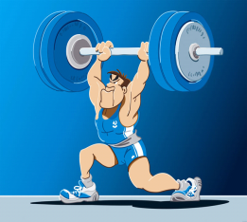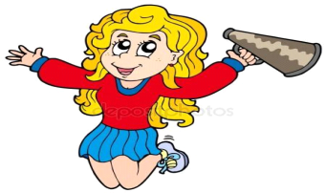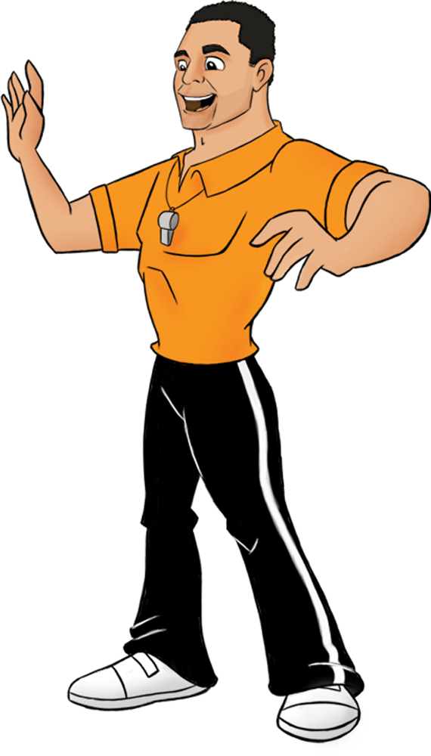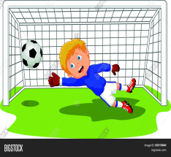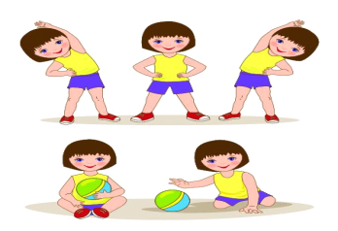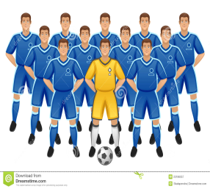  -Now, please tell me what is the theme of our lesson?  Drilling with new words.  -Let's pronounce these words. | Students answer the questions.  Students say what they see in the pictures.  1. captain  2. training  3. exercise  4. goalkeeper  5.coach  6. trophy  7.fan  8. athlete  Students say the theme “Sport”  Students listen to the speaker and repeat after him.  Tape script 68
Pre-listening | Lead-in  - With books closed , ask children what can they remember about the story from lesson 1 in the previous unit.  - Establishing the main facts , ask students to make predictions about what the story will be about in this lesson.  - What do think is Jim’s surprise? Let’s make guesses about what it will be. | Students compare and discuss their ideas.
Listening | Development of listening skills. | Students listen to the  Tape script 67 and follow the story text in their books.
Speaking | Development of Speaking skills.  - What are the children doing in picture 4 and 6?  - Where are they?  - What are they watching?  - What is Jim’s surprise?  - Does Jim’s team win the match?  - What job has Jim got for them? | Students listen to the  Tape script 67 and follow the story text in their books a second time.  They answer the questions.
Reading | Development of reading skills.  -Teacher writes the dialogue from frame 3 on the board and read it with the students).  -Teacher rubs out four words and students to read the dialogue again , saying the missing words.  - Teacher continues rubbing out words until the students are saying the dialogue from memory.  - Teacher leaves only the characters’ names at the start of each line to help them. | Students read the dialogue on pg 80 .  Students act out the dialogue on pg 80 .
Speaking | Development of Speaking skills.  - Let’s divide into two groups. And let’s try to act out the dialogue. | Students act out the dialogue on pg 80 .
Checklist | Surname Content 5 points Lexics 5 points Grammar 5 points Pronunciation 5 points  There are descriptors for each student.  - If your score is:  18 - 20 points - excellent  14 -17 points - good  10 - 13 points – try again | Students put points to each other.
Break | Break- time  - Well, students let’s have a rest. | Students do some exercises.  https://www.youtube.com/watch?v=h4eueDYPTIg
Post-speaking | Using of vocabulary .  - Will you open your class books on page 80 exercise number 3.  - Now let’s make a crossword.  - Person who likes watching a special team play sport and always wants the team to win.  - Person who is good at a sport such as running, jumping.  - Noun. Activity that you do with your body to stay healthy , for example running or swimming.  - Noun. A gold or silver cup that you get when you win a competition.  - The person in a football team who uses his hands to stop the other team scoring a goal.  - 1)Person whose job is to train athletes . 2) a bus that travels long distances.  - Noun. The most important player on a sport team, who tells the other players what to do.  - Noun. Practice that you to get better at sport.  5  6  7  2  1  4  3  8  - https://bilimland.kz/ru/courses/english-language/core-curriculum-for-english/year-12/lesson/043-take-regular-exercise | Students do exercises 3 pg 80. They should choose the right word.
Reflection | Were the lesson objectives /learning objectives realistic?  Easy! I get it! I can do this by myself. OK! I need a little more help Hard. I still need a lot of help  Retell the dialogue with support  Make a crossword using vocabulary  Make up the monological speech abt sport | Students value their self.

