Архитектурные памятники Республики Беларусь
Architectural monuments and sights of Belarus
Aims:
- to develop speaking and reading skills
- to develop students’ interest to the history of Belarus, it’s legends and foreign countries
- to develop students’ memory, interest, activity, discipline.
- Introduction
Good day! Take your seats, please. We are going to start our lesson. How are you? Look at the board and guess the topic of our lesson.
- Dialogue speech.
Today we’ll organize a virtual excursion around Belarus, pay attention to such an old town as Nesvizh, you’ll hear a legend connected with Nesvizh castle. You’ll learn some new facts about Stonehenge which is one of the most mysterious monuments in the world. I think even today people can’t guess what it was built for and how it was built.
And now answer my questions.
- Are there many architectural sites in Belarus?
- Which of them can you name?
- Which of this sights have you visited?
- How many people have been asked in Belarus on the Internet to list their favourite seven architectural sights out 46?
- What was number one? (Radziwills Nesvizh Palace)

- Speaking.
So, guys let’s make an excursion to one of the oldest town of our country. It’s Nesvizh. Some pupils have prepared a legend about Barbara Radziwill.
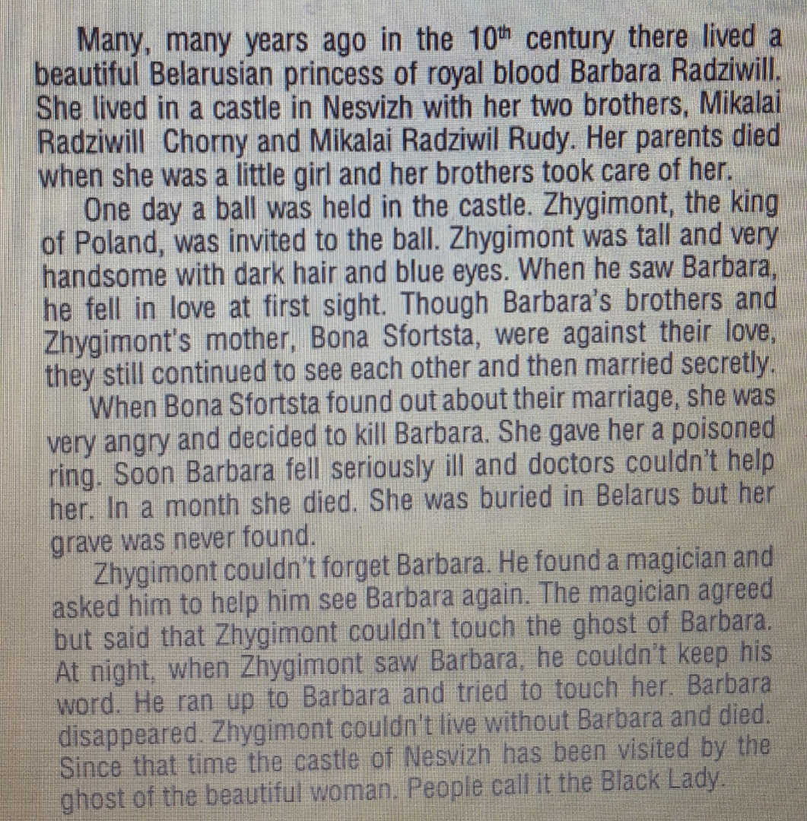

Thank you for the legend. At the stage of our State Academic Theatre named after Y.Kupala there is a performance which is called “Chornaya Panna Nyasvizha” I advise you to go and watch it.
- Let’s relax. Close your eyes. Imagine that you are in the ancient castle and listen relaxing music.
- Watching video.
Now we’ll watch fantastic video about great sights of London. Do you remember some of them? Thank for attention.
I’ve prepared text about Stonehenge.

Stonehenge
The Stonehenge stone circles are in England. People transported the first stones to this place about 5000 years ago. We don't know a lot about Stonehenge. Who built it? How did they build it? Why did they build it? It's a mystery.
People built Stonehenge with bluestones and sarsen stones. There were about 80 bluestones. They came from mountains 250 kilometers away. They are very heavy – some weigh about 4 metric tons. The sarsen stones are even bigger and heavier. About 4000 years ago, people transported them from 30 kilometers away.
How did people use Stonehenge? Maybe they used it as a cemetery or a place for studying the sun and the stars. Maybe it was also a temple. It's still a special place for some people today. Every year, on June 21st, lots of people go to Stonehenge to celebrate the longest day of the year.
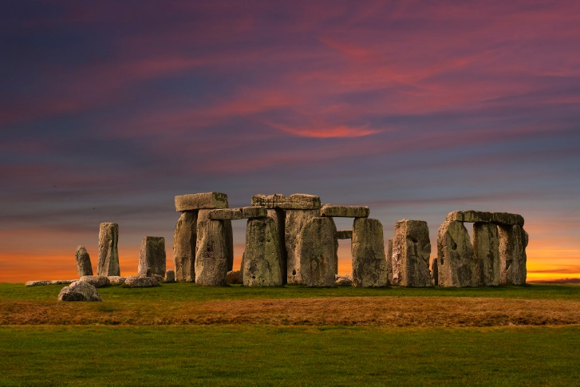
Let’s read and discuss it. Have you heard about it? Can you summarize what have you read?
- Reflection.
- Marks.

