Цели проведения:
Заинтересовать учащихся в изучении английского языка.
Активизировать у учащихся творческие способности при подготовке и проведении мероприятия.
Оборудование:
оформление класса( болото, домик, деревья, цветы, презентация);
учащиеся заранее подготавливают костюмы для сказки;
заранее разучиваются песни, подготавливают танец;
учащиеся разучивают стихотворения;
Ход мероприятия.
Teacher: Good afternoon, dear guests! I’m very glad to see you at this event. 5th a grade students have prepared for you the story in English «Thumbelina». I want to be in a good mood doesn’t leave you during the event. Enjoy your viewing and relaxation.
Scene 1
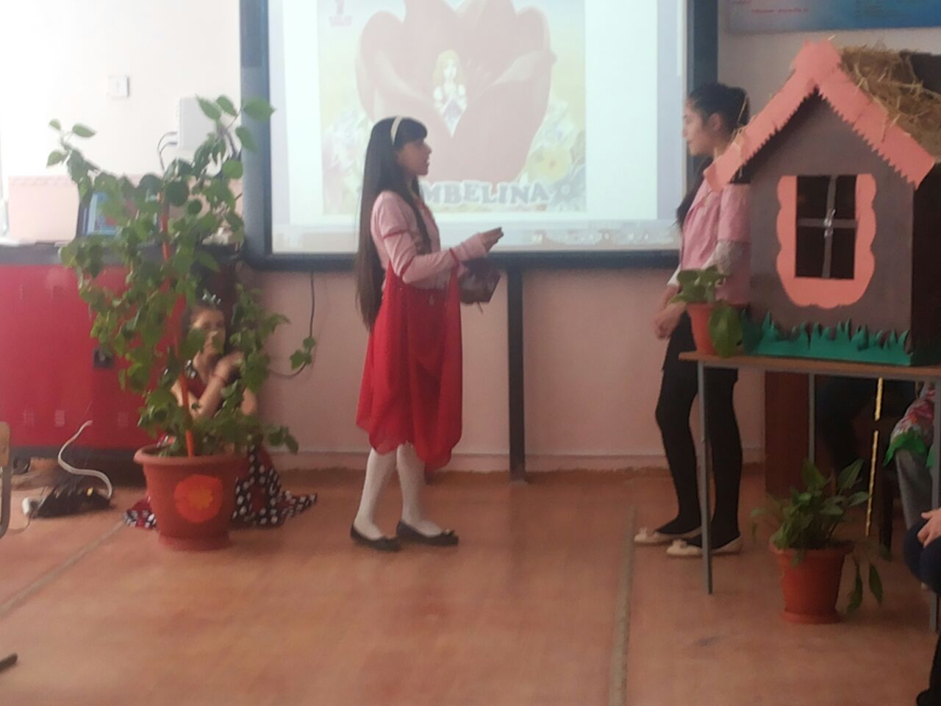
Танец
Woman: Hello! My name is Mary. I live in the village nearby. I have a husband, but we are not happy. We don’t have a child. What should I do?
Witch/Wizard: Hello, Mary! I’m a young and clever Witch.
Woman: Good morning, Mrs. Witch.
Witch/Wizard: I can help you. I know your dream. ONE, TWO, THREE…
Woman: OH!
Witch/Wizard: Take this seed. Plant it in the flowerpot.
Woman: Oh! Thank you, thank you very much.
Scene 2
Woman: Here is my flower. Look! It is very beautiful, isn’t it?
Thumbelina: Hello! Are you my mother?
Woman: Yes, yes, I’m your mother and I’m very happy. You are so tiny girl. Not bigger than my thumb.
I’ll call you Thumbelina.
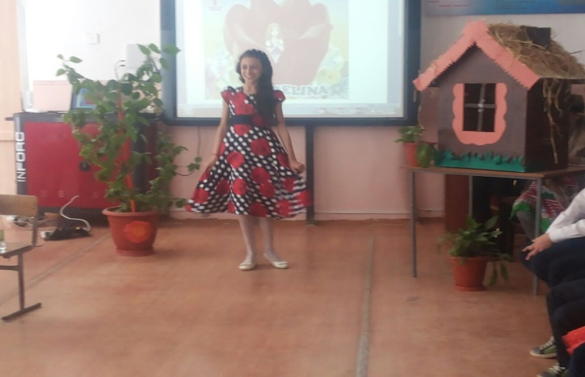
A song:
What is your name?
What is your name?
Now, tell me, please,
What is your name?
My name is Thumbelina,
My name is Thumbelina,
My name is Thumbelina,
That’s my name.
Thumbelina: Oh, my dear Mother, I’m very tired. I want to sleep in my flower bed.
Mother: Good night, my dear!
Scene 3
Toad: Good night, everybody! Look at me! I’m a huge old ugly toad. But what can I see? She is a pretty girl! She would be a lovely bride for my Son. I want to take her to my pond.
A song 2: Looby Loo.
Here we go Looby Loo
Here we go Looby Light
Here we go Looby Loo
All in a Saturday night.
1.Put you right hand in,
Put you right hand out,
Give your hand a shake, shake, shake
And turn yourself about, oh,
Here we go Looby Loo
Here we go Looby Light
Here we go Looby Loo
All in a Saturday night.
2. Put your left hand in…
3. Put your right foot in…
4. Put your left foot in…
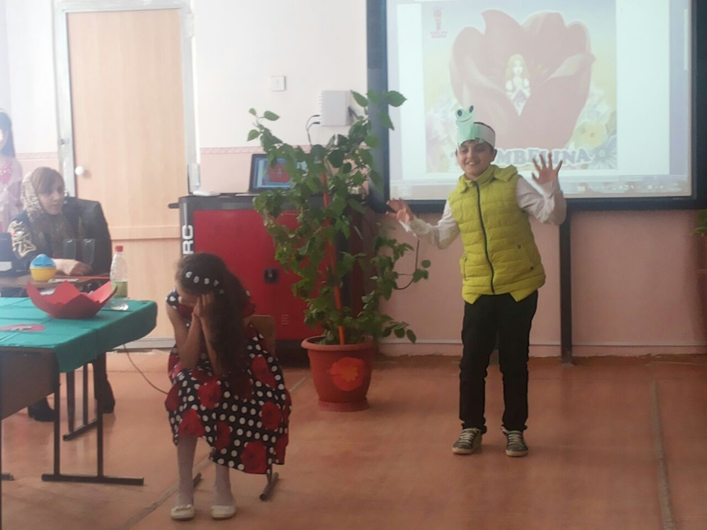
Thumbelina: Where am I? Where is my Mother? Who are you?
Toad: You are in the middle of my pond. I want to marry you!
Thumbelina: Who are you?
Toad: I am a huge green ugly Toad, I am like my Mother!
Thumbelina: Oh, no, no never! I want to go home! I want to see my Mother.
Toad: Don’t cry! Don’t worry! We’ll come back soon. See you, my dear!
Thumbelina: (cries) What shall I do? Dear butterfly, help me, please!
Butterfly: Yes, yes, dear Thumbelina, I want to help you.
Dance (танец бабочки и Дюймовочки)
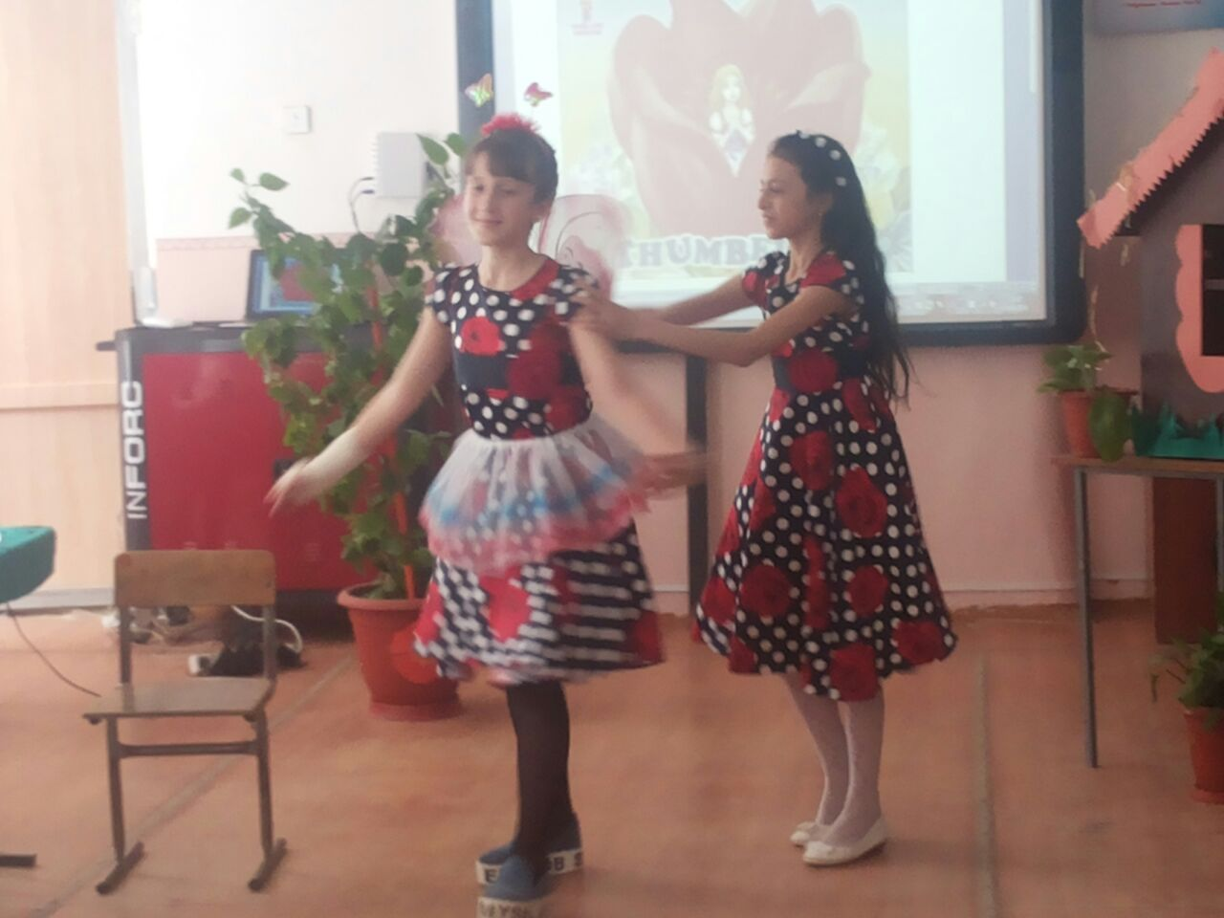
Scene 4
Thumbelina: Thank you, dear Butterfly, good-bye!
Beetle: Hello, my fairy lady! What’s your name?
Thumbelina: Good morning! My name is Thumbelina, I’m a girl. But who are you?
Beetle: I’m Mr. Beetle. I love you. (A lot of bugs come)
To the lady-bird:
Lady-bird, lady-bird,
Fly away home,
Your house is on fire
And your children all gone;
All expect one
And that’s little Ann
And she has crept under
The warming pan.
Butterfly:
Butterfly, butterfly,
Where can you fly?
I can fly very high
In the blue, blue sky!
Bird:
Once I saw a little bird
Come hop, hop, hop,
And I cried, Little bird,
Will you stop, stop, stop?
I was going to the window
To say, How do you do?
But he shook his little tail
And away he flew.
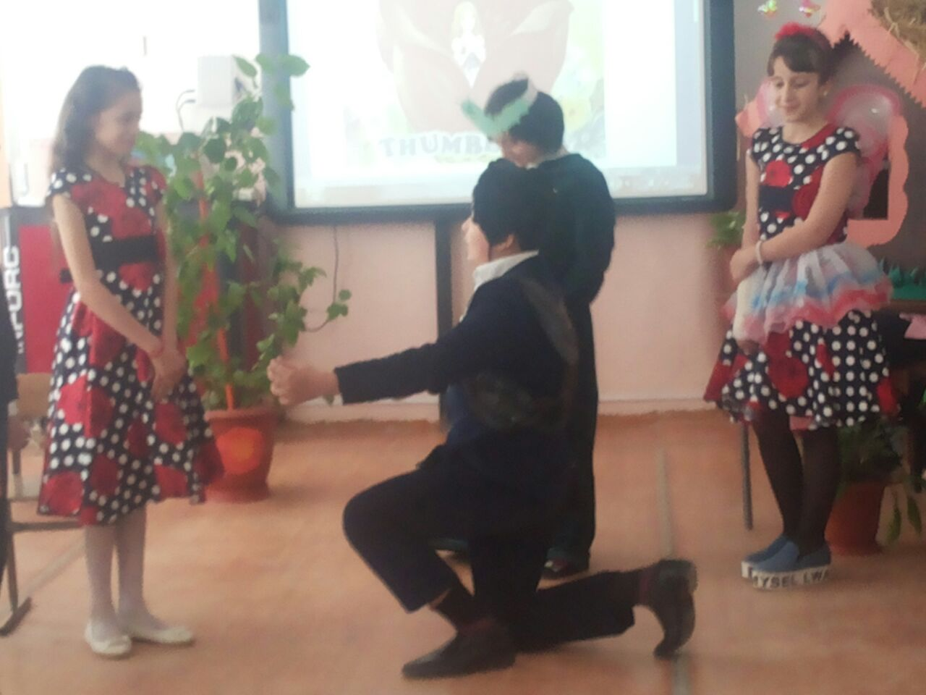
Beetles: Who is she? She is so ugly! She has only two legs! She has no feelers! She can’t fly and hop!
Beetle: Yes, you are very ugly! Go away! Now!
Thumbelina: Bye! (cries and goes away)
Scene 5
Thumbelina: It’s very cold and rainy. I’m cold. And I’m wet. I’m very hungry too. I can’t live in the field in winter. What shall I do? Where shall I go?
Mouse: Who are you?
Thumbelina: I’m a poor little girl. My name is Thumbelina. In summer I lived in the field, but now it’s very cold!
Mouse: I live in the nice warm house. Can you help me with my housework?
Thumbelina: Yes, I can help you with your housework, and I can tell you stories. (The Mole appears)
Mouse: Mr. Mole is my neighbour. He lives in the big long dark tunnels and he likes to listen to you stories too.
Thumbelina: Good day, Mr. Mole, nice to meet you!
Mole: I’m blind, but I can hear well. You are a nice girl with a lovely voice.
Thumbelina: Thank you, Mr. Mole. Thank you, dear Mouse.
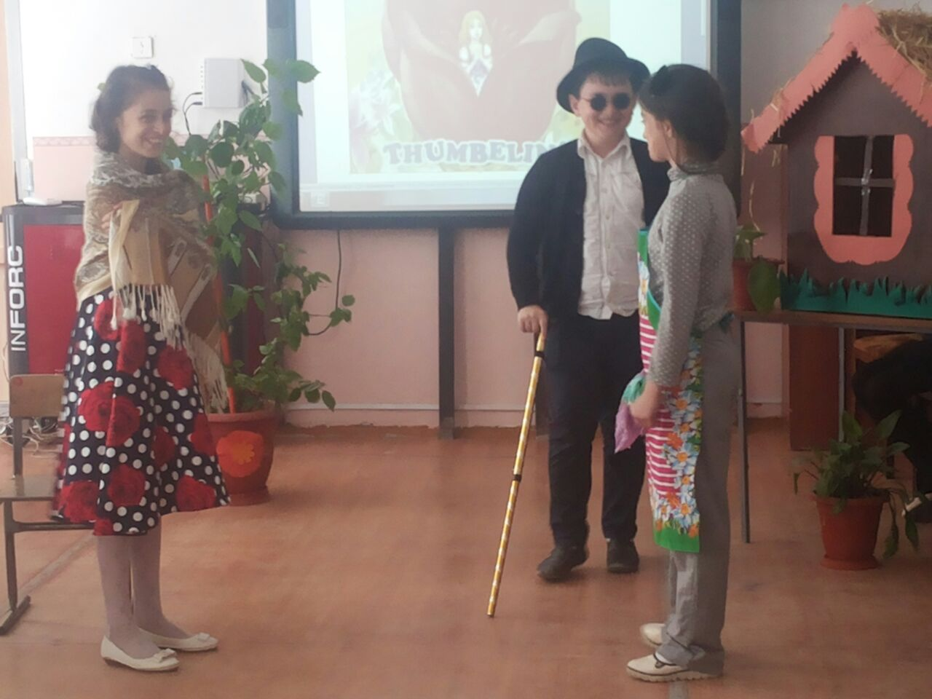
Scene 6
Thumbelina: It’s winter now. It’s cold and there is a lot of snow. I live in the house of the Mouse. I work from morning till night. I’m very unhappy. Mr. Mole wants to be my husband. I don’t like him. He’s old. He’s blind. Poor me!
Swallow: Help me! Help me, dear girl!
Thumbelina: What’s wrong with you, dear Swallow?
Swallow: I hurt my wing. I’m cold. I’m hungry. I’m thirsty.
Thumbelina: Oh? I can help you. Here are some seeds for you. Then I have some water in this jar. And you can have my scarf to warm yourself.
Swallow: Thank you, dear girl. And what is your name?
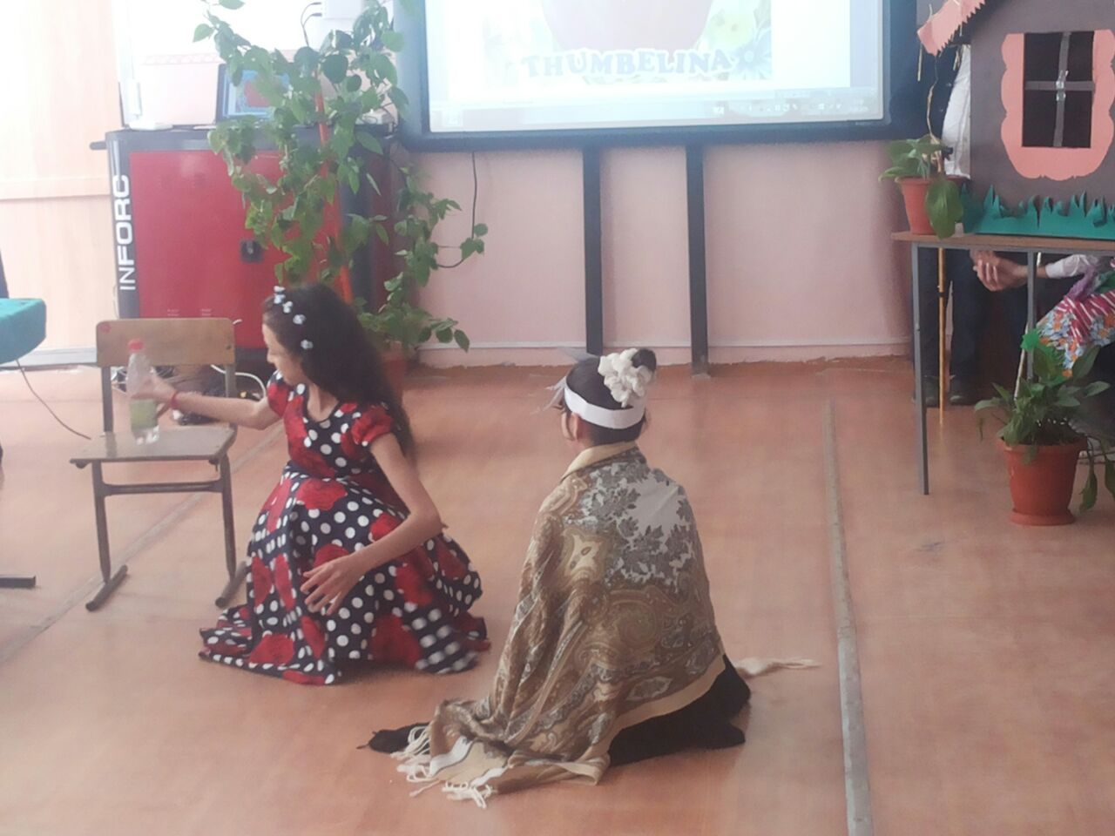
Thumbelina: My name is Thumbelina. Nice to meet you!
Mouse: Thumbelina, Thumbelina! Where are you?
Thumbelina: I’m here!
Mouse: Mr. Mole has come! He wants to marry you! You are a very happy little girl!
Thumbelina: No! No! I’m very unhappy! I don’t want to marry old blind Mole!
Swallow: I can help you! I’m going to fly to the South. Come with me!
Mouse: No, you can’t do it!
Thumbelina: Yes, I can. Thank you, dear Swallow. Bye, Mrs. Mouse! Bye, Mr. Mole!
Scene 7
Swallow: Here we are, dear Thumbelina. We live on this beautiful palace, look!
Flower spirits: Hello! My name is Thumbelina. My friend, Swallow, brought me to your country. May I live here?
Prince: Nice to meet you, Thumbelina. I’m the Prince of the Flower spirits. I loved you from the first sight! Would you marry me and be the Princess of the Flower Spirits?
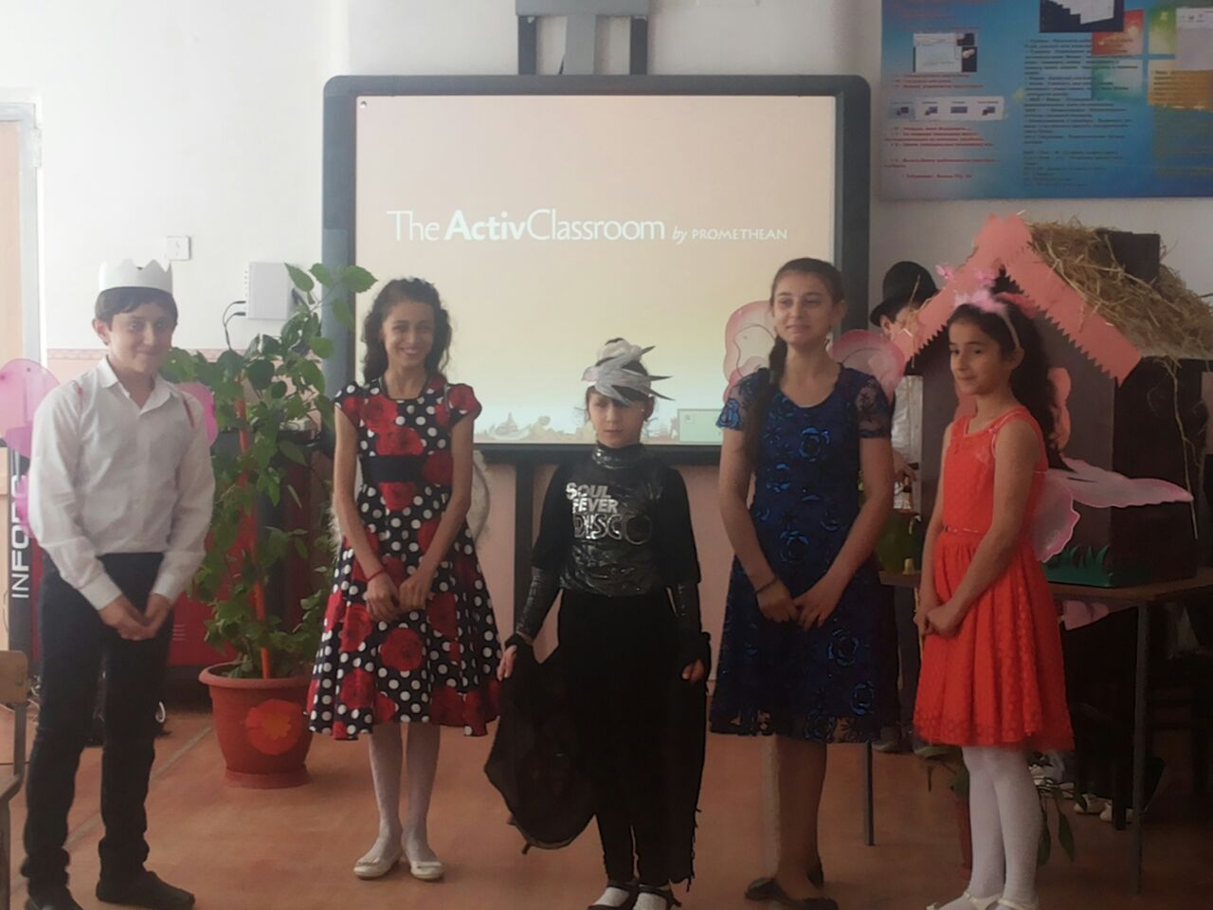
Thumbelina: Yes, I would!
Prince: And here is my present - your wings!
Thumbelina: Oh, Thank you! I’m the happiest girl in the world!
Swallow: Soon, the Prince and Thumbelina got married and lived happily ever after.

The song
If you’re happy and you know it, clap your hands.
If you’re happy and you know it, clap your hands.
If you’re happy and you know it, And you really want to show it,
If you’re happy and you know it, clap your hands.
If you’re happy and you know it, stomp your feet.
If you’re happy and you know it, stomp your feet.
If you’re happy and you know it, And you really want to show it,
If you’re happy and you know it, stomp your feet.
If you’re happy and you know it, slap your knees.
If you’re happy and you know it, slap your knees.
If you’re happy and you know it, And you really want to show it,
If you’re happy and you know it, slap your knees.
If you’re happy and you know it, click your fingers. If you’re happy and you know it, click your fingers.
If you’re happy and you know it, And you really want to show it,
If you’re happy and you know it, click your fingers.
If you’re happy and you know it, say we are, we are.
If you’re happy and you know it, say we are, we are.
If you’re happy and you know it, And you really want to show it,
If you’re happy and you know it, say we are, we are.

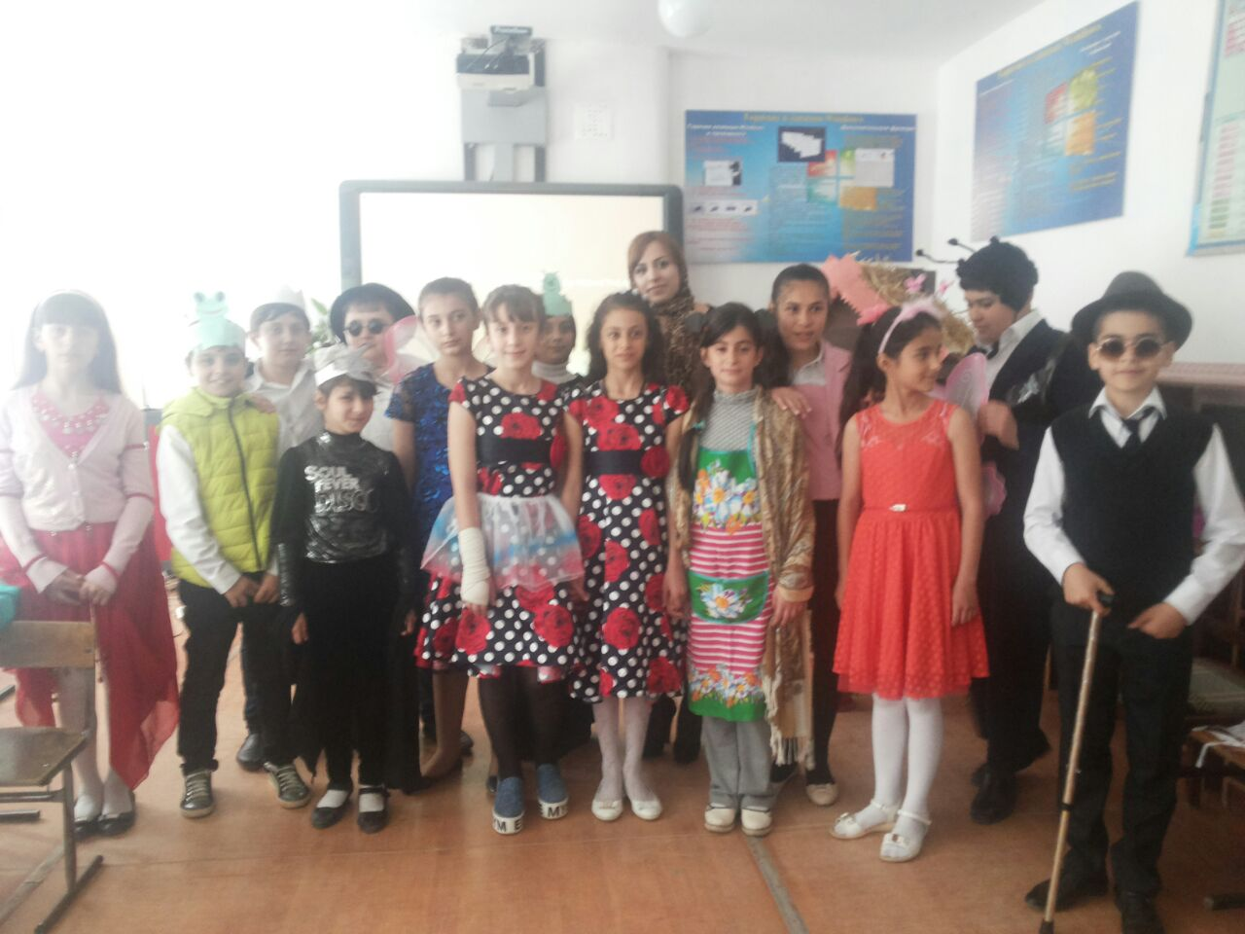

МБОУ «Гимназия №1»

Открытое внеклассное мероприятие

«Thumbelina»
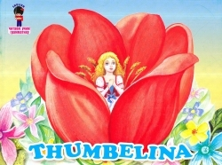

Гамзаева Маида Рафиковна,
учитель английского языка
Ответственные: 5 «А»класс.

Дербент, 2016г.

