Ход урока

I. Приветствие. Вводная беседа
T: Good morning boys and girls! How are you? What date is it today? What day of the week is it today? Who is away?
Today we have the lesson on the topic “What’s the time? ”. We shall learn how to ask the time.
You have three cards on your desks: red, blue, green. At the end of the lesson you will raise one.
The red one- I worked very well.
The blue one- I could work better.
The green one- I didn’t work.

II. Основная часть
1. Чтение вслух, наизусть (д/з) р.45 ех.6 poem “Big Ben”
Tick- tock,
Tick- tock,
This is Big Ben.
Big Ben is a clock.
Day and night
With all its might
Big Ben, the clock,
Says: Tick- tock.
2. Активизация вопроса “What’s the time?” + числительные 1-12
- работа с часами (учащиеся указывают время на циферблате) For example: it is 3 o’clock.
- работа с аудиозаписью. (Часы отбивают определенное время, учащиеся отвечают на вопрос “What’s the time?”, ”It’s … o’clock”)

3. Аудирование песни
T: What and when do Lin and Eddy do? We’ll learn from the song “This is the time I go to school” .
This is the time I go to school, go to school, go to school,
This is the time I go to school,
It’s eight o’clock in the morning!
This is the time I eat my lunch, eat my lunch, eat my lunch,
This is the time I eat my lunch,
It’s twelve o’clock, noon!
This is the time I watch TV, watch TV, watch TV,
This is the time I watch TV,
It’s six o’clock in the evening!
This is the time I go to bed, go to bed, go to bed,
This is the time I go to bed,
It’s nine o’clock at night!
T: Now match the words and the time.
(Написать на доске действия, время выполнения, время дня, когда происходит действие.)
I go to bed  I eat my lunch  I watch TV  I go to school | It’s 9 o’clock  It’s 8 o’clock  It’s 12 o’clock  It’s 6 o’clock | noon  at night  in the morning  in the evening
Индивидуальная работа по карточкам. (Рис. 1)

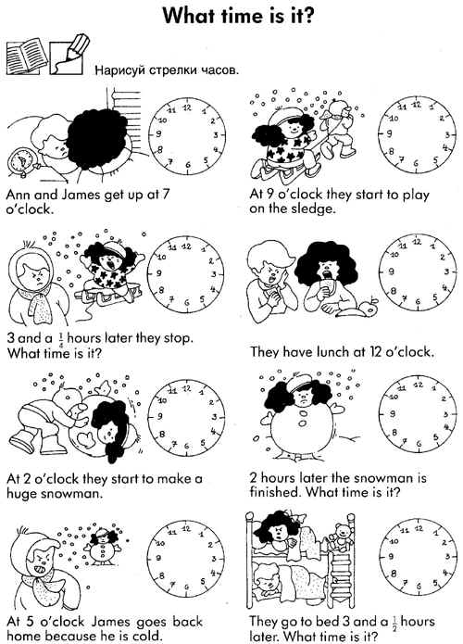

Рис. 1
(На доске написать новые слова, записать их в тетради перед выполнением задания.)
1/4 hours = 15 minute = a quarter
1/2 hours = 30 minute = half (past)
T: Read and translate. Draw the strikes on the clocks.

III. Итог урока
Домашнее задание.
T: Our lesson is coming to the end. Now it is the time to raise the cards. Red, blue or green?
(Учащиеся поднимают карточку и таким образом оценивают свою работу на уроке.)
You are excellent/ super/ fantastic pupils ! Tell me, please, what was the most interesting (difficult) thing at our lesson

