1a. Guess what the song is it about.

1. Look at the pictures. What do you see? What do they depict?

**9 lesson**

 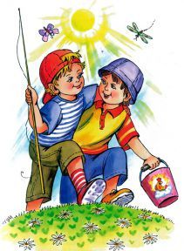 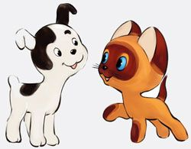

_____________________________________________________________________________

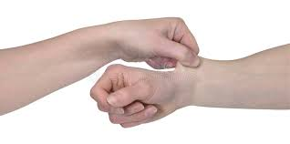

Zero Conditional:

If/when + Present Simple, …Present Simple

First Conditional:

If+ present, …will + Infinitive

Note:

Pinch

_____________________________________________________________________________

2a. Listen to the song and fill in the gaps.

scared, wake, perfect, smile

There are days  
I 1)______ up and I pinch myself  
You're with me, not someone else  
And I'm 2) __________, yeah, I'm still scared  
That it's all a dream

'Cause you still look 3)________ as days go by  
Even the worst ones, you make me 4)________  
I'd stop the world if it gave us time

2b. Number the sentences in the correct order.

__a) 'Cause when you love someone  
__b) You open up your heart

__c) You probably never loved someone like I do  
__d) When you love someone  
__e) If you love someone

__f) You make room  
__g) And you're not afraid to lose 'em  
__h) You probably never loved someone like I do



Note:

Vibe – настрой

Bond – связь

3a. Listen to the song and write the missing words.

It's been a long day without you, my ________  
And I'll tell you all about it when I _____ you again  
We've come a long _______ from where we began  
Oh, I'll tell you all about it when I see you _______  
When I see you again

3b. Match the lines.

First, you both go out your way and get lost   
And what's small turned to a friendship, a friendship turned to a bond  
And that bond will never be broken, the love will never get lost  
The love will never the vibe is feeling strong

4. Do you understand the ideas of the songs? Which song do you like? Do you have friends? (Since childhood)

5. Can you name the title of the first song, the second one?

Lukas Graham - Love Someone

Wiz Khalifa - See You Again ft. Charlie Puth

6. Find and write the examples of Zero Conditional and First Conditional.

_____________________________________________________________________________________________________________________________________________________________________________________________________________________________________________________________________________________________7. Make your own sentences with Zero/First Conditionals.

____________________________________________________________________________________________________________________________________________________________________________________________________________________________________

[9. Make a poster about gadgets (warning signs, weather, work etc.) and make descriptions using Conditionals.](https://www.youtube.com/watch?v=RgKAFK5djSk)

[8a) What gadgets do you have? Will you use them in the future? Will they be important for you? Why?](https://www.youtube.com/watch?v=RgKAFK5djSk)

[8b) In pairs. Discuss your future plans for tomorrow/next week/month using Conditionals.](https://www.youtube.com/watch?v=RgKAFK5djSk)