**CROSSWORD «ANIMALS»**

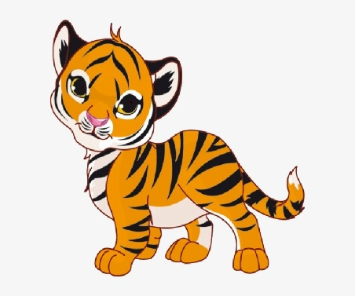2 9 4

 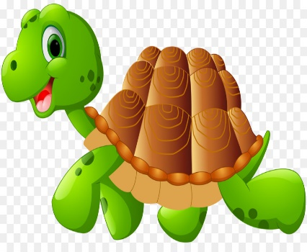

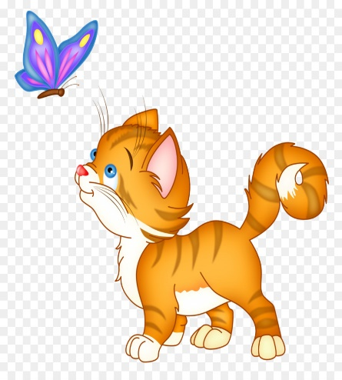

7

|  |  |  |  |  |  |  |  |  |
| --- | --- | --- | --- | --- | --- | --- | --- | --- |
|  | 1 |  | 2 |  |  |  | | |
|  | | | 3 |  |  |  |  | |
| 4 |  |  |  |  |  | | | |
| 5 |  |  |  |  |  |  |  | |
|  | | | 6 |  |  |  |  |  |
|  | | 7 |  |  |  | | | |
|  | 8 |  |  |  |  |  |  | |
| 9 |  |  |  |  |  |

8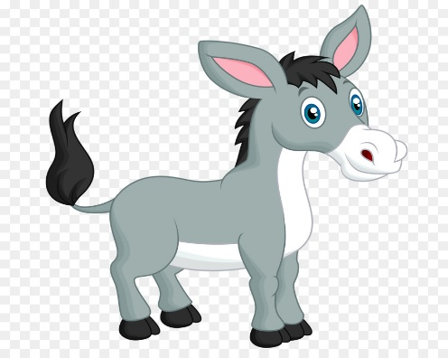 6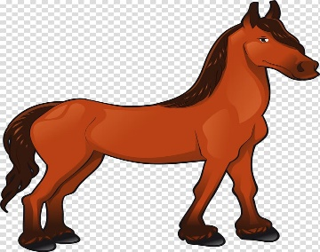5 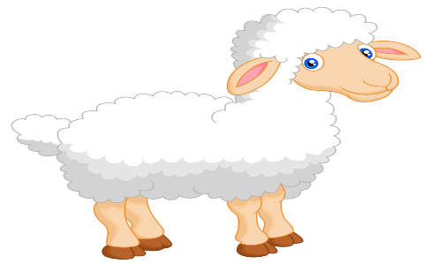1

3