Spotlight 6 Test 3
V-1
I Match the word and the word definition
1. Parking zone | a) An area which people use for walking.
2. Zebra crossing | b) A place where you can park a car.
3. Pavement | c) White stripes on the road. People can cross the road on it.

II Fill in: in, on, by, of.
- Walk _____ the pavement.
- We go to school _____ foot.
- Don’t learn out _____the window.
- She is afraid of traveling _____plane.
- Be careful____ the roads.

III Fill in the correct word.
● watch ● road ● plane ● bike ● boat ● car ● lights ● left ● handgrip ● kerb
- My father is a pilot. He can fly a ...............
- Can your brother sail a....................................
- Use the........ when there are no free seats on bus.
- Always stop at the traffic ............................. when they're red.
- My friend can't ride a ........................
- Turn...........into Road street.
- I can't drive a............
- ........... out! There's a car coming
- Don't run from the pavement onto the ..................
- Stand on the pavement, near the.........................

IV Complete with can or can’t
- You _____ turn right. 2) You ___ drive at 75 mph. 3) You ___ park here. 4) You ___ stop here. 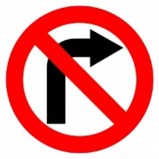 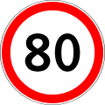 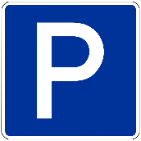 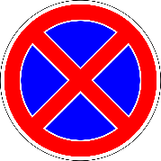
V Make rules of the road safety.
wear a seat belt, lean out of the window, look both ways when you cross the road, run onto the road, walk on the pavement, talk to the driver
Do’s:
Don’ts:

VI Translate
- Дорожный знак 2) пользоваться ремнями безопасности 3) дорожная безопасность
4) идти пешком 5) пешеходный переход

Spotlight 6 Test 3
V-2
I Match the word and the word definition
1. Pedestrian | a) A name of a job. This person watches the traffic and makes it safe.
2. Traffic warden | b) A person who is on foot, not by car/ bike, etc..
3. Traffic sign | c) A sign on the road.

II Fill in: in, on, by, of.
- Always wear your seat belt when you travel __car.
- I go to school _____ foot.
- Don’t learn out _____the window.
- Never carry a second person ___ your bike.
- I don’t use my car very often. I prefer to go ___ bike.

III Fill in the correct word.
● watch ● road ● fly ● bike ● boat ● car ● bright ● right● handgrip ● kerb
- Stand on the pavement, near the.........................
- It’s dangerous to run onto the....................................
- Use the........ when there are no free seats on bus.
- Wear ____clothes in daytime.
- Kate can't ride a ........................
- Turn...........into Apple street.
- My brother is very young. He can't drive a............
- There’s a bus coming! ........... out!
- She sailed a ..................herself!
- I think it’s too difficult to ...........a plane

IV Complete with can or can’t
1)You _____ turn left. 2) You ___ drive at 75 mph. 3) You ___ park here. 4) You ___ go straight. 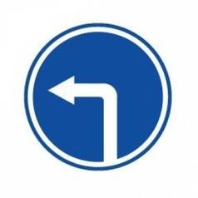 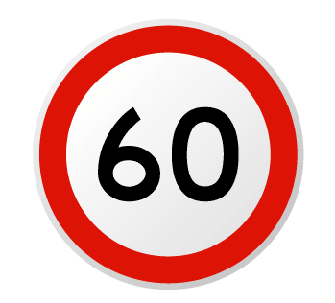 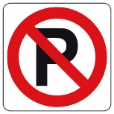 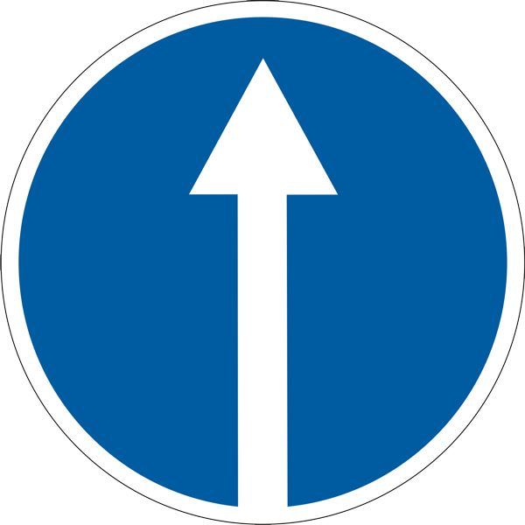
V Make rules of the road safety.
Listen and look both ways for traffic, cross the road when the light is red, wear a seat belt, use bike lanes, cross between parked cars, talk to the driver
Do’s:
Don’ts:

VI Translate
1)ехать на автобусе 2) дорожная безопасность 3) пешеходный переход
4) парковка 5) идти по тротуару

