Материал мастер – класса «Организация урока иностранного языка развития навыков определенного вида речевой деятельности» в ходе проведения курсовых мероприятий по повышению квалификации учителей иностранного языка в рамках проекта модернизации образования

План – конспект урока английского языка по теме “Natural disasters”
(проектная технология на уроке английского языка)

Учитель: Ударцева Елена Юрьевна, учитель английского языка высшей квалификационной категории МБОУ СОШ № 39 г. Ставрополя
Класс: 8
Тема: Природные катаклизмы
Цель урока: создать условия для совершенствования лексических навыков по теме, развивать умения чтения, монологической речи в форме защиты проекта.
Задачи урока:
общеобразовательные
- активизировать ранее изученные ЛЕ по теме «Природные катастрофы» в устной и письменной речи;
- совершенствовать навыки изучающего чтения;
- развивать коммуникативные речевые умения письменной и устной речи при составлении кратких характеристик природных явлений;
развивающие
- развивать умение использовать ЛЕ в собственных мини-высказываниях на уровне одного предложения;
- извлекать из текста необходимую информацию;
- высказывать предположение, прогнозировать;
- опровергать утверждения или соглашаться с ними;
- развивать умение восприятия и понимания речи на слух;
- развивать умение поиска, систематизации, обработки информационного материала при создании и презентации проектов;
воспитательные
- развивать у учащихся самостоятельное мышление;
- развивать у учащихся внимание;
- интерес к урокам иностранного языка;
- повысить мотивацию учащихся к изучению английского языка, оптимизируя процесс обучения с помощью проектной деятельности.
Необходимое оборудование и материалы: мультимедийный проектор для показа презентаций, раздаточный дидактический материал.
Ход урока:
- Greetings
Hello boys and girls! How are you? Are you ready to begin our lesson?

- Planning
Ok, let’s look at an unusual item for our lesson. What is it? How is it connected with the theme to discuss today? You are right, we are going to speak about NATURAL DISASTER that can happen all over the world. Such phenomena occur more often nowadays. We need to know about them as much as possible and be ready to protect ourselves.
The Earth is a beautiful place to live on. We can see wonderful landscapes , we can climb mountains, swim in rivers, lakes and seas, lie on the beach.
But do you agree that our planet is a dangerous place? Really, the Earth is a dangerous place. Why?
There are a lot of different kinds of disasters on the Earth. What are they?

- Work with words
(Pronounce the words
drought flood tornado earthquake tsunami cyclone avalanche hurricane )

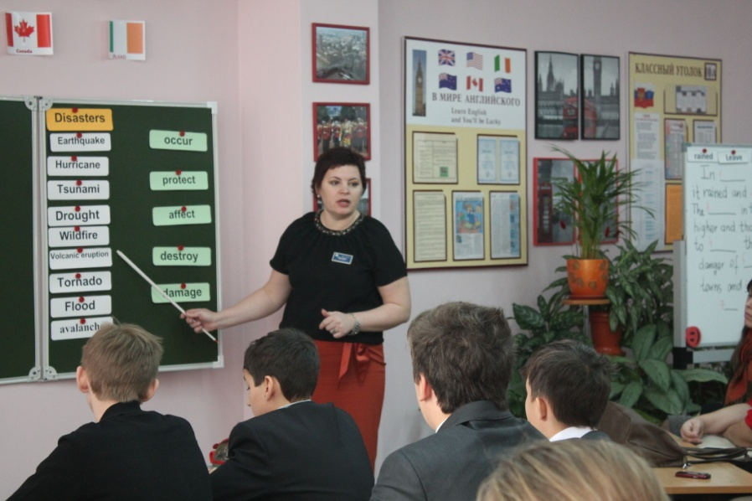

Answer the teacher’s questions:
- What is a natural disaster?
(Pupil: A natural disaster is some terrific weather conditions such as storm, shower, earthquake, avalanche, which bring a lot of damage to buildings, wildlife and people)
The teacher concludes: “A natural disaster is bad consequences of natural phenomenon.”
T: Could you explain some of the disasters (natural phenomena)?
(учитель раздаёт карточки учащимся, где есть только определение какому – либо стихийному бедствию, учащимся необходимо сказать – что это)
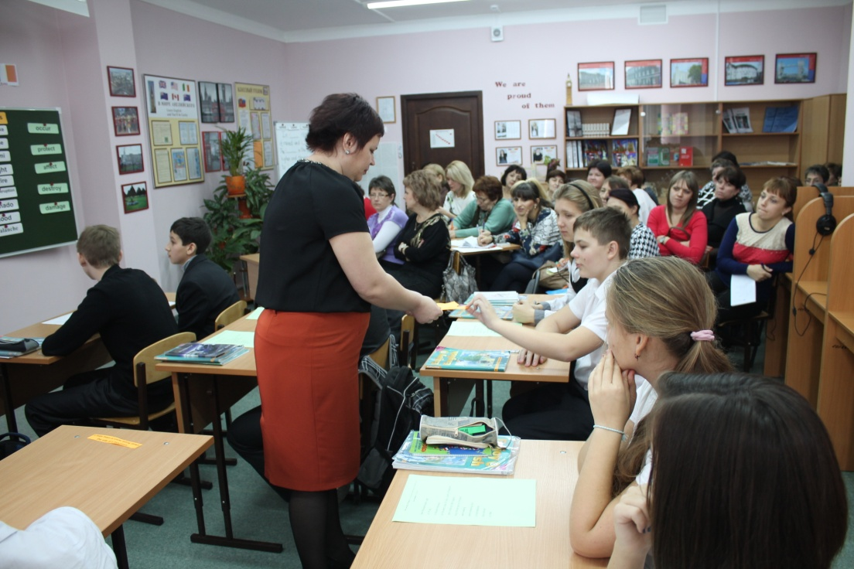
Pupils:
drought - a long period of time without rain. People suffer from limited fresh water flood – a large amount of water that covers an area which is usually dry tornado - a violent wind storm which consists of a tall column of air spinning around very fast tsunami - a huge wave caused by an earthquake which flows onto land earthquake - a sudden rapid shaking of the ground avalanche - a large mass of snow falling down the side of a mountain hurricane - an extremely violent wind or storm
T: What can cause them?
P: The changes in climate, the meeting of cold and warm air in the atmosphere, the movement of tectonic plates and so on.
Students work with Smartboard (topic.ru)
- Students’ projects
Work with texts
Text 1

Hit, hurricane, leave, destroyed, winds, hour

Hurricanes are very strong ______ that come from the sea. Warm wet air rises in a spiral and goes faster and faster - over 160 km an ______. In 1992, “Hurricane Andrew”_____Florida. The people there had to _____their homes and move to other towns and wait. When the______arrived, it killed 15 people and_______thousands and thousands of buildings. More than 50,000 people had nowhere to live.

What is the most violent wind? Of course, it’s a tornado.

Ilya Poluyanov was interested in the problem, he investigated it in details and now he is ready to present his conclusions.

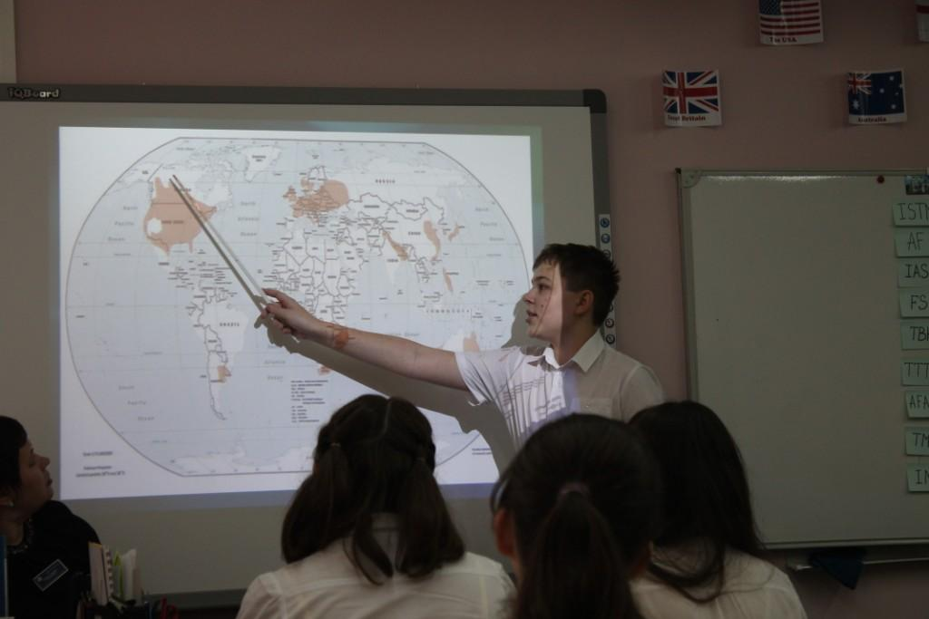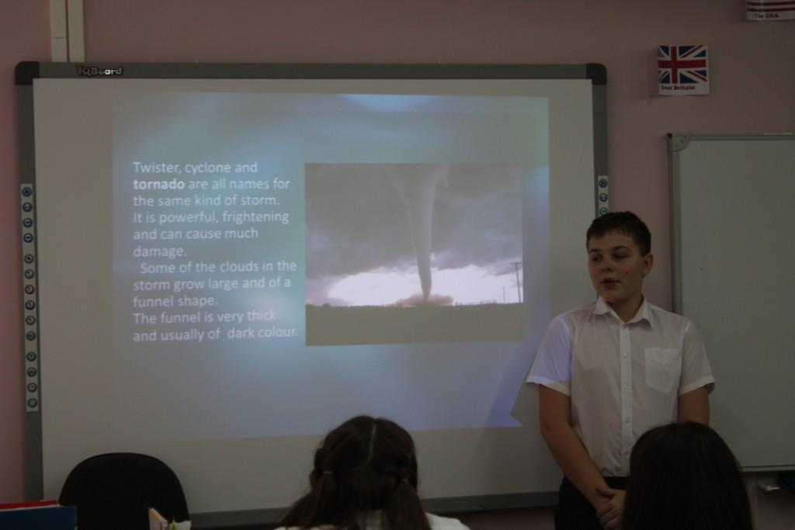

Project “Tornado”

Text 2
Floods, leave, rained, water, level, waited, January
In _______ 1995 in the Netherlands, it rained and ______ for more than two weeks. The ______in the canals and rivers rose higher and higher and thousands of people had to ______ their homes because of the danger of ______. They went to other towns and ______ until the water ______ fell again.
The most terrible flood caused by tsunami. What is a tsunami? How does it look out?
What aftereffects does it have?
How to protect yourselves? Victoria has studied this phenomenon.
(Victoria Bardicova’s project “Tsunami”)

Listening comprehension
Look at our screen. Who knows the painting? Yes, The Last Day of Pompeii is a large canvas painting by Russian artist Karl Briullov in 1830-33
What disaster is pictured here?
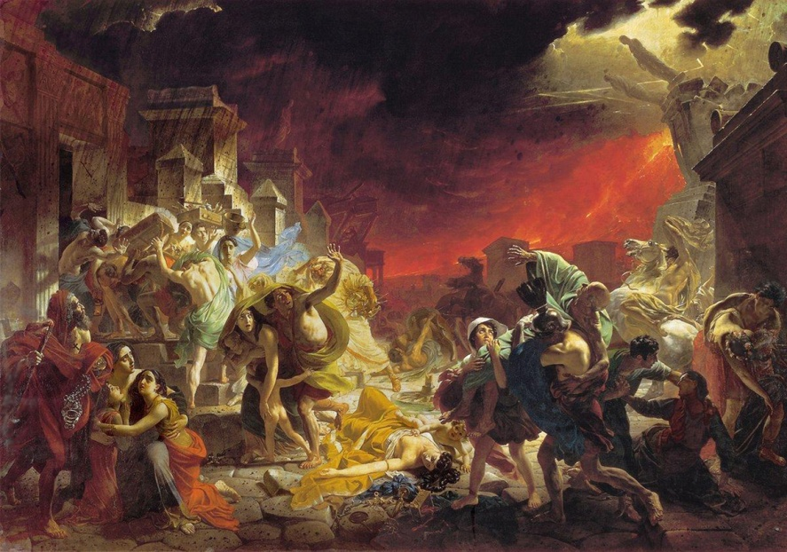

Volcanic eruption in Italy (задание по аудированию)
Nearly two thousand years ago, in 79 AD, a volcano called Vesuvius erupted on the west coast of Italy, south of Naples. It was one o’clock on 24th August. In the busy Roman port of Pompeii, people were walking about in the streets, families were preparing lunch and children were playing. Suddenly Vesuvius erupted. There was a loud explosion. There was dust and ash everywhere. People rushed into the streets screaming. Children ran to their parents crying. People tried to run away, taking their things with them. They tried to escape, but most of people and animals died.
Vesuvius has erupted many times. The last big eruption was in 1944. Will Vesuvius erupt again? Nobody knows. If it does, it might be a small eruption or a big one. Some people live close to Vesuvius because the soil around it is good for growing crops. But it is also very dangerous.

Questions:
What is Vesuvius?
Where is Vesuvius?
When did Vesuvius erupt?
What was there after eruption?
How many people and animal died?
When was the last big eruption of Vesuvius?
Why do some people live close to Vesuvius? Is it dangerous?

Project VOLCANO ERUPTION
Kirill and Daniel are interested in volcanoes. They have prepared a report about them. Be attentive and polite.
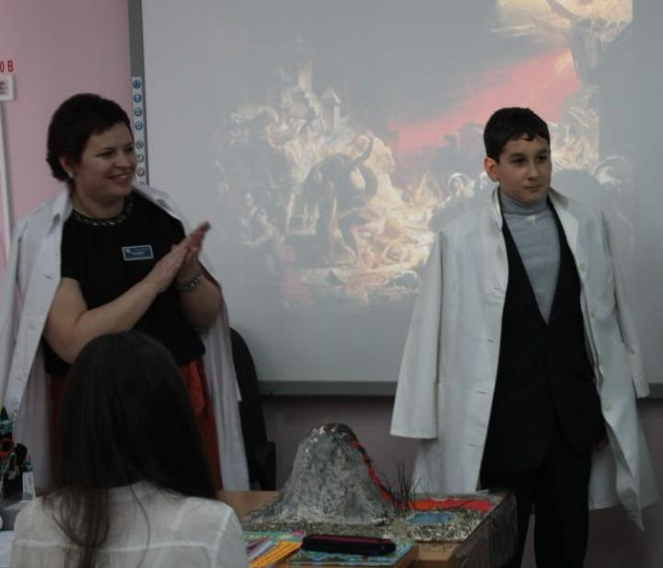
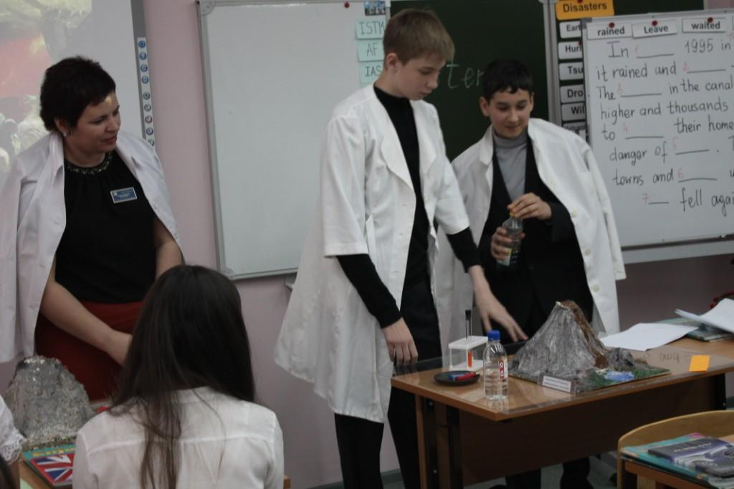

How clever you are! Thank you for your educational information.

As I know you are captivated by one song WE ARE THE WOL RD WE ARE THE CHILDREN. It was written by Michel Jackson 25 years ago. But in February 2010 80 artists and performers walked into the room with their hearts and souls completely open to coming together to help the people of Haiti, where a terrible earthquake occurred.

What is the main idea of the song?
(pupils are singing the song)

- Summering
- Reflexion
- Valuating

Приложение 1
Guess what disaster it is about?

It is a mountain with a hole at the top
It is a sudden movement of the ground
a large mass of snow falling down the side of a mountain
a huge wave caused by an earthquake which flows onto land
a violent wind storm which consists of a tall column of air spinning around very fast
a long period of time without rain. People suffer from limited fresh water
a large amount of water that covers an area which is usually dry

Приложение 2
( доп. материалы к уроку)
Volcanic eruption in Italy
Nearly two thousand years ago, in 79 AD, a volcano called Vesuvius erupted on the west coast of Italy, south of Naples. It was one o’clock on 24th August. In the busy Roman port of Pompeii, people were walking about in the streets, families were preparing lunch and children were playing. Suddenly Vesuvius erupted. There was a loud explosion. There was dust and ash everywhere. People rushed into the streets screaming. Children ran to their parents crying. People tried to run away, taking their things with them. They tried to escape, but most of people and animals died.
Vesuvius has erupted many times. The last big eruption was in 1944. Will Vesuvius erupt again? Nobody knows. If it does, it might be a small eruption or a big one. Some people live close to Vesuvius because the soil around it is good for growing crops. But it is also very dangerous.
Questions:
What is Vesuvius?
Where is Vesuvius?
When did Vesuvius erupt?
What was there after eruption?
How many people and animal died?
When was the last big eruption of Vesuvius?
Why do some people live close to Vesuvius? Is it dangerous?
Disaster in Africa
Sometimes in desert climates, it does not rain for a long time. This happened between 1968 and 1974 in the Sahel, in West Africa. The winds changed direction and the area did not receive any rain for six years. Hundreds of thousands of people and nearly half of the animals in the area died because there wasn’t enough water. The crops did not grow and many countries suffered from famine. People had to walk hundred kilometers to find water.
Questions:
Which disaster was in Africa between 1968 and 1974? (drought)
Why didn’t the area in West Africa receive any rain for six years?
How many people and animals died?
Why did many people and animals die?
Disaster in Texas
When the famous Galveston Hurricane struck in the United States in September 1900, the whole city of Galveston, Texas, was destroyed and about 6000 people were killed.
Disaster in Florida
Hurricanes are very strong winds that come from the sea. Warm wet air rises in a spiral and goes faster and faster – over 160 km an hour. In 1992, «Hurricane Andrew» hit Florida. The people there had to leave their homes and move to other towns and wait. When the hurricane arrived, it killed 15 people and destroyed thousands of buildings. More than 50 000 people had nowhere to live.
Questions:
What are hurricanes?
What may the speed of a hurricane be?
Which disaster happened in Florida in 1992?
How many people did «Hurricane Andrew» kill and how many buildings did it destroy?
Disaster in the Netherlands
The Netherlands is very flat and part of the country is below the level of the sea. The people there have to make sure that the walls by the sea – the dykes – are very strong.
Usually, there is no problem, but in January 1995, it rained and rained for more than two weeks. The water in the canals and rivers rose higher and higher, and thousands of people had to leave their homes because of a danger of floods. They went to other towns and waited until the water level fell down again.
Questions:
What disaster happened in the Netherlands in 1995?
Why did flood occur?
Why did people have to leave their homes?

Disaster in China
An awful flood happened in China in 1998. It was caused by heavy rainfall. Nearly 4000 people were killed. The flood destroyed houses and left millions of people homeless, a lot of farmland was damaged.
Disaster in South-Eastern Asia
Such a terrible disaster as tidal wave happened in South-Eastern Asia on 25 December 2004. Such countries as Thailand, Sri Lanka, and Indonesia were damaged greatly. The consequences of it are terrible. More than 200000 people were killed, a lot of injured people, thousands of people became homeless, unemployed, a lot of people need water, food clothes, medical and psychological help. There is a threat of different diseases and epidemics. Different countries of the world provide help for injured people in these countries. Russia is among them. The consequences of tidal wave wouldn’t have been so awful, and not so many people would have been killed if people were warned, but they weren’t. There was no notification system in that area.

Приложение 3

We are the world we are the children (слова песни)
There comes a time
When we heard a certain call
When the world must come together as one.
There are people dying
And it's time to lend a hand to life –
The greatest gift of all.
We can't go on
Pretending day by day
That someone, somehow will soon make a change.
We are all a part of
God's great big family
And the truth, you know love is all we need.
We are the world
We are the children
We are the ones who make a brighter day
So let's start giving.
There's a choice we're making
We're saving our own lives.
It's true we'll make a better day
Just you and me.
Well, send them your heart
So they'll know that someone cares
And their lives will be stronger and free.
As God has shown us by turning stone to bread
And so we all must lend a helping hand.
We are the world
We are the children
We are the ones who make a brighter day
So lets start giving
There's a choice we're making
We're saving our own lives
It's true we make a better day
Just you and me

Приложение 4
Пример презентации проекта по теме «Цунами»

