Батыс Қазақстан облысы Орал қаласы
№44 мектеп-гимназиясының
II санатты III денгей
ағылшын тілі пәнінің мұғалімі
Рахматуллина Замзагүл Жансейтқызы

Long-term plan unit:  School Objects |  | School-gymnasium: №44 Grade: 1
Date: |  | Teacher name: Rakhmatullina Zamzagul Zhanseitovna
Theme of the lesson: School Objects
Learning objectives that  this lesson is contributing to |  | 1.L3 recognise with support common names and names of places; recognise the spoken form of a limited range of everyday and classroom words  1.L9 recognise the names of letters of the alphabet  1.S1 make basic personal statements about people; objects and classroom routines  1.S3 pronounce familiar words and expressions intelligibly  1.UE3 use basic adjectives to describe people and things  1.UE6 use demonstrative pronouns this, these, that, those to indicate things
Lesson objectives |  | To identify school items
Extra materials |  | - Slips of paper with a number from 1 of 5 for the Beginning the Lesson activity  - Flashcards (7-11)  - Story cutouts from the Activity Book for Ex.6 Extension Activity (Optional)
Previous learning |  | My School
Plan
Planned timings | Planned activities |  | Resources
Beginning | “A round of happiness” say everybody “Hello!”  Activities to revise the vocabulary from the previous lesson  Before going into class write a number from 1 to 5 on slips of paper. Duplicate the number so that each pupil has got a slip.  Hand out a slip of paper to each pupil. Explain the activity. The pupils move around the classroom, trying to and their classmates with the same number. They ask and answer without showing their slip of paper. Demonstrate the following exchange:  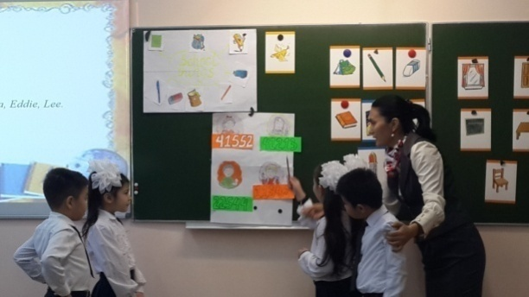  e.g -What’s your number?  -(three). What’s your number? -( four). etc  The pupils get into grounds according to the number of their slip of paper. When all the groups have been formed, check that the pupils are in the correct group.  Play the Numbers song from the previous lesson (Trask 19 CD1). Encourage the pupils to sing along. |  | Slips of paper with a number from 1 of 5;  Numbers song  (Track 19 CD1)  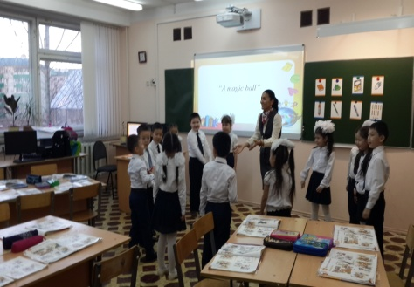
Middle  End | Listen, point and repeat. (track 21 CD1)  The pupils repeat the numbers, chorally and/or individually. Point to each flashcard in random order. Ask individual pupils to say the word. Ask the rest of the class for verification. Name a school item, e.g. book. Ask a pupil to show you a book. Repeat with the rest of the items.  Work with a book.  Play the CD. The pupils listen, point to the pictures and repeat the words. Play the CD again pausing after each word. The pupils repeat, chorally and/or individually.  AUDIOSCRIPT  Schoolbag, book, pen, pencil, rubber  Group work.  I’ll give the posters with tasks to each group, pupils must do it in a group and say.  Trace and colour. Then point and say.  Refer the pupils to the picture and elicit the school items. Revise the colours by pointing to different items around the classroom and eliciting the colours. Ask the pupils to trace and colour the school items. Allow the pupils some time to complete the activity. Then call out an item and ask from individual pupils to point to it and say what colour it is.  Sing the Get your pencil song! (Track 22 CD1)  Pick up a pencil and a pen, point to them and say:  Get your pencil! Get your pen! The pupils repeat after you. Follow the same procedure and present the rest of the song.  Play the CD. The pupils listen to the song. Divide the class into two groups and a sign a verse to each group. Ask them to have the corresponding school items at hand. Play the song again. The groups listen to the song and hold up the items every time they are heard. Play the song a third time. The groups the assigned verses.  AUDIOSCRIPT  Let's listen! (Track 23 CD1)  Set the scene by asking the pupils questions about what they can see in the pictures.  e.g. Teacher: (pointing to picture 1) Where are Liam andAndy? At….  Class: school!  Teacher: (pointing to the rubber) What's this?  Class: It's a rubber!  Teacher: Yes! (pointing to the book in picture 2)  And what's this?  Class: It's a book! etc  Play the CD. The pupils listen and follow the dialogue in their books.  AUDIOSCRIPT  - Liam: What's this?  Andy: It's a rubber.  - Andy: What's this?  Liam: It's a book!  - Liam: Hey, wait!  Boy: Oh, dear!  - Boy: Thanks! I'm Walter and this is Waggy!  Play the CD again with pauses for the pupils to repeat, chorally and/or individually.  Hold up your book to the class. Say the dialogue and point to the pictures in turn. Repeat, this time inviting the pupils to complete your sentences.  e.g. Teacher: What's…  Class: this? Etc  Reflection . How do you feel?  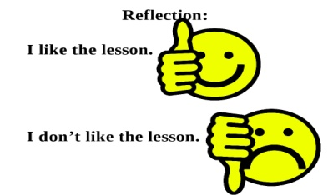  Evolution. Giving stars.  The lesson is over. Thank you children. Good bye |  | Track 21-23 CD1  Flashcards (7-11)  Story cutouts from the Activity Book  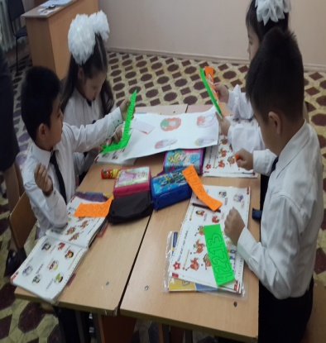  AUDIOSCRIPT  Get your pencil,  Get your pen,  Get your book,  It's school again!  Get your rubber,  Your schoolbag, too.  Get your things,  And go to school!

