Батыс Қазақстан облысы Орал қаласы
№44 мектеп-гимназиясының
II санатты III денгей
ағылшын тілі пәнінің мұғалімі
Рахматуллина Замзагүл Жансейтқызы

Form: 1
The theme: | Nico in the classroom
The aim: | Pupils revise the classroom items from the previous lesson.
The results: | 1. Pupils know the name of school things.  2. Pupils understand the teacher’s saying and do it in actions.  3. Pupils match the pictures with the words.
The visual aids: | Computers,CD disk, Vocabulary cards, Interactive board, felt tips, posters.
The procedure of the lesson:
 | Teacher’s activity | Pupils’ activity
Introduction  (7 min) | I. Organization moment.  greeting  Good morning, good morning,  Good morning to you.  Good morning, dear pupils,  We are glad to see you.  II.Singing a song: ”What’s your name?”  CD Track 3  III. Revising the words playing a game with  “A magic ball”  IV. Video. Revising the words. (a door, a table, a chair, a window, a board and classroom items) | Greeting of pupils  Good morning, good morning,  Good morning to you.  Good morning, dear teacher,  We are glad to see you.  Pupils make a circle and introduce yourselves, then sing a song:  ”What’s your name?”  Pupils play a game and revise the words.  Pupils watch a video from Interactive board.
Presentation  ( 5 min) | I. To introduce with the picture of Nico.  Open the books at page 16. Look at the picture. What are you seeing?  II. New lesson: Nico in the classroom.  III. Playing a game.  Now, let’s play a game: “Nico says…”  Nico says: clap, stamp, point to the window, (door, board, table, chair) jump, dance, sit.  Thank you. | Pupils answer the questions.  Nico, Bella, Anna, Eddie, Lee.  And the names of classroom items.  Pupils play a game and do actions.
The main part  (15 min) | I. Group work. Nico’s tasks: ( 3 min )  1) Find the pictures of school things  2) Find the telephone numbers of Bella, Anna, Eddie,  Lee.  3) Find the pictures of things in classroom.  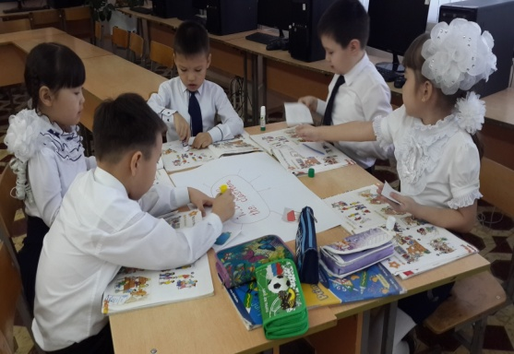  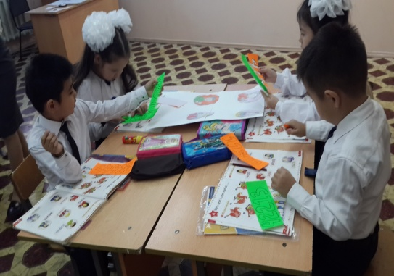  II. Physical minute. CD Track 5 Say and do  Point to the window  Clap, clap  Point to the door  Clap, clap  Point to the board  Clap, clap  Point to the table  Clap, clap  Point to the window  Stamp, stamp  Point to the door  Stamp, stamp  Point to the board  Stamp, stamp  Point to the table  Stamp, stamp | Pupils do the tasks in group and protect their projects.  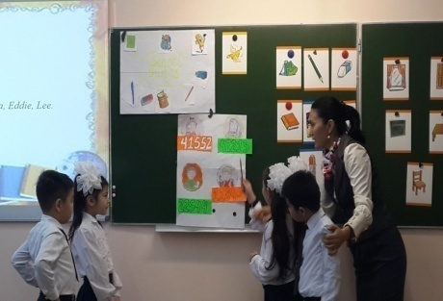  Pupils sing and do actions.  Point to the window  Clap, clap  Point to the door  Clap, clap  Point to the board  Clap, clap  Point to the table  Clap, clap  Point to the window  Stamp, stamp  Point to the door  Stamp, stamp  Point to the board  Stamp, stamp  Point to the table  Stamp, stamp  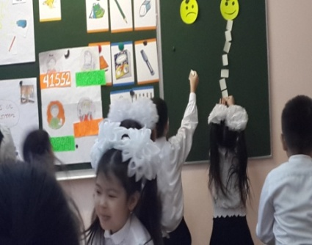
Conclusion  - min) | I.Reflection  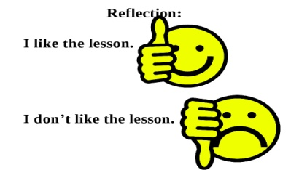  II. Evaluating pupils knowledge.  The lesson is over. Good bye, children. | Pupils help Nico to choose school things.  Good bye, teacher.

