Историко-краеведческий материал
« 80-летие Ростовской области»
по английскому языку для учащихся 9-11 классов

The history of Rostov region

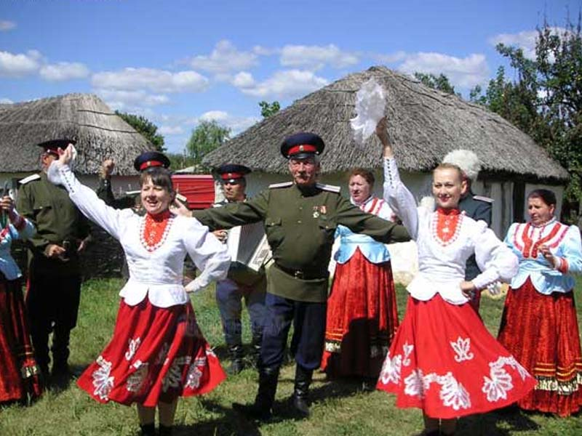

- In the archeologists’ opinion the first people on the Don appeared about 150 thousand years ago.
- In the XVII th century the peasants from Central Russia ran to the Don.
- There they founded small villages and called them stanitsas.
- The men lived on the Don were called “Kazak”. It means a “free man”.
- The first Cossack’s settlements on the Don were Aksay, Cherkassk, Manych and Razdorsky. Cherkassk was the capital of the Don Cossack’s Army.
- In the year 1648 on the left bank of the river Don was founded Bagayevskaya. Now it is a modern settlement with gas and water.
- We are proud of history of our region and follow old traditions.

The Don
- The longest river of our region is the Don. It is 1870 kilometres long, it takes the third place after the Volga and the Ural in the European part of Russia.
- The first information about the Don belonged to the Vth century before our erа.
- At that time the Don was called Amazonia because there lived women’s tribes . Then the Don was named Tanais.
- The word “Don” came from Assetian which means “a river”. People liked their Don , they named it the Don-Ivanovich because the river begins from the Ivan-lake in Tula region.
- But the Don flows not only in Russia. The point is that the Don has 5 “brothers”.
- There is the Don in France, India, Canada, Scotland and England. On the English Don stands the city Doncaster.

Cities and towns of Rostov region

- In Rostov region there are 22 towns and about 3 thousand villages. Let’s travel from south to north and visit some of the towns.
- The oldest town is Azov. It was founded in the year 1067.
- In Taganrog lived and wrote his works Anton Pavlovich Chekhov.
- Novocherkassk became the capital of the Don Cossack’s Army in 1805.
- Shakhty is one of the industrial coal-mining centers in the south of Russia.
- Rostov -on - Don is the capital of our region. It is one of the main industrial, cultural and transport centers in the Northern Caucasus . It was founded on December,15 1749.
- At first it was a fortress named after the Saint Dmitry Rostovsky.
- In the year 1999 to the 250th anniversary of the city the monument to this Saint was founded near the main Cathedral in Rostov.
- There live nearly 1 million people. They enjoy visiting theatres, galleries and museums in their city. They are proud to live and work in the most beautiful city in our country.
- Rostov is a big transport junction, it is named a port of 5 seas. Every day many planes and trains, buses and ships connect Rostov with other cities and regions.
- Almost in each town there is a museum which materials and exhibits tell about the history and traditions of people living there.

February, 14 , 1943 is the Day of Liberation of the city ROSTOV-ON-DON from the German fascist invaders. There is the Victory Monument on Teatralnaya Square in Rostov.
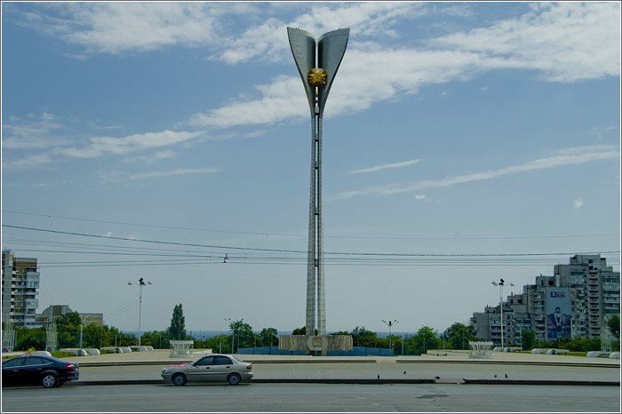

The Monument to the Motherland with the Everlasting Fire
in K. Marx’s Square in Rostov

