Unit 1 Homes and away |  |  |  | School: Zhanazhol secondary school
Date: |  |  |  | Teacher name:Kurmanova G
Class: 5 |  |  |  | Number present: |  | absent:
Lesson title |  | Homes 1
Learning objectives(s) that this lesson is contributing to (link to the Subject programme) |  | L1. Understanding sequence of supported classroom instructions S7. Use appropriate subject- specific vocabulary and syntax to talk about a limited range of general topics  UE3. Use a growing variety of adjectives and regular and irregular comparative and superlative adjectives an a limited range of familiar general and curricular topics  W3 write with support factual descriptions at text level which describe people,places and objects
Lesson objectives |  | All learners will be able to:  Name parts of yurt, understand vocabulary, describe places  Most of learners will be able to:  Understand specific vocabulary
Assessment criteria |  | Say topic words with clear pronunciation. Say expressions clearly  describe places and objects use adjectives in degrees
Language objective |  | Yurt , shanyrak uwyk a carcass
Values links |  | To keep ,to increase and to hand down traditions and friendship between people
Cross-curricular links |  | art
Previous learning |  | Review
Plan
Time | Planned activities |  |  |  |  |  |  | Resources
Start | Greetings Good morning pupils! Who is on duty today? Who is absent? Teacher divides pupils in 2 groups with cards: “ Yurts’, “ Homes”
Middle | L1 Task 1 Listen to and repeat attentively after teacher : a bedroom, a dining room, bathroom, a living room, a toilet, a study, a round-shaped , a shanyrak , a kerege ,a uwyk  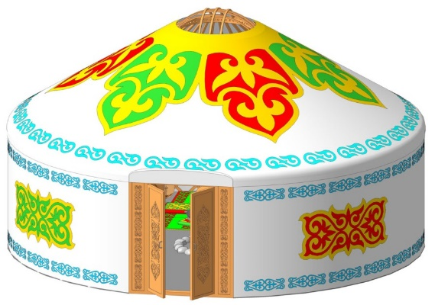  L 1 Task 2 Match the pictures with the words Yurt is a round-shaped, it consists of three main parts and many other smaller parts. Three main parts include Shanyrak – top of the Yurt, Kerege – walls carcass and Uwyk – a carcass part from Kerege to the Shanyrak. Yurt usually does not have rooms in it, and it was a common practice to have a separate  Yurt as a bedroom, separate one as a kitchen, guesthouse, etc as long as people could afford that. Task 2 Find out which of these adjectives inpositive degree, in comparative degree, in superlative degree 1 A building is bigger than yurt. 2. Yurt is smaller than a building. 3. A house is modern. 4. A living room is the most comfortable room in the house. 5.Yurt is the oldest house. Descriptor: Learners find degrees of adjectives W3 Task 4 Write things you remember from the texts Yurt, kerege ,house ,shanurak .small ,beautiful ,modern Bedroom, living-room comfortable  Descriptor: Pupils write names of rooms ,describe of house
End | Answer the question “ How can be a modern house?”  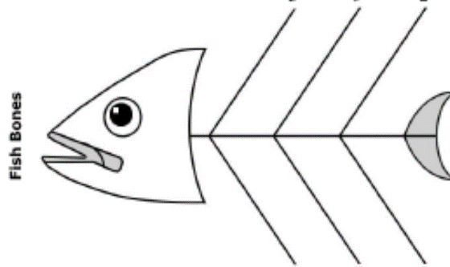
Additional information

Differentiation – how do you plan to give more support? How do you plan to challenge the more able learners? |  |  | Assessment – how are you planning to check learners’ learning? |  |  |  | Health and safety check
Differentiation can be achieved through the selection of activities, identification o learning outcomes for a certain student, provision of individual support to learners, selection of learning materials and resources based on the individual abilities of leaners (Theory of Multiple Intelligences by Gardner). |  |  | Use this section to record the techniques that you will use to assess what the learners have learned during the lesson. |  |  |  | Health saving technologies.  Using physical exercises and active activities.  Rules from the Safety Rules book which can be applied in this lesson.
Reflection  Were the lesson objectives/learning objectives realistic? Did all the learners achieve the lesson objectives/ learning objectives? If not, why? Did my planned differentiation work well? Did I stick to timings?What changes did I make from my plan and why? |  |  |  |  | Use the space below to reflect on your lesson. Answer the most relevant questions from the box on the left about your lesson.
Summary evaluation
What two things went really well (consider both teaching and learning)?
1:
2:
What two things would have improved the lesson (consider both teaching and learning)?
1:
2:
What have I learned from this lesson about the class or individuals that will inform my next lesson?

