Short term plan
Lesson:  Unit 7 Fantasy world |  |  | School: №176 school-gymnasium
Date 21.07.2017 |  |  | Teacher name: Ablemitova Zarina
Class: 5 |  |  | Number present :29 | Absent: -
Theme of the lesson |  |  | Animals
Learning objectives that this lesson is contributing to |  | 5R2 understand with little support specific information and detail in short, simple texts on a limited range of general and curricular topics. .  5W3 write with support factual descriptions at text level which describe people, places and objects.  5UE3 use a growing variety of adjectives and regular and irregular comparative and superlative adjectives on a limited range of familiar general and curricular topics  5C6 Organise and present information clearly to others
Lesson objectives |  | All learners will be able to:  - recognise the new vocabulary  - distinguish the usage of superlative and comparative adjectives  Most learners will be able to:  Write degrees of superlative and comparative adjectives  Can answer to the questions from text  Some learners will be able to:  - say some information about animals.  - can describe animals using regular and irregular adjectives
Assessment criteria |  | -can say some information about any animal  -distinguish the usage of superlative and comparative adjectives  - answer the questions
Value links |  | Take care of animals
Cross-curriculum |  | Biology
ICT skills |  | Worksheets, pictures, video
Previous learning |  | Reading for pleasure
Plan
Planned timings | Planned activities (replace the notes below with your planned activities) |  |  |  | Resourses
Beginning Lead in  3min  Revision of previous lesson 4 min  Warm-up  2 min  Middle  3 min  3min  4min  2min  9min  5min | Organization moment.  Greeting, duty’s report.  Now answer to questions from cards and make a picture from these cards (puzzle of a fish) Questions: who is the author of the this tale? What about this tale? What is the main idea of the tale?  Listen, repeat then read the poem :  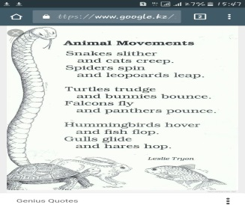  I’ll give you cards with pictures of the animals. Students with the same pictures should sit in one group. I’ll hand out cards with pictures of eagle, leopard and dolphin. What can you say about these pictures? Can you guess today’s our new theme? Our new theme is “Animals”  Grammar. Today we also use adjectives to describe animals, that why I want explain you usage of superlative and comparative adjectives of irregular and regular adjectives. Now let’s watch the video. There are examples to the degrees of adjectives. Now please make your own examples.  Keys of knowledge. I have some keys of knowledge. I’ll give them to students who answers correct, who will be active.You collect them, then at the end of the lesson who collect more keys wins the big, gold key of knowledge.  Now let’s write an exercise. You should put given adjectives in comparative or superlative forms.  Put the adjectives in the comparative or superlative forms  1. Dogs are ______ (friendly) than cats.  2 Dolphins are _____________ (intelligent) animals of all.  3. Giraffes have got ________ (long) legs than elephants.  1 Parrots are ________ (colourful) birds of all.  2. Cheetahs are ________ (fast) of all land animals.  3 Horses are _________(big) than goats.  1 Dogs make _______(good) pets of all.  2 Elephants are ________ (heavy) than goats.  3. Eagles are ______(strong) than crowns.  Vocabulary  Match the words with the pictures  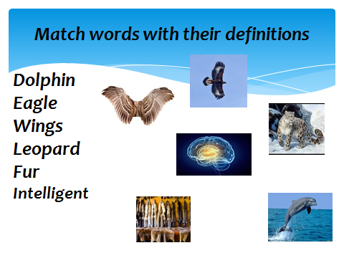  Pre reading. Find and underline the new words from the text.  While reading: Jigsaw. I’ll hand out different texts about animals to each group. You should read, understand text then should retell it to another group.  Post-reading. Now answer to the questions to win more keys. How many species of dolphins are there in the world? Where do snow leopards live? What can you say about the smallest eagle? |  |  |  | http://www.google.kz/imgres.  http://youtu.be/gzQT6TrYTVk  Excel 5  WB p52
End  8 min  Reflection  2 min | Differentiation by level. I’ll give you posters and markers you should choose an animal: Project work. Draw a picture, then describe it using vocabulary.  Descriptor: All learners:  - Can name the animal  Most of them  -can describe the animal with support (question-answer)  Some of them  -can describe the animal without support.  Assessment.  I’ll hand out you pictures of animals you should write there you feelings from today’s lesson and glue them on the poster with nature’s picture. You should glue them in correct place. What do you see in this picture?  I want to say that we should protect our nature, animals. We should take care of them. |  |  |  | Excel 5  WB p51
Summary evaluation

What two things went really well (consider both teaching and learning)?
1st:
2nd:
What two things would have improved the lesson (consider both teaching and learning)?
1st:
2nd:
What have I learned from this lesson about the class or individuals that will inform my next lesson?

