Эссе по дисциплине «Английский язык»
на тему «Sport in the Republic of Mordovia»

Выполнила: студентка 4 курса Козлова Светлана Николаевна
специальность 35.02.07 «Экономика и бухгалтерский учет»

2019г
It is well-known fact that the Republic of Mordovia proved the whole world that even a small Russian region can become an important factor in the world’s Olympic movement. Our sportsmen won many medals on the Olympic Games and World Champions. And Mordovia left far behind most states of the world in terms of medals.
Track records of the Republic of Mordovia are the results of hard and purposeful work. The main objective of the Government and the Head of the Republic of Mordovia, is health promotion. One of the most important instruments in solving this problem is the development of mass physical culture and sports of high results. Furthermore, one should not forget that many unique sports buildings have been built and are being built in Mordovia. Champions and prizewinners of International Competitions practice there. In all the districts of the Republic sports centres open to the public with athletic halls, swimming pools and skating rinks are being built. Every citizen of Mordovia, whether he lives in Saransk or in a remote village, has an opportunity to go in for sport.
The Olympic Games winners are the main pride of Mordovia. They are race walkers, wrestlers, boxers, athletes, biathletes, and tennis players. They bring glory not only to their native Mordovia, but the whole Russia, making the amount of medals bigger. Their victories are the evidence of the fact that Mordovia is rightfully considered to be the Sports Republic.
Mordovia has been proving the whole world that it is one of the most developed sports regions. Sportsmen from Mordovia took all the three out of three highest awards. Olga Kaniskina, Valery Borchin and Sergey Kirdaypkin denied the theory that all the gold medals on race walking couldn’t be won by one country. Journalists called this phenomenal success of Mordovian race walkers “The Second Brandenburg Gates Capture”.
Viktor Chegin is the head coach of the Centre of the Olympic training of Mordovia. The Race Walking Centre of the Olympic Training was named after him. . Thanks to Victor Chegin’s diligence the Republic got the results the whole world is talking about.
Many famous athletes and coaches are natives of the Republic or representatives of the Mordovian ethnicity: Alexander Ovechkin, Svetlana Khorkina, Alexei Nemov, Yuri Borzakovsky, Gyuzel Manyurova, Aklexey Mishin, Oleg Maskaev, Irina Starkina and many others (card1). The Mordovian sportsmen’ glorious victory made them, as well as our republic, famous all over the world.
Health is the most precious treasure a man has and it should be preserved. What about me, twice a week after classes I go to basketball. I am convinced that …a sound mind in a sound body.

Приложение 1
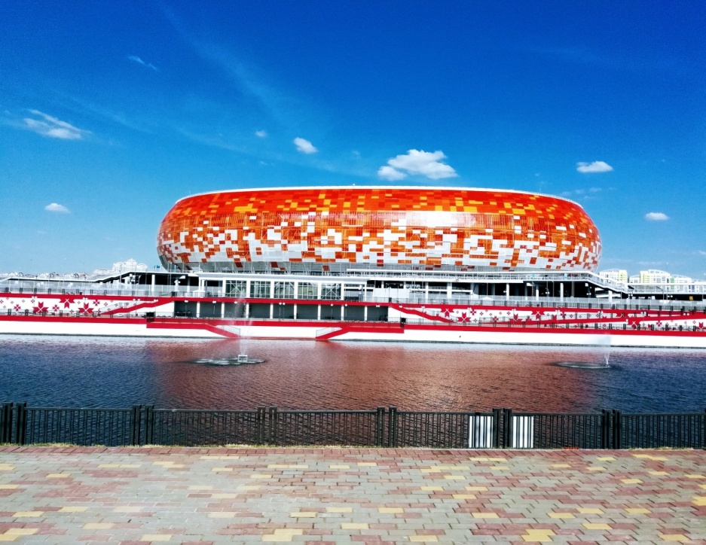
Mordovia Arena
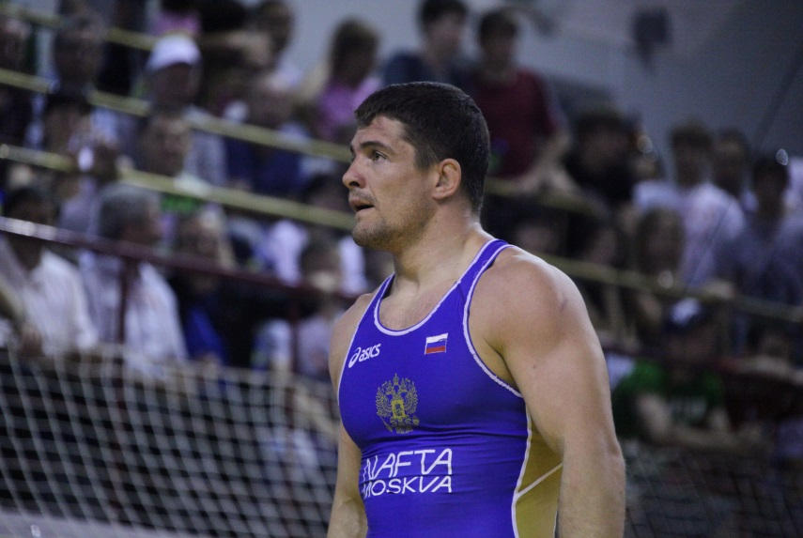
Alexey Mishin
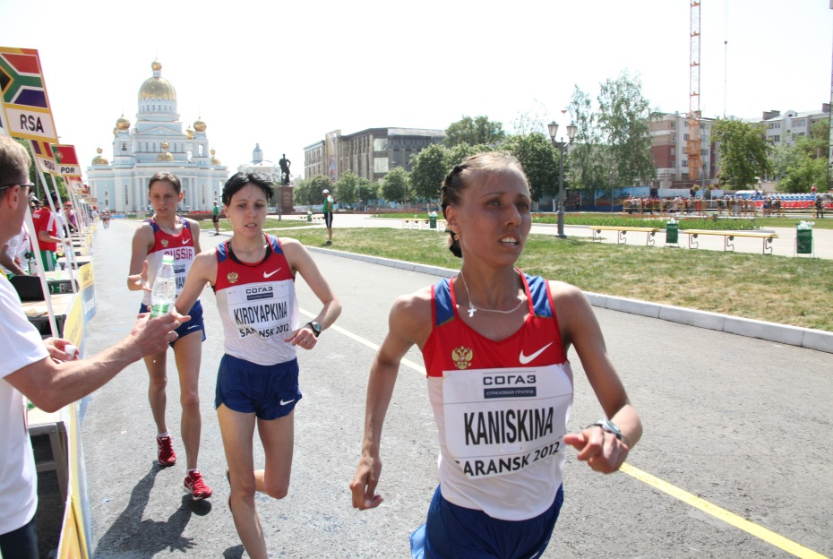
The 2012 World Race Walking Cup in Saransk.
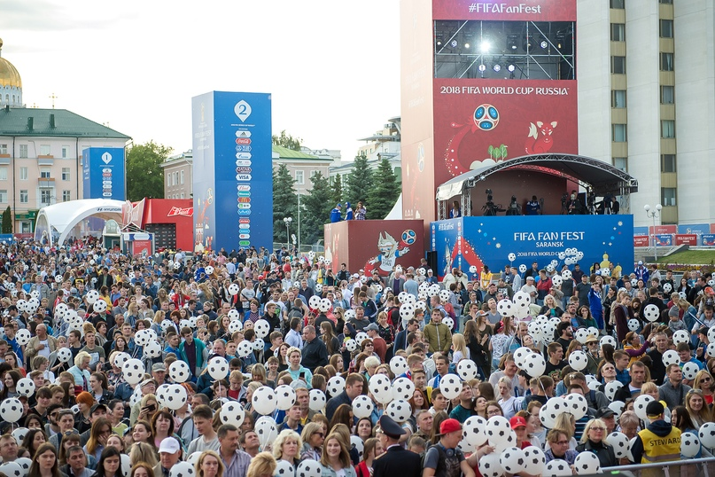
FIFA FAN FEST
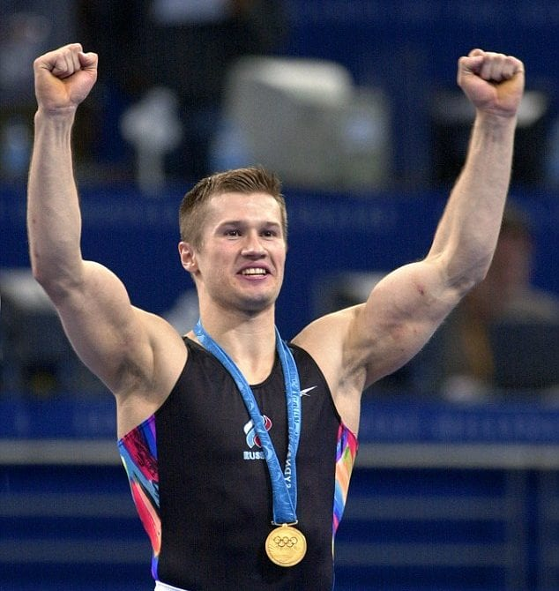
Alexei Nemov
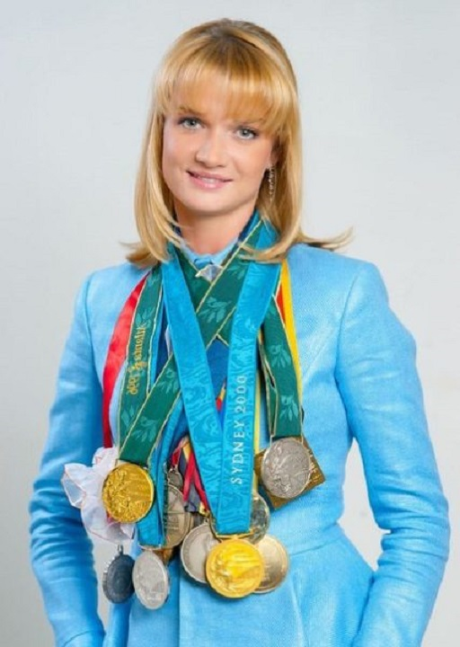
Svetlana Khorkina
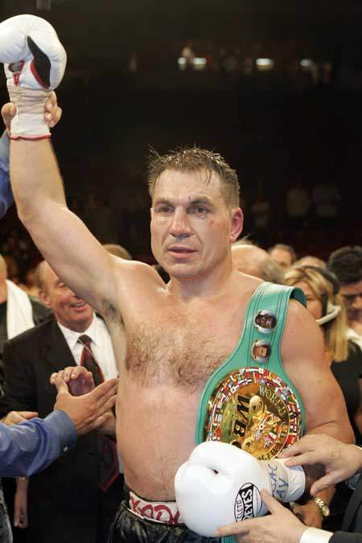
Oleg Maskaev

