**1**.

NUMBERS- WORDSEARCH

**FIND THE HIDDEN NUMBERS.**

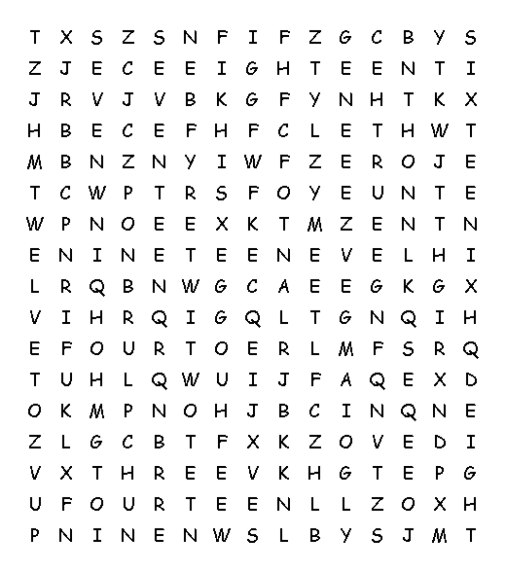

**zero one two three four five six seven eight nine ten eleven**

**twelve thirteen fourteen fifteen sixteen seventeen nineteen**

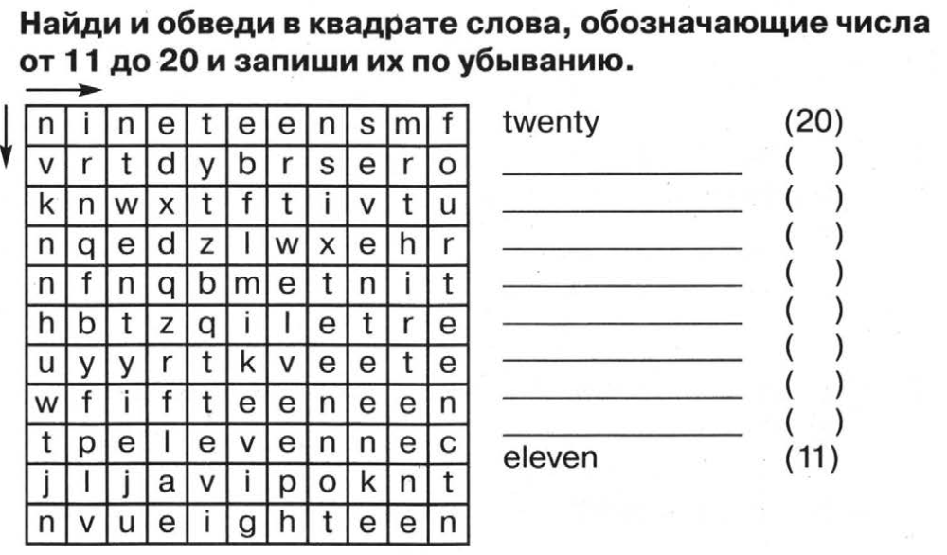

**2.**

1.

KEY

