Name:

Tasks | 1st-task | 2nd-task | 3rd-task | 4th-task
 | Work in pairs | Listen and draw lines | Read the text | Group work
Points: | 2 points | 4 points | 6 points | 2 points
Total point:

Name:

Tasks | 1st-task | 2nd-task | 3rd-task | 4th-task
 | Work in pairs | Listen and draw lines | Read the text | Group work
Points: | 2 points | 4 points | 6 points | 2 points
Total point:

Name:

Tasks | 1st-task | 2nd-task | 3rd-task | 4th-task
 | Work in pairs | Listen and draw lines | Read the text | Group work
Points: | 2 points | 4 points | 6 points | 2 points
Total point:

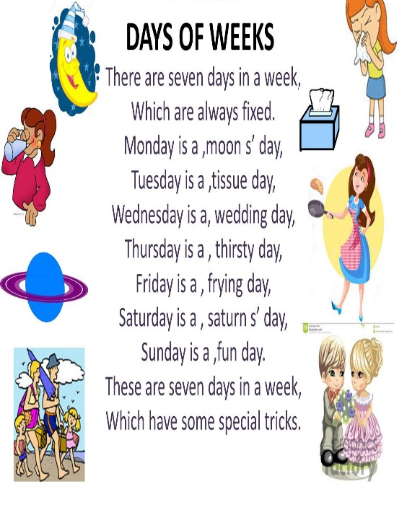

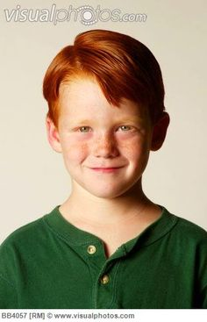

Today

Yesterday

Tomorrow

True or False
- Mike is ten years old. + -
- He can ride a bike. + -
- Mike plays computer games on Thursday. + -
- He draws pictures on Wednesday. + -
- He plays football with his sister. + -
- He swims on Tuesday. + -

Sunday
Monday
Tuesday
Wednesday
Thursday
Friday
Saturday
Danced with friends
Watched TV
Went to school
Played tennis
Visited his grandma
Did homework
Took photos

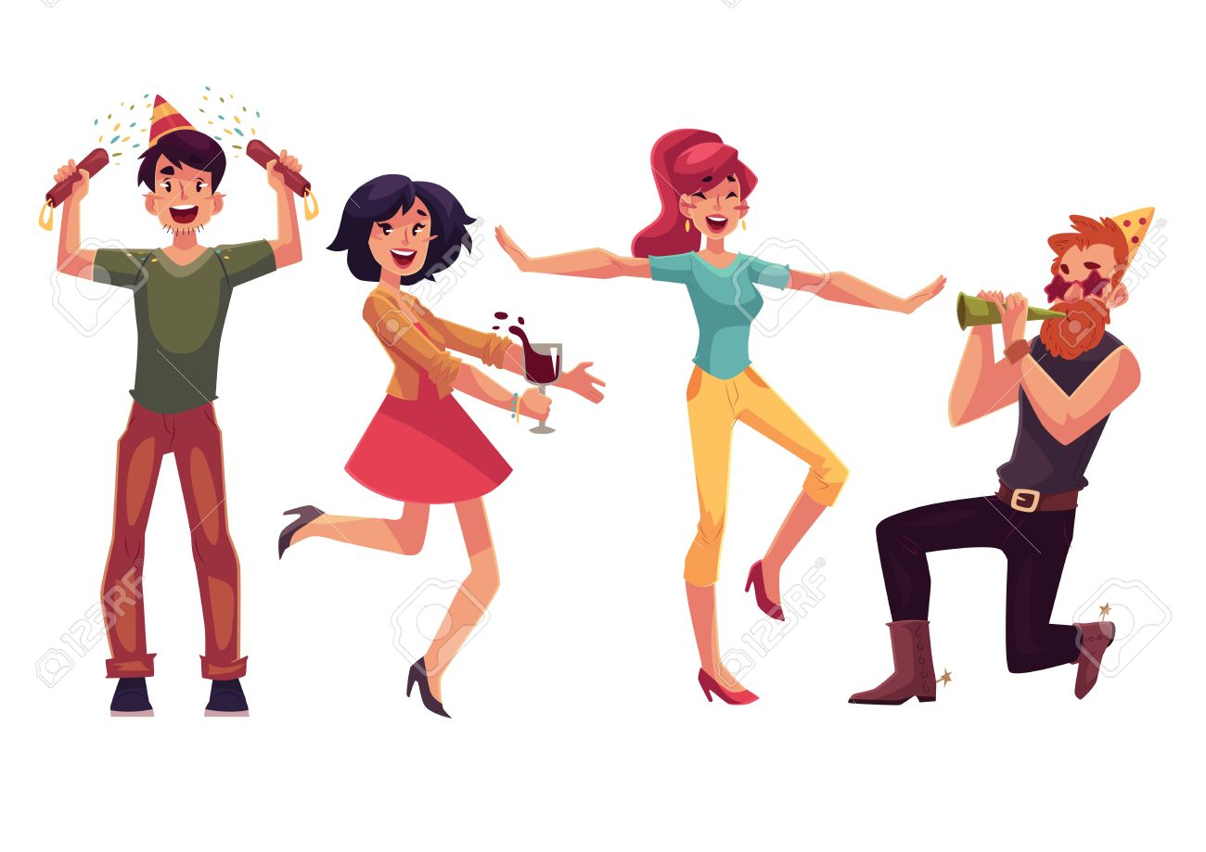
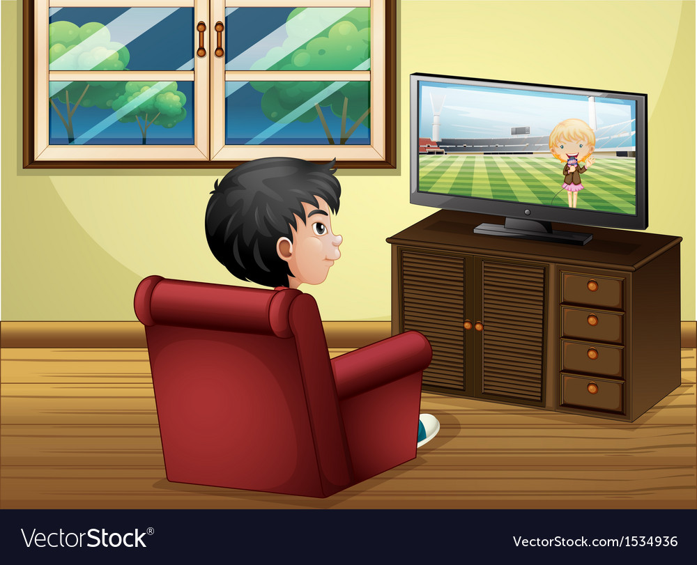
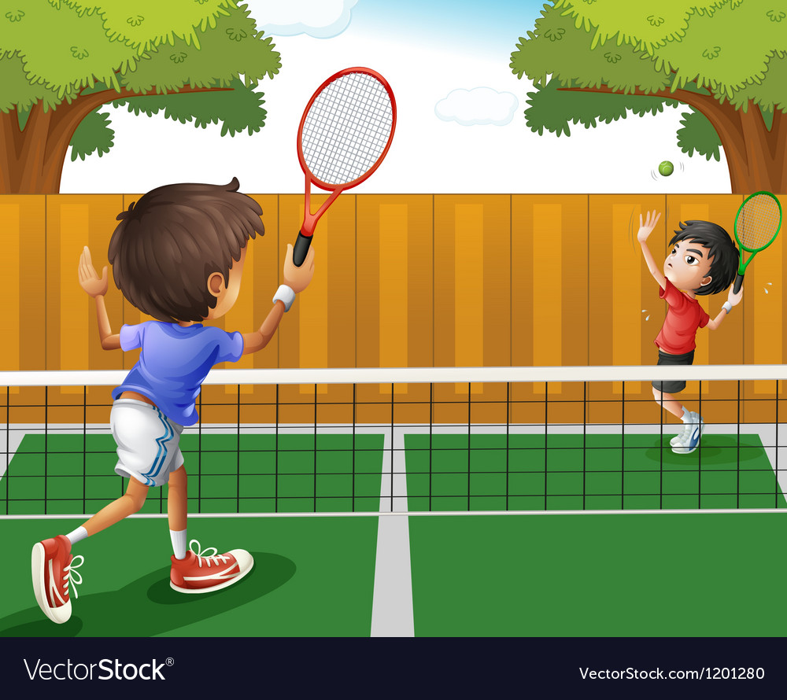
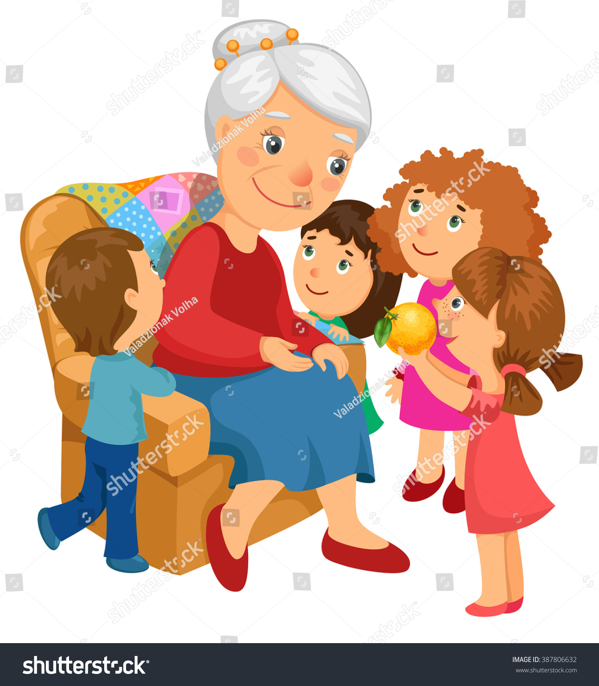

A: Did you 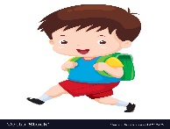 yesterday?
B: Yes I did. \ No, I didn’t.
B: Did you yesterday?
A: Yes I did. \ No, I didn’t.

A: Did you 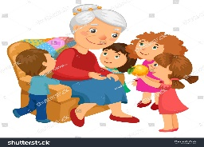 yesterday?
B: Yes I did. \ No, I didn’t.
B: Did you 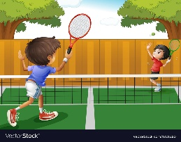 yesterday?
A: Yes I did. \ No, I didn’t.

A: Did you yesterday?
B: Yes I did. \ No, I didn’t.
B: Did you 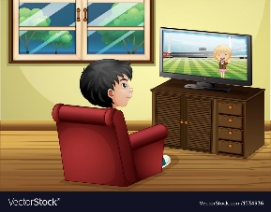 yesterday?
A: Yes I did. \ No, I didn’t.

A: Did you yesterday?
B: Yes I did. \ No, I didn’t.
B: Did you yesterday?
A: Yes I did. \ No, I didn’t.

A: Did you yesterday?
B: Yes I did. \ No, I didn’t.
B: Did you yesterday?
A: Yes I did. \ No, I didn’t.

A: Did you yesterday?
B: Yes I did. \ No, I didn’t.
B: Did you yesterday?
A: Yes I did. \ No, I didn’t.

A: Did you yesterday?
B: Yes I did. \ No, I didn’t.
B: Did you yesterday?
A: Yes I did. \ No, I didn’t.

A: Did you yesterday?
B: Yes I did. \ No, I didn’t.
B: Did you yesterday?
A: Yes I did. \ No, I didn’t.

A: Did you yesterday?
B: Yes I did. \ No, I didn’t.
B: Did you yesterday?
A: Yes I did. \ No, I didn’t.

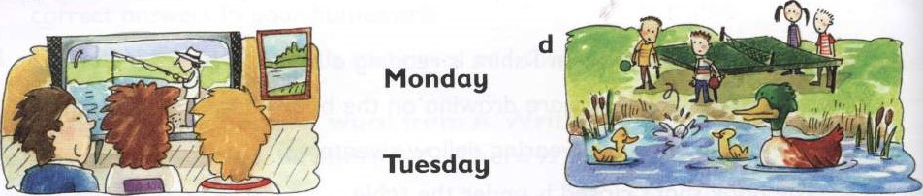
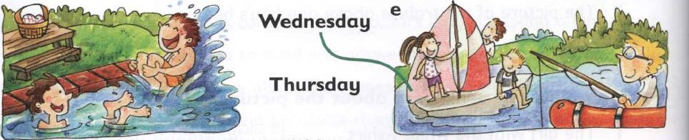
Friday
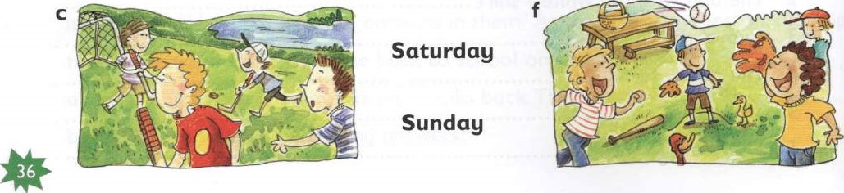

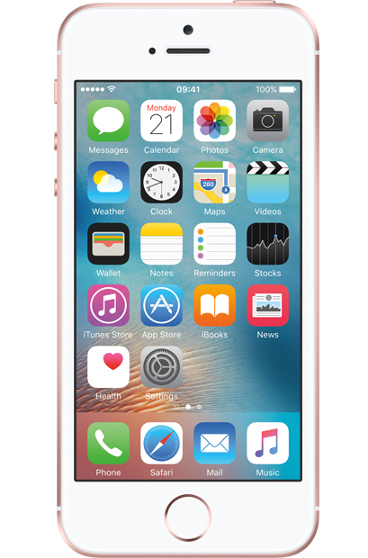

Sunday

Monday

Tuesday

Wednesday

Thursday

Friday

Saturday

