Grade: 6 Date:
The theme of the lesson: A slice of life
The aims and objectives of the lesson:
a) educational to introduce knowledge about present simple ,to teach students talk about their daily life , doing exercises , to enlarge their interest in learning foreign languages .
b) developing to develop pupils habits in translating, to develop communication skills and abilities, to teach them to poly languages.
c) cultural to bring up pupils to love and to respect their native and foreign languages, to teach them to respect each other and to educate them to be a honesty.
The type of the lesson: new lesson
The kind of the lesson: practical
The methods of the lesson: question-answer.
Visual aids of the lesson: workbook , CD disk , student’s book and grammar tables.
The procedure of the lesson:
І. Organization moment
- Hello, boys and girls.
-I’m glad to see you.
-Sit down, please.
- How are you?
- Who is absent today ?
- -What date is it today?
- What day is it today ?
II.Check up hometask
What was your hometask?
Who wants read ?
III. Main part
Ex 1 p8
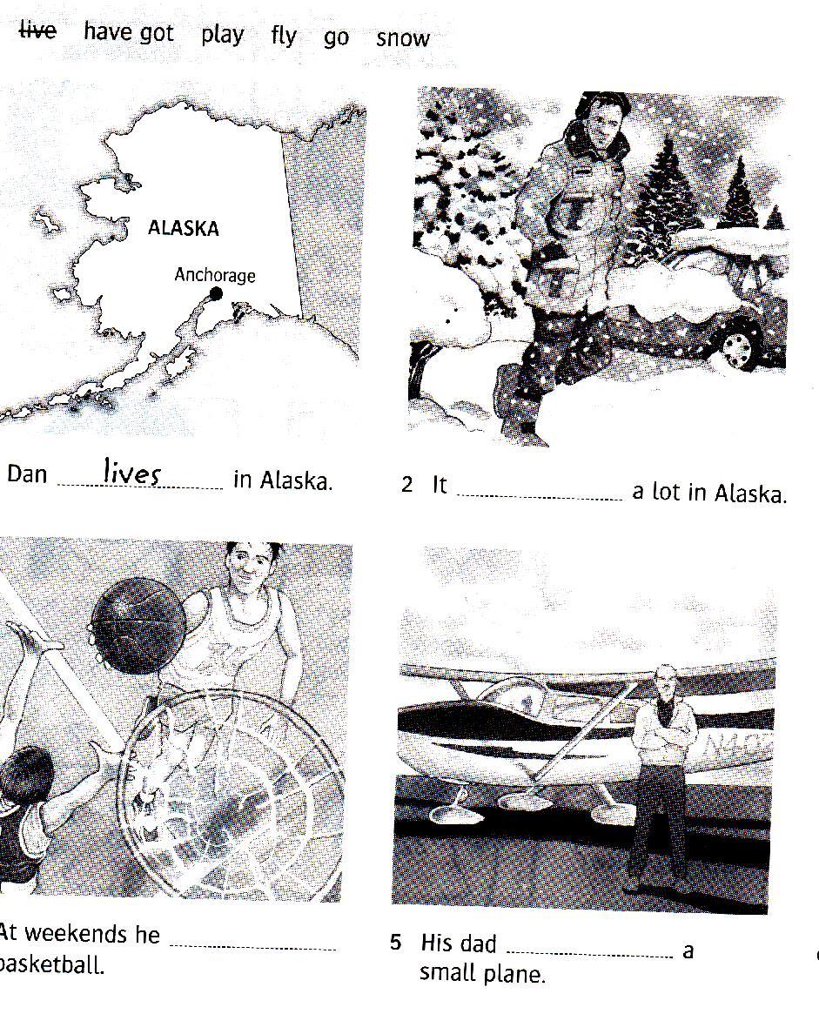

Ex 2p 8
1.doesn’t enjoy
2.doesn’t like
3.doesn’t snow
4.don’t go
5.don’t care
6.doesn’t go

Ex 3 p 9

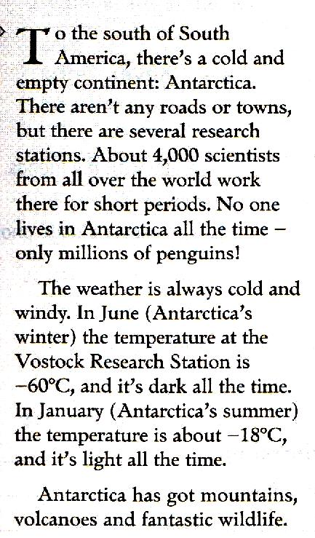

Ex 4 p9
1 .Does- Yes he does.
2.does –No he doesn’t.
3. does- No she doesn’t.
4.does- yes she does
5.do- yes they do

IV. Evaluation
Give marks.
Open your diary and write down your home task : Ex 5 p 9
V. The end of the lesson
The lesson is over
Good-bye pupils

