План-конспект мероприятия по английскому языку
«In the city»
Цель урока: созд.условий для совершенствования языковой компетенции уч-ся
Задачи:
Образовательная: созд.условий для совершенствования устной речи учящихся. Развивающая:созд.условий для развития способности осуществлять репродуктивные и продуктивные речевые действия
Воспитательная:воспит.интерес к изучению иностранного языка
Тип урока: урок повторения и обобщения изученного материала
Ход урока

Организационный эпат:
Today we have an unusual lesson, we have a game lesson, today we will have a competition!
You need to complete all the tasks, find the treasure on the map and a sweet prize awaits the winner!
For each completed task you will receive a word, at the end of the game you will make a sentence from these words and find a treasure
And first you need to split into 2 teams, then each team should come up with a name for itself
Ход мероприятия:
- Let's get started and first repeat our active vocabulary , your first task is to match the words with their transcriptions
[ˈlaɪbrərɪ] seat belt
[ʧɜːʧ] bright
[brɪʤ] church
[siːt belt] library
- Very well, both teams coped with this task and we continue, now we will remember all the prepositions that we learned
in the second task, you should insert the prepositions into the sentences
- There is a tunnel ___the mountain
- A car is going ___of the tunnel
- There is a bright___the river
- There is a church in front___ the bank

- You are right and now look at the blackboard you can see pictures, please connect the safety rules with the picture, using our modal verb MUST/MUSTN`T
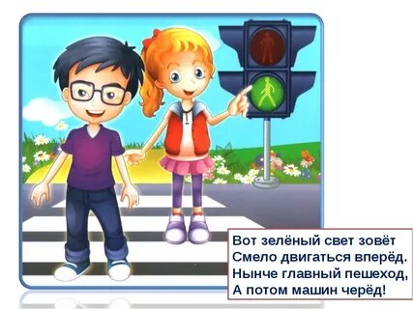We must to cross the street only when the traffic light is green
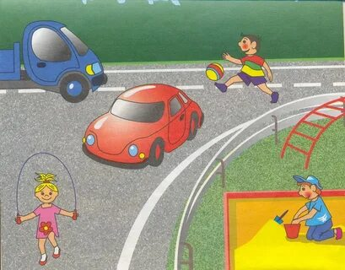We must not to play on the road
- Well done, you know all the safety rules and now we will check how you navigate on the map and know how to make a route
Please, use the map and to make a route
(from library to supermarket ,from supermarket to library)

- Good, you were able to make a rout, but can you be ask the way, let’s check …
Using these phrases you need to make a dialog
(Excuse me,how can I get to…?
Go straight ahead……

- And now a crossword is waiting for you!Please, look at the pictures and guess the word, be very attentive
- You coped with all our challenges and now you can make a sentence from the words that you have collected And using the map on the blackboard you will find a treasure, hurry up!
Заключительный этам:
Congratulations, you did it, you found a treasure! This is your prize
Do you like our game?What task do you like more? What other task would you like to complete?
Thank you for playing, goodbye

