Question tags таблица.
Основная часть | Краткий вопрос | Примеры
am | Aren’t I | I am ten, aren’t I?
am not | am | I am not tall, am I?
is | isn’t | Greg is here, isn’t he?
are | aren’t | Kids are at home, aren’t they?
is not /isn’t | is | Greg isn’t here, is he?
are not/aren’t | are | Kids aren’t at home, are they?
was | wasn’t | Greg was here, wasn’t he?
were | weren’t | Kids were at home, weren’t they?
was not /wasn’t | was | Greg wasn’t here, was he?
were not /weren’t | were | Kids weren’t at home, were they?
have | haven’t | I have played chess, haven’t I?
has | hasn’t | Paul has played chess, hasn’t he?
have not /haven’t | have | I haven’t played chess, have I?
has not /hasn’t | has | Paul hasn’t played chess, has he?
had | hadn’t | I had played chess, hadn’t I?
hadn’t | had | Paul hadn’t played chess, had he?
will | won’t | Molly will phone us, won’t she?
won’t | will | Greg won’t phone us, will he?
would | wouldn’t | It would be possible, wouldn’t it?
would not /wouldn’t | would | He wouldn’t come, would he?
can | can’t | Molly can swim, can’t she?
can not /can’t | can | You cannot do this, can you?
could | couldn’t | Molly could swim, couldn’t she?
could nоt / couldn’t | could | You couldn’t do that, could you?
may | mayn’t | I may be free, mayn’t I?
may not / mayn’t | may | I mayn’t write here, may I?
might | mightn’t | It might be true, mightn’t it?
might not /mightn’t | might | It mightn’t be so late, might it?
must | mustn’t | You must keep calm, mustn’t you?
mustn’t | must | You mustn’t panic, must you?
should | shouldn’t | You should eat less, shouldn’t you?
should not /shouldn’t | should | You shouldn’t eat cakes, should you?
does not / doesn't | does | Greg doesn't like Jim, does he?
do not / don't | do | We do not like Greg, do we?
did not / didn't | did | Molly didn't come, did she?
like | don’t | You like watching TV, don’t you?
likes | does | She likes playing piano, doesn’t she?
played | did | They played football, didn’t they?

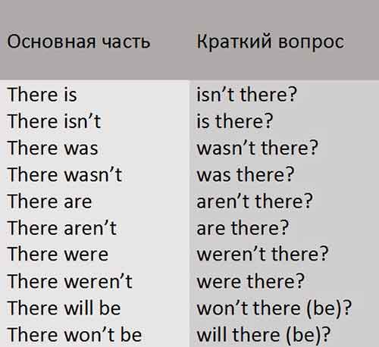
Таблица разделительных вопросов с оборотом there is.

