Сценарий к празднику «День Победы» + презентация
План:
- Ведущий с речью
- Начало войны «Священная война»
- Стихотворение «Их расстреляли на рассвете»
- «Здесь птицы не поют»
- Наум Коржавин «Дети в Освенциме»
- Стихотворение «Жди меня и я вернусь»
- «Катюша»
- Стихотворение «Что такое война?»
- «День победы»
Слайд 1:
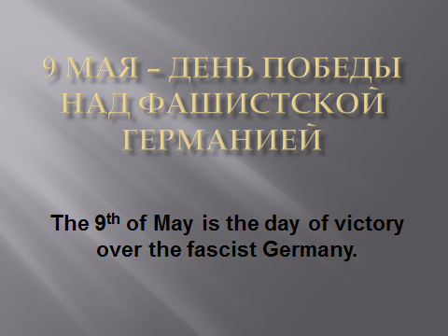
Слайд 2:
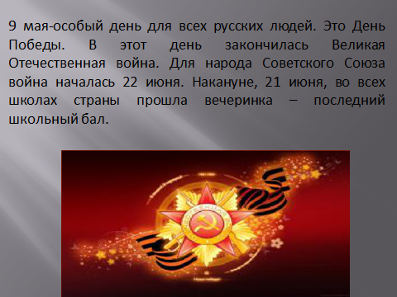
The 9th of May is a special day for all Russian people. This is the Day of Victory. This is the day when the Great Patriotic War finished. For the Soviet Union People the war started on the 22nd of June. A day before, on the 21st of June, in all schools of the country there was a party – the last school ball.

Слайд 3:
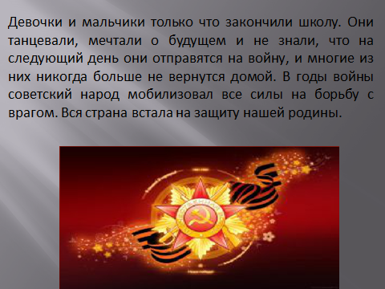
Girls and boys had just finished school. (вальс, гул самолетов)
They were dancing, dreaming of the future and did not know that the following day they would go to war and many of them never come home again.
During the war the Soviet people mobilized all the forces for the struggle against the enemy. The whole country got up defending our motherland.
(9 мая-особый день для всех русских людей. Это День Победы. В этот день закончилась Великая Отечественная война. Для народа Советского Союза война началась 22 июня. Накануне, 21 июня, во всех школах страны прошла вечеринка – последний школьный бал. Девочки и мальчики только что закончили школу. Они танцевали, мечтали о будущем и не знали, что на следующий день они отправятся на войну, и многие из них никогда больше не вернутся домой. В годы войны советский народ мобилизовал все силы на борьбу с врагом. Вся страна встала на защиту нашей родины.)
Слайд 4:
Песня «Священная Война» (гимн защитников отечества)

The Sacred War
Get up gigantic country
Get up to mortal war
Against the dark fascistic force
Against the damned horde
Refrain:
Get up and let the noble rage
Strong boil like a wave
A Sacred War is going on
It’s time to fight and pray

We'll fight against the enemies
Of our great plans
The rapists and the torturers
And the black fascist gangs

Get up and let the noble rage
Strong boil like a wave
A Sacred War is going on
It’s time to fight and pray

We'll make the fascist rotten scums
Get bullet to the head
All spawns of the humanity
We'll put into the grave

Don't let the black and evil wings
Fly over Motherland
On our beautiful wide fields
We don't allow to stand

We'll fight with them by all our strength
All force, all souls, all minds
We will defend our native land
Which we love by our hearts

Get up and let the noble rage
Strong boil like a wave
A Sacred War is going on
It’s time to fight and pray

Get up gigantic country
Get up to mortal war
Against the dark fascistic force
Against the damned horde

Get up and let the noble rage
Strong boil like a wave
A Sacred War is going on
It’s time to fight and pray
Слайд 5:
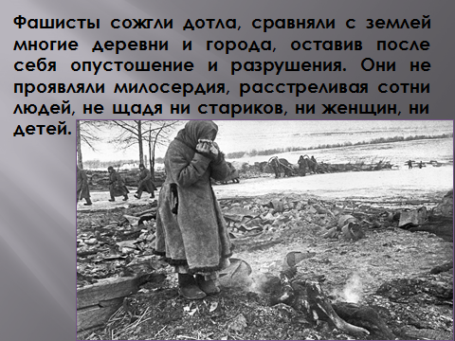
Ведущий:
The fascists burned to the ground, leveled many villages and towns leaving devastation and destruction behind. They showed no mercy, shooting hundreds of people, sparing neither the elderly, nor women, nor children.
Слайд 6:
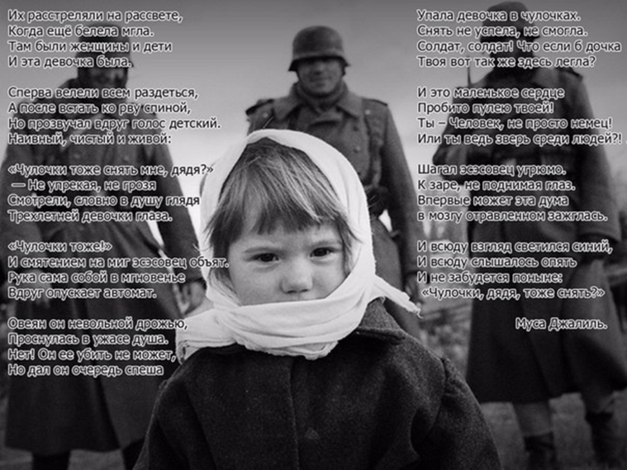

“They were shot at an early dawn” Mussa Jallil  They were shot at an early dawn,  When the mist was still white.  There women were and children were  And was that little child.  First they were ordered to undress  And stand with backs to moat,  But suddenly a girl's voice rang  Naive, alive and loud:  Should I take off my stockings, too?  Without judging or decries,  They looked into the soldier’s soul.  A three-year-old girl’s eyes.  "The stockings too" - and with confusion  For little moment embraced the SS-man  The hand by it-self with a slow motion  Abruptly lowered the fatal machine gun.  He suddenly is bound by the blue gaze,  It seems he’s rooted deep into the ground,  The same glance as my little daughter has? –  In strong confusion said and looked around.  For him it is impossible to kill,  To kill this child who looks at him without fear  But he gave in a hurry rapid fire.  He trembled unwittingly, and soul awoke in terror.  The girl in stockings fell not taking off them  She had no time to do it, she could not.  Oh Soldier, what if your little child  Lay down here on the ground that so cold…  You see, that guiltless little heart  Is pierced by you, her life is gone forever  But who are you, just wicked German  Or only a spiteful beast although clever…  The SS man was walking sullenly and grimly,  Without raising eyes from cooling ground,  And maybe for the first time this relieving thought  Lit up the brain which poisoned all throughout.  And everywhere he could hear that little voice,  And everywhere he could see that blue gaze  “Should I take off my stockings too?”  It won’t be forgotten to these days. | «Их расстреляли на рассвете» Муса Джалиль  Их расстреляли на рассвете,  Когда еще белела мгла.  Там были женщины и дети,  И эта девочка была.  Сперва велели им раздеться,  И встать затем ко рву спиной,  Но прозвучал вдруг голос детский  Наивный, чистый и живой:  Чулочки тоже снять мне, дядя?  Не осуждая, не браня,  Смотрели прямо в душу глядя  Трехлетней девочки глаза.  «Чулочки тоже» — и смятеньем  на миг эсэсовец объят  Рука сама собой с волненьем  вдруг опускает автомат.  Он словно скован взглядом синим,  И, кажется, он в землю врос,  Глаза, как у моей дочурки? —  в смятенье сильном произнес.  Охвачен он невольно дрожью,  Проснулась в ужасе душа.  Нет, он убить ее не может,  Но дал он очередь спеша.  Упала девочка в чулочках…  Снять не успела, не смогла.  Солдат, солдат, что если б дочка  Вот здесь, вот так твоя легла…  Ведь это маленькое сердце  Пробито пулею твоей…  Ты Человек, не просто немец,  Или ты зверь среди людей…  Шагал эсэсовец угрюмо,  С земли не поднимая глаз,  впервые может эта дума  В мозгу отравленном зажглась.  И всюду взгляд струится синий,  И всюду слышится опять,  И не забудется поныне:  Чулочки, дядя, тоже снять?»

Слайд 7:
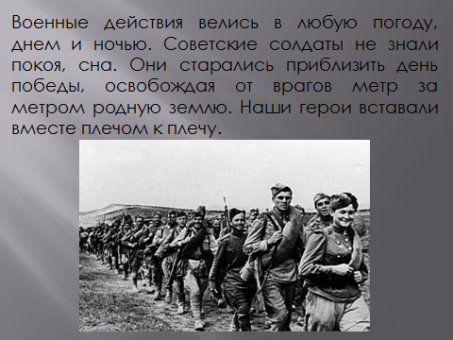
Ведущий:
Military operations were conducted in any weather, day or night. The Soviet soldiers did not have any rest or sleep. They tried to bring the victory day closer, freeing our scorched and destroyed native land from the enemies meter by meter. Our heroes stood up together shoulder to shoulder.
Слайд 8:
Песня «Здесь птицы не поют»
Here birds don’t ever sing,
Here trees are scarce in spring
And we alone grow into earth,
Shoulder to shoulder linked.
The planet spins and smolders, heated,
Through smoke, we watch our country burn.
This means at last one victory is needed,
Just one for all of us.
The price is no concern!
We are with fire awaited
But it’s in vain at any rate.
Cast doubt aside,
Into the night
Departing
Is Paratrooper’s
Tenth and separate
Brigade.
As soon as battle fades down
New order will resound
The postman will go mad,
As we cannot be found.
Up overhead red rocket’s speeding,
Machineguns’ fire won’t adjourn.
This means at last one victory is needed,
Just one for all of us.
The price is no concern!
From Kursk down to Orel
The war spins in a whirl
And to the gates of enemies
My brother, we are hurled…
We will look back when we’ve succeeded
With disbelief at every turn,
But here, today, one victory is needed,
Just one for all of us.
The price is no concern!

Слайд 9:
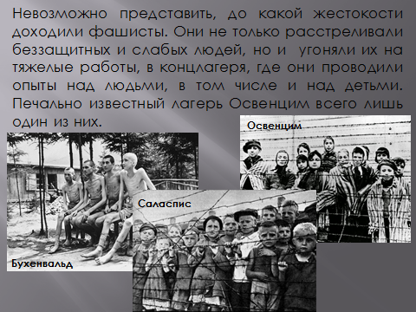
Ведущий:
It is impossible to imagine the cruelty the fascists committed. They not only shot defenseless and weak people, but also drove them to hard work, to concentration and death camps, where they conducted experiments on people, including children. The infamous Auschwitz camp is just one of them.
Слайд 10-11:
Наум Коржавин «Дети в Освенциме»
'Children in Auschwitz', Naum Korzhavin  The adults tortured little kids.  They did it shrewdly, with intention.  They tortured youngest generation  Doing routine duty, making bids.  And it was every day, off hand,  With curses, swearing, they daunted ...  The children couldn’t understand  Whatever, actually, they wanted.  Why were all those insulting words,  Starvation, beatings, and dogs’ growl?  The children thought at first it was  For disobedience and howl.  They couldn’t fancy what was plain  To any one in this connection:  The ancient logic will explain:  From adults children seek protection.  The days went by, as dark as death,  The kids were well behaved and clever.  But they were  beaten  nevertheless  Their guilt was not relieved as ever.  They grabbed for people standing by.  They loved, beseeched and asked for favour  But men had some “ideas”, however,  They tortured kids despite the cry.  I breathe, love people. Have all one needs.  But sometimes I do not feel happy,  As I recall: it's true! It happened!  The men did torture little kids! | Наум Коржавин, 'Дети в Освенциме'  Мужчины мучили детей.  Умно. Намеренно. Умело.  Творили будничное дело,  Трудились — мучили детей.  И это каждый день опять:  Кляня, ругаясь без причины...  А детям было не понять,  Чего хотят от них мужчины.  За что — обидные слова,  Побои, голод, псов рычанье?  И дети думали сперва,  Что это за непослушанье.  Они представить не могли  Того, что было всем открыто:  По древней логике земли,  От взрослых дети ждут защиты.  А дни всё шли, как смерть страшны,  И дети стали образцовы.  Но их всё били.  Так же.  Снова.  И не снимали с них вины.  Они хватались за людей.  Они молили. И любили.  Но у мужчин "идеи" были,  Мужчины мучили детей.  Я жив. Дышу. Люблю людей.  Но жизнь бывает мне постыла,  Как только вспомню: это — было!  Мужчины мучили детей!

Слайд 12-13:
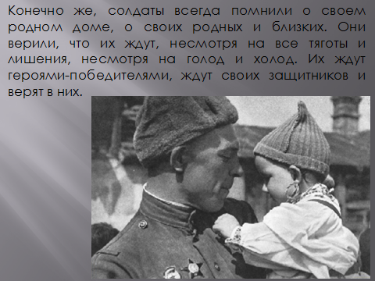
Ведущий:
Of course, the soldiers always remembered their native home, their relatives and friends. They believed that they were waited by them, despite all the hardships, despite the hunger and cold. They were expected to be victorious heroes. Their relatives waited for their defenders and believed in them.
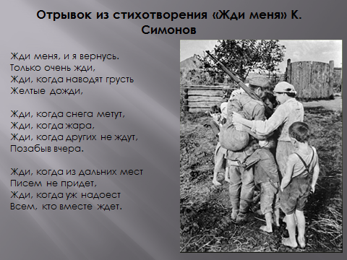
Отрывок из стихотворения «Жди меня» К. Симонов
Wait for Me.  Wait for me, and I'll come back!  Wait with all you've got!  Wait, when dreary yellow rains  Tell you, you should not.  Wait when snow is falling fast,  Wait when summer's hot,  Wait when yesterdays are past,  Others are forgot.  Wait, when from that far-off place,  Letters don't arrive.  Wait, when those with whom you wait  Doubt if I'm alive. | Жди меня.  Жди меня, и я вернусь.  Только очень жди,  Жди, когда наводят грусть  Желтые дожди,  Жди, когда снега метут,  Жди, когда жара,  Жди, когда других не ждут,  Позабыв вчера.  Жди, когда из дальних мест  Писем не придет,  Жди, когда уж надоест  Всем, кто вместе ждет.
Слайд 14:
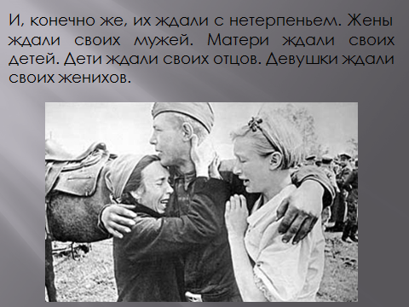
Ведущий:
And of course they were eagerly awaited. The wives were waiting for their husbands. Mothers were waiting for their children. The children were waiting for their fathers. The girls were waiting for their b.
Слайд 15:
Песня «Катюша»
Apple trees and pear trees in flower,
River mist was rising all around.
Young Katusha went strolling by the hour
On the steep banks,
O'er the rocky ground.

By the river's bank she sang a love song
Of her hero in a distant land.
Of the one she'd dearly loved for so long,
Holding tight his letters in her hand.

Oh, my song, song of a maiden's true love,
To my dear one travel with the sun.
To the one who Katusha loves so,
Bring my greetings to him, one by one.

Let him know that I am true and faithful,
Let him hear the love song that I send.
Tell him as he defends our home that grateful,
True Katusha will our love defend.

Слайд 16:
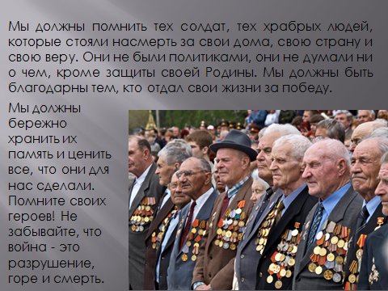
Ведущий:
We must remember those soldiers, those brave people who stood up till death for their homes, their country and their believes. They were not politicians, they were not thinking about anything except protecting their Motherland. We must be grateful to those who gave their lives for the victory. We must keep their memory carefully and appreciate everything they did for us. Remember your heroes! Do not forget that war is destruction, grief and death.
Слайд 17:
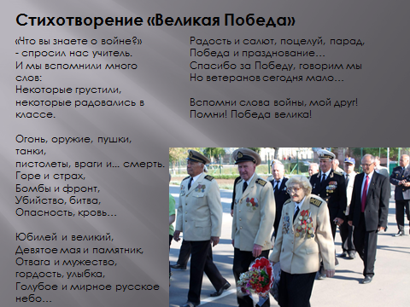
Стихотворение «Великая Победа»
The Victory is Great!

What d’you know about war?
The teacher asked us.
And we remembered many words:
Some sad, some glad in class.

Fire, weapon, cannons, tanks,
Pistols, enemies and… death.
Grief and fear,
Bombs and front,
Murder, battle,
Danger, blood…

Anniversary and great,
Ninth of May and monument,
Brave and courage, proud, smile,
Blue and peaceful Russian sky…

Joy and salute, kiss, parade,
Victory and celebrate…
Thanks for the Victory, we say
But veterans are few today…

Remember words of war, my friend!
Remember! Victory is great!
Слайд 18:
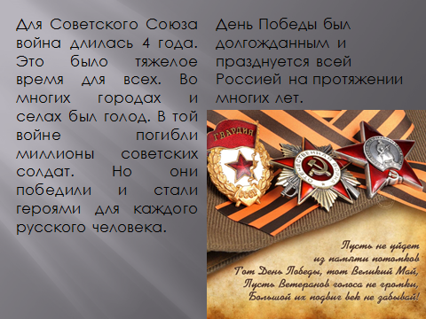
Ведущий:
For the Soviet Union the war lasted for 4 years. It was a hard time for everyone. In many cities and villages there was starvation. Millions of Soviet Soldiers died in that war. But they won and became heroes to every Russian person. Victory Day was long-awaited and has been celebrated throughout Russia for many years.
Слайд 19:
Песня «День Победы»
The Day of Victory, like an ember in the fire,
Seemed so distant, but remained our hearts' desire.
Miles behind us, scorched and battered there we stood,
Bringing victory as closer as we could

That's our Day of Victory
Ringing through the skies
Proud and joyful
We have bought it for a price
There is gladness
But with sadness in our eyes.
The Day of Victory!
The Day of Victory!
The Day of Victory!

Plants and factories kept on working day and night
On the home front we've put up a valiant fight
Without respite toiling for the common good
Bringing victory as closer as we could

Come now, mother. I have made it back to you...
Feel like running barefoot in the morning dew.
Miles behind us, we've lost many souls for good
Bringing victory as closer as we could
