Exit Test
1. Match the words with their meanings.
- beach holiday  - activity holiday  - fishing  - cruise  - jet skiing | - круиз  - пляжный отдых  - катание на водных лыжах  - активный отдых  - рыбная ловля
2. Fill in with can or can’t.
1) ____ we listen to some music?
2) You _____ swim here, the beach is closed.
3) I’m sorry, but you _____ take photographs in here.
4) It’s a nice café! We _____ have lunch here!
5) Excuse me, you _____ eat or drink in the classroom.
3. Circle the correct answer.
1) I want to buy a pair of shoes, I go to the ______.

a) clothes shop
b) shoe shop
c) café

2) I am making a cake and want to buy eggs, I go to the ______.

a)chemist’s
b)baker’s
c) supermarket

3) You can buy a new CD at the ______.

a) record shop
b) newsagent’s
c) greengrocer’s

4) You can buy a new jacket at the _____.

a) jeweler’s
b) fast food restaurant
c) clothes shop

5) I’m hungry! Let’s go to the ______ and have lunch there!

a) restaurant
b) chemist’s
c) bookshop

6) We went to the _____ yesterday, hamburgers were very delicious there.

a) supermarket
b) fast food restaurant
c) clothes shop

7) I will go to the ______ and buy new earrings tomorrow.

a) jeweler’s
b) bookshop
c) newsagent’s

8) I like to go to the seaside because I like _______ very much.

a) swimming
b) hiking
c) sleeping

9) Let’s go ______, you can see lots of beautiful fish under water!

a) jet skiing
b) sunbathing
c) scuba diving

10) Ann likes to go to the mountains; she goes ______ and takes a lot of photos.

a) hiking
b) swimming
c) windsurfing

4. Read the text and mark the sentences T (true) or F (false).
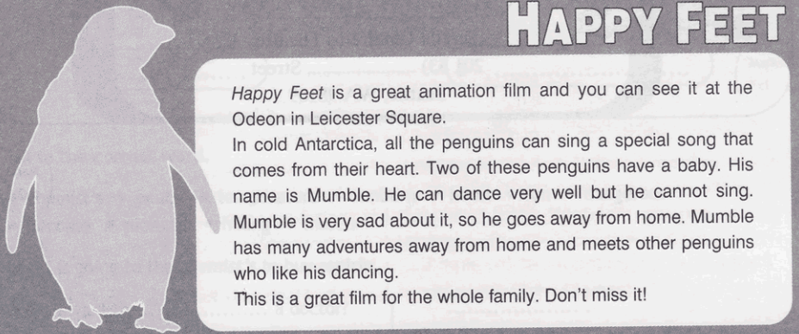
E.g. Happy Feet is a fantasy film. F
1) The story takes place in Ireland. ______
2) Mumble can’t sing. ______
3) Mumble can dance well. ______
4) Mumble doesn’t meet any other penguins. ______
5) Happy Feet is a film for the whole family. ______
5. Choose the correct response.
- Let’s go swimming!  - Let’s go whitewater rafting!  - Would you like to go fishing?  - Would you like to go hiking with me?  - Do you like scuba diving? | - Yes, I do. I like it very much!  - Yes, sure, I will catch a big fish!  - No, thanks, it is too dangerous!  - OK! It’s sunny today and the water is warm.  - I would love to! I want to see the mountains!

