МБОУ «Симферопольская академическая гимназия»

ВНЕКЛАССНОЕ МЕРОПРИЯТИЕ
ПО АНГЛИЙСКОМУ ЯЗЫКУ
ВИКТОРИНА для 6 классов

«Alice’s adventures in wonderland»

УЧИТЕЛЬ
Английчкого языка
Атауллаева Диана Азисовна

Симферополь - 2020

Цели:
образовательная – проверка знаний учащихся, полученных от прочтения книги, обогащение словарного запаса учащихся;
воспитательная – воспитание потребности в чтении художественной литературы, привитие эстетического вкуса, развитие мотивации к изучению предмета Иностранный язык;
развивающая – расширение кругозора учащихся в области литературы и культуры страны изучаемого языка, развитие памяти, познавательных и творческих потребностей учащихся.
Данное мероприятие предназначено для 7 классов. Мероприятие проводится во внеурочное время. Учащиеся получают задание и самостоятельно ищут ответы на поставленные задачи.
Учащимся необходимо по фотографии отгадать писателя. Назвать его настоящее имя, псевдоним, дату рождения, известную книгу.
- Guess the writer and his book.
- 1. What was his real name? Charles L. Dodgson
- 2. What’s his pen -name? Lewis Caroll
- 3. When was he born?in 1832 in England
4. Give the name of his famous book
Alice ‘s adventures in Wonderland
5. When did the first Russian translation come?in 1923
- Lewis Caroll . His real name is Charles L. Dodgson. He wrote a famous book for children “Alice ‘s adventures in Wonderland”. Charles L. Dodgson was born in England in 1832. He got his early education at a public school. Then he became a student at Oxford. Charles studied mathematics and later taught this subject in the same college. Charles Dodgson had no family, but he loved children very much. He often visited his friend, who had a large family. There were three little girls in the family. One of them Alice, was four years old.
- Dodgson liked Alice very much and he often told her interesting stories which he made up himself. Charles told Alice Liddell about the adventure of a little girl, and she liked the stories very much. When Alice Liddell was about ten years old, she asked Charles to write down the stories for her, and he did so. He called the heroine of his book also Alice. This hand-written book had many pictures made by Charles himself. They were not very good pictures but the children liked them. One day a friend of the Liddells, a writer, came to see the family. He saw the hand-written book made by Charles Dodgson and began to read it with great interest. He read the book to the end and said that it was good and that all the children in England must read it.
Charles decided to publish the book but he did not want to do it under his own name. So he took the pen-name “ Lewis Caroll”. The book came out in 1865 and all the people who read it liked it very much. Later the book was published in the United States, in France and in Germany. The first Russian translation came out in 1923. In England the book was published very many times during the author's life and you can find it in the bookshops of today. "

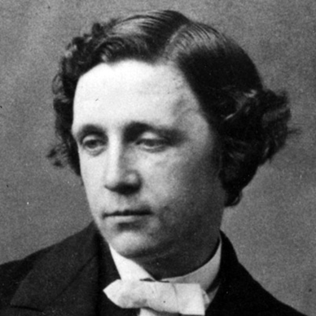

1.ЗАДАНИЕ- МАРТОВСКОГО КРОЛИКА. Учащимся предлагается закончить письмо Мартовского кролика. Необходимо вставить пропущенные слова
.
“The letter of March Rabbit”
The White rabbit wrote a letter to queen but he didn’t know the verbs.
Help him.
The letter of March Hare.
I am March Hare. My birthday is on 1st of April. I am proud of this fact. English Queen Elizabeth was born in April too Well, I didn’t have a birthday party because my house isn’t big. I didn’t invite my best friends. I live with Dormouse and Hatter in a terraced house. There isn’t garden in front of the house. Our house is quite small. I like drawing. Dormouse forces to sleep in the teapot. Hatter is fond of drinking tea every day.
We have a big collection of coins. We began to collect coins many years ago. There are more than 200 coins from different countries in our collection. Some of them are cold and rare. And we would like to give this collection to our Queen. We are going to get a new big house with a small garden.
За каждый правильный ответ 1 балл максимальное колличество 4

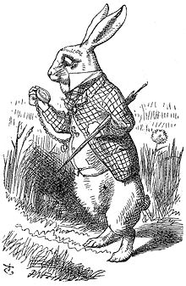

2. ЗАДАНИЕ БЕЗУМНОГО ШЛЯПНИКА. Учащимся необходимо выбрать правильный вариант ответа на поставленный вопрос.

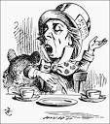
  - Alice noticed a table which had
- 3 legs
- 4 legs
- 5 legs

- When she opened one of the doors, she saw ……
- a lake
- a garden
- a castle
- Alice saw something swimming in front of her. It was …
- a crocodile
- a mouse
- a cat
- When Alice came to the White Rabbit’s house, she saw…..
- a little bottle
- a little cake
- Marry Ann
- A White Rabbit had … eyes.
a. pink
b. green
c. red
6. The … could easily appear and vanish.
a. Cheshire Cat
b. Hatter
c. March Hare
7. At the end of the story … was of her full size again.
a. the Rabbit
b. the Cat
c. Alice
8. Alice said “ You are nothing but a pack of …”.
a. leaves
b. cards
c. leaflets
Максимальное колличество 8
3.ЗАДАНИЕ КОРОЛЕВЫ ЧЕРВЕЙ. Учащимся предлагается составить предложения.

Королева смешала все слова в предложениях, как колоду карт. Попробуйте составить предложения из этих слов.
The words in the sentence are jumbled up. Put the words in the right order.

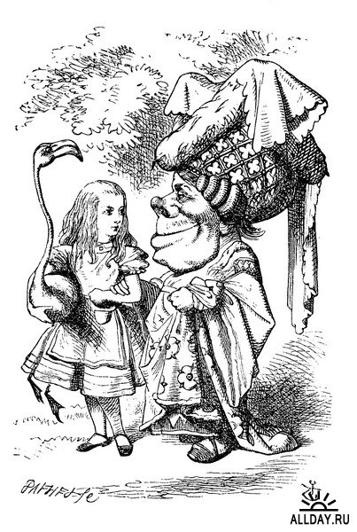
  - A watch, out of, the Rabbit, its, took, pocket, and, at, look, it.
правильный ответ
The Rabbit took a watch out of its pocket and look at it.
  - A table, and, a little, noticed, key, gold, she.
правильный ответ
She noticed a table and a little gold key.

  - Didn’t, cats, the Mouse, dogs, like, and.
правильный ответ
The Mouse didn’t like cats and dogs.
  - Alice, suddenly, that, near, saw, the mirror, a bottle, stood.
правильный ответ
Alice stood near the mirror and suddenly saw a bottle.
За задание учащиеся могут получить 8 баллов (2 балла за каждый правильный ответ).

4.ЗАДАНИЕ АЛИСЫ. Учащимся предлагается выбрать и нарисовать одного из персонажей сказки. 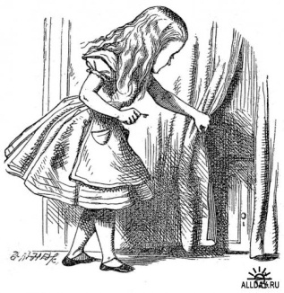CHOOSE AND DRAW A CHARACTER from THE BOOK «ALICE’S ADVENTURES IN WONDERLAND»
За задание учащиеся могут получить 10 баллов . Общеее кол-во баллов - 30

Таблица результатов
 | The 1st task | The 2nd task | The 3rd task | The 4th task | Total
1 группа

2 группа

